**CAN THO UNIVERSITY**

**COLLEGE OF INFORMATION AND COMMUNICATION TECHNOLOGY**

**DEPARTMENT OF INFORMATION TECHNOLOGY**

**🙞 🕮 🙜**



**BASIS THESIS**

**BACHELOR OF ENGINEERING IN**

**INFORMATION TECHNOLOGY**

**(HIGH-QUALITY PROGRAM)**

**FORUMBOT: CHATBOX FORUM ABOUT INTERNSHIP**

**Student: Nguyen Trung Tam**

**Student ID: B1910697**

**Class: 2019-2023 (K45)**

**Advisor: Dr. Tran Nguyen Minh Thu**

**Can Tho, 05/2019**

**CAN THO UNIVERSITY**

**COLLEGE OF INFORMATION AND COMMUNICATION TECHNOLOGY**

**DEPARTMENT OF INFORMATION TECHNOLOGY**

**🙞 🕮 🙜**



**BASIS THESIS**

**BACHELOR OF ENGINEERING IN**

**INFORMATION TECHNOLOGY**

**(HIGH-QUALITY PROGRAM)**

**FORUMBOT: CHATBOX FORUM ABOUT INTERNSHIP**

**Student: Nguyen Trung Tam**

**Student ID: B1910697**

**Class: 2019-2023 (K45)**

**Advisor: Dr. Tran Nguyen Minh Thu**

**Can Tho, 05/2019**

EVALUATION OF ADVISOR

....................................................................................................................................................................................................................................................................................................................................................................................................................................................................................................................................................................................................................................................................................................................................................................................................................................................................................................................................................................................................................................................................................................................................................................................................................................................................................................................................................................................................................................................................................................................................................................................................................................................................................................................................................................................................................................................................................................................................................................................................................................................................................................................................................................................................................................................................................................................................................................................................................................................................................................................................................................................................................................................................................................................................................................

Advisor

Tran Nguyen Minh Thu

ACKNOWLEDGMENTS

I wish to express my deep gratitude and sincere thanks to my professor Tran Nguyen Minh Thu – A lecturer at the College of Information and Communication Technology who gave me the golden opportunity to do this wonderful thesis on the topic “ForumBot: Chatbox forum about internship”, which also helped me in doing a lot of Research and I came to know about so many new things I am really thankful to them. Then I would like to thank the lecturers of Can Tho University, specifically, the lecturers of the College of Information and Communication Technology who taught me invaluable knowledge when I studied.

I am extremely grateful to my family for their love, prayers, and care for the completion of this thesis. I am very much thankful to my friends for their support when I was doing research at Can Tho university.

Sincerely,

Can Tho, 16/05/2022

Nguyen Trung Tam

TABLE OF CONTENTS

CHAPTER 1: INTRODUCTION 12

1.1. Problem 12

1.2. History of problem-solving 12

1.3. Purpose 15

1.4. The objectives and scope 15

1.5. Research Methods: 16

1.6. Result 16

CHAPTER 2: PROBLEM DESCRIPTION 17

2.1. Detailed description of the problem 17

2.2. Background 21

2.2.1. MongoDB 21

2.2.2. Vue 22

2.2.3. NodeJS 22

2.2.4. Python 24

2.2.5. Machine Learning 25

2.2.6. Rasa 27

2.2.7. Other technologies 28

CHAPTER 3: DESIGN AND IMPLEMENT OF THE WEBSITE 29

3.1. Overview 29

3.2. Analyst and Design 30

3.2.1. Database Design 30

3.2.2. Database Model 31

3.2.3. Use Cases diagram 46

3.2.4. Detail Use Cases 49

3.3. ForumBot: Chatbot to answer questions automatically 67

3.3.1. Overview 67

3.3.2. Training data 67

3.4. Detail Of Functions In The System 74

3.4.1. Authenticate 74

3.4.2. Chat function 74

3.4.3. Question function 74

3.4.4. Answer function 75

3.4.5. Comment function 75

3.4.6. Recruitment function 75

3.4.7. Apply recruitment 75

3.4.8. User content management 76

3.4.9. Recruiter management 76

3.4.10. Admin management 76

3.4.11. User Interface 76

CHAPTER 4: TESTING 116

4.1. Purpose of Testing 116

4.2. Testing scenario 117

4.3. Testing results 118

4.3.1. Register feature 118

4.3.2. Login feature 119

4.3.3. Update profile feature 119

4.3.4. Chat feature 119

4.3.5. Question feature 120

4.3.6. Answer feature 120

4.3.7. Comment feature 121

4.3.8. Recruitment feature 122

4.3.9. Apply recruitment feature 122

CHAPTER 5: CONCLUSION AND FUTURE WORK 124

5.1. Conclusion 124

5.2. Future work 124

REFERENCES 125

LIST OF FIGURES

Figure 1. Indeed website 13

Figure 2. Flexjob website 13

Figure 3. LinkedIn website 14

Figure 4. Database CDM diagram 30

Figure 5. Database PDM diagram 31

Figure 6. Rasa intents example 38

Figure 7. Rasa responses example 39

Figure 8. Rasa training data example 40

Figure 9. Rasa story example 41

Figure 10. Flowchart of an example of a conversation between chatbox and user 71

Figure 11. Home page prototype 42

Figure 12. Detail question page prototype 43

Figure 13. Recruitments page prototype 43

Figure 14. Detail recruitment prototype 44

Figure 15. Admin panel prototype 45

Figure 16. Recruiter panel prototype 45

Figure 17. User use case diagram 46

Figure 18. Recruiter use case diagram 47

Figure 19. Admin use case diagram 48

Figure 20. ForumBot intents 69

Figure 21. Response example of ForumBot 69

Figure 22. Story example fo ForumBot 72

Figure 23. Rule example of ForumBot 73

Figure 24. Chatbox evaluation results 73

Figure 25. Navigation bar before signing in 76

Figure 26. Navigation bar after signing in 76

Figure 27. Navigation bar after signing in with recruiter role 77

Figure 28. Navigation bar after signing in with admin role 77

Figure 29. Main page 78

Figure 30. Chatbox popup message 78

Figure 31. Sign-up form on the sign-up page 79

Figure 32. Login form on the login page 80

Figure 33. Chat page 81

Figure 34. List of questions and categories on the home page 82

Figure 35. List of answers, and comments on the detail question page 82

Figure 36. Questions topic page 83

Figure 37. List of recruitments on the recruitments page 84

Figure 38. Detail recruitment info on the detail recruitment page 85

Figure 39. Apply recruitment form 86

Figure 40. Search questions result page 87

Figure 41. Search the recruitments result page 88

Figure 42. User profile setting page 89

Figure 43. Questions management page for users 90

Figure 44. Question form for users 91

Figure 45. Answers management page for users 92

Figure 46. Edit the answer page for the user 93

Figure 47. Comments management page for users 94

Figure 48. Edit the comment page for the user 95

Figure 49. Categories management page 96

Figure 50. Edit category form 96

Figure 51. Accounts management page 97

Figure 52. Companies management page 98

Figure 53. Add company form 99

Figure 54. Edit company form 99

Figure 55.Fields management 100

Figure 56. Add field form 100

Figure 57. Edit field form 101

Figure 58. Skills management 102

Figure 59. Add skill form 102

Figure 60. Edit skill form 103

Figure 61. Questions management page 103

Figure 62. Add question form 104

Figure 63. Update question form 105

Figure 64. Answers management page 105

Figure 65. Add answer form 106

Figure 66. Update answer form 107

Figure 67. Recruitments management page 108

Figure 68. Add recruitment form (1) 109

Figure 69. Add recruitment form (2) 109

Figure 70. Update recruitment form 110

Figure 71. Update recruitment form (2) 111

Figure 72. Recruitments management page 112

Figure 73. Add question form 114

Figure 74. Update question form 114

Figure 75. Recruitments management page 115

LIST OF TABLES

Table 1. Table role 31

Table 2. User table 32

Table 3. Author table 32

Table 4. Recruiter table 33

Table 5. User detail table 33

Table 6. Category table 33

Table 7. Question table 34

Table 8. Answer table 34

Table 9. Comment 35

Table 10. Company table 35

Table 11. Skill table 35

Table 12. Field table 35

Table 13. Recruitment table 36

Table 14. Apply table 36

Table 15. Recruitment detail table 37

Table 16. Recruitment skill 37

Table 17. Functionalities testing scenario 117

Table 18. Usability testing scenario 117

Table 19. Compatible testing scenario 117

Table 20. Data testing scenario 118

Table 21. Security testing scenario 118

Table 22. Test case register feature 119

Table 23. Test case login feature 119

Table 24. Test case update profile feature 119

Table 25. Test case chat feature 120

Table 26. Test case question feature 120

Table 27. Test case answer feature 121

Table 28. Test case comment feature 121

Table 29. Test case recruitment feature 122

Table 30. Test case apply recruitment feature 123

**OVERVIEW**

Chatbox Forum – a chatbox website for post question, answer, and recruitment about internships using HTML, CSS, JS, Node JS and Python, and ML

Nowadays, the necessity for an internship is becoming more and more important, especially in technology fields, because of the rapid development of IT and the need for experienced and skillful IT employees. However, there are many questions and problems that IT students need to know and understand before participating in an internship. They need to search for the info and prepare for the internship to take the most of it before they graduate and get a job.

Chatbox forum was created to provide a useful tool to assist those who want to find and answer questions about practical internships in the most effective, fast, and convenient way. In addition, the website also supports collecting and updating practical internship information suitable for students, and recruitment information. Besides, the website also allows students to search for internship information according to their desire to help students find answers quickly.

The web application has the following main functions:

1. Ask chatbox questions
2. View the questions
3. View recruitment information
4. Apply for a recruitment
5. Post a question
6. Post an answer
7. Post recruitments
8. Search questions
9. Filter questions by topic
10. Search recruitments
11. Filter recruitments by company
12. Filter recruitments by skills
13. Filter recruitments by fields
14. User management

* Manage posted questions
* Manage posted answers
* Manage posted comments

1. Recruiter management

* Manage recruitments
* Manage applicants

1. Admin management

* Manage companies
* Manage question topic (category)
* Manage skills
* Manage fields (position for recruitment)
* Manage questions
* Manage recruitments
* Manage answers
* Statistic

# INTRODUCTION

## Problem

Students across the country in general and students of Can Tho University, in particular, have dreams, want to have a good job, and get a suitable internship to hone their skills. Most want to have a stable job right after graduation but do not have much experience in the job search. Therefore, it is very necessary to have a website to update news about internship-related issues for you to track information, supplement knowledge, and update recruitment information of businesses, from which students can Register directly on the website. Therefore, the website exchanges information, updates actual internship news, advertises recruitment, and supports searching for information at will so that others can participate in answering questions, from which students can understand the actual internship situation, the work to be prepared as well as the requirements related to the actual internship. At the same time, the website also has an integrated chatbox trained from a database of common problems to help students get answers as quickly as possible.

## History of problem-solving

Related websites:

Indeed

Indeed is the job site in the world with over 300M unique visitors every month. Indeed strives to put job seekers first, giving them free access to search for jobs, post resumes, and research companies.

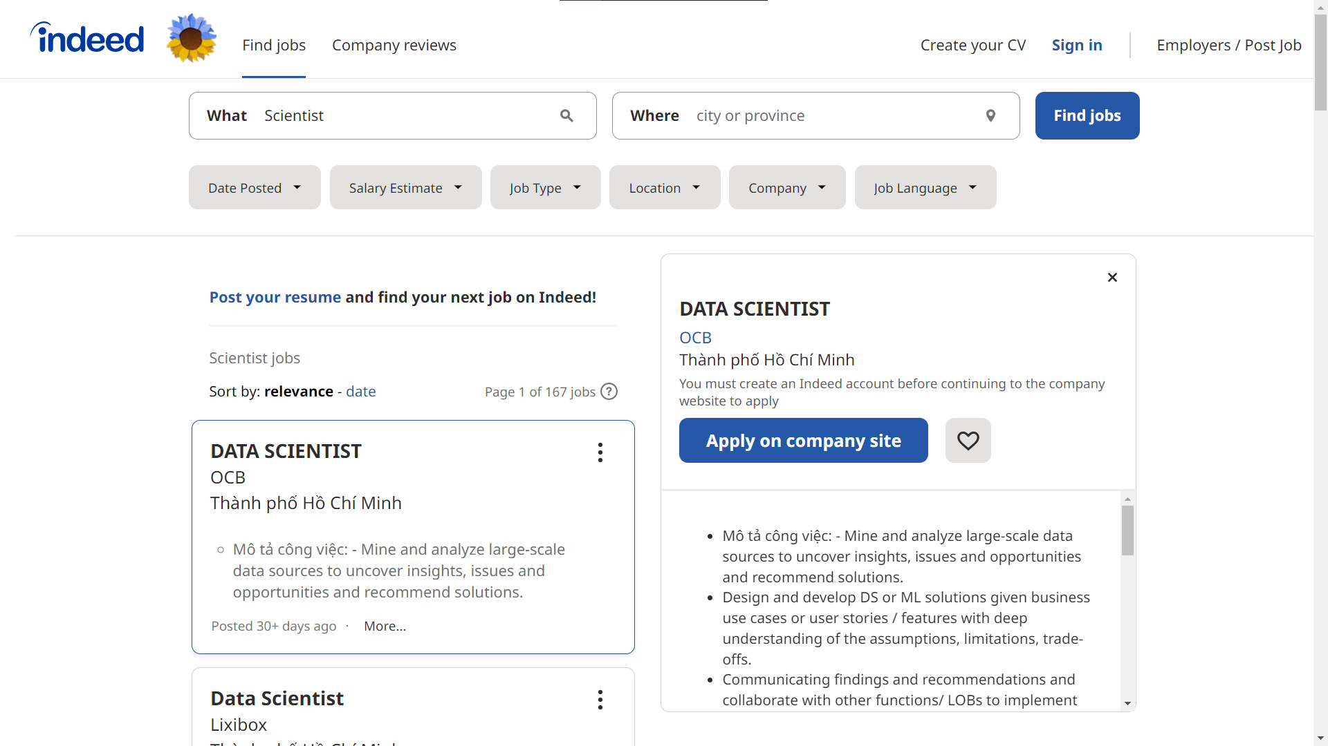

Figure 1. Indeed website

Flexjob:

Flexjob is the job search site for manually screened flexible, remote jobs (work from home). Flexjob also supports posting resumes, training, and career help for users

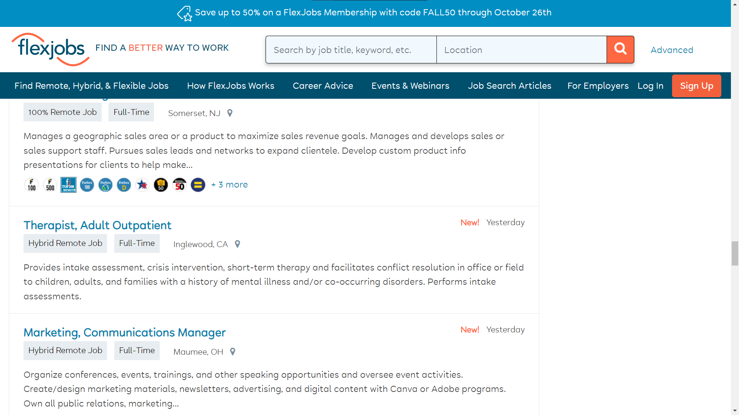

Figure 2. Flexjob website

Linkedin

LinkedIn is an online service website for businesses and job seekers. LinkedIn allows users to post CVs to help find the right job and allows employers to post job recruitments.

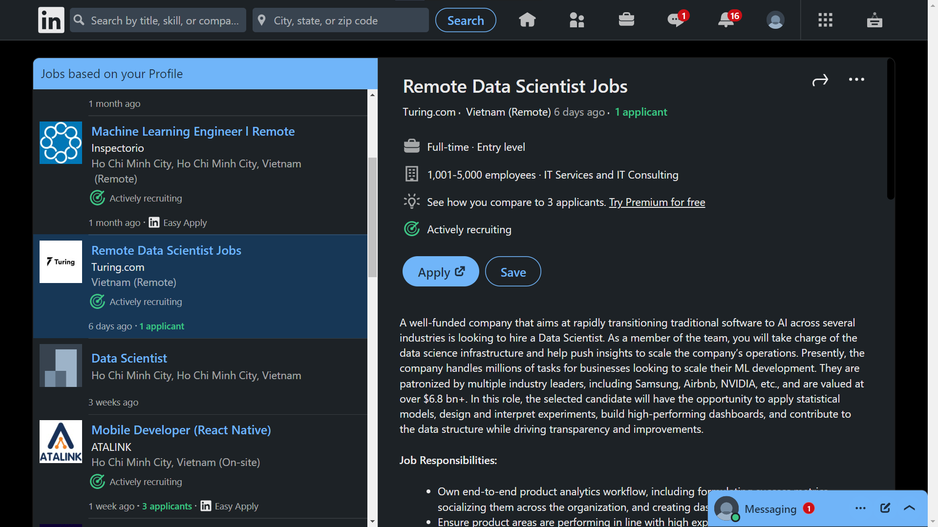

Figure 3. LinkedIn website

Related chatbox:

Building a chatbot for student support

- The purpose of the article is to create a chatbox to support students during online learning, to automatically direct frequently asked questions that students encounter.

- The data for the training chatbox will be collected using surveys. The data processing and analysis are carried out by qualitative analysis of the responses from the surveyors

- Chatbox is built based on Design Science Research Methodology (DSRM) called UAbot. UAbot is installed using Módulo de Ambientação Online (MAO - bootcamp training module)

- Chatbox UAbot has been successful in supporting students in an online learning environment, providing quick and effective answers, and working 24/7.

Singibot - a student services chatbot

- The purpose of the article is to create a chatbox to support students of Singidunum University with a restful website platform, to automatically direct frequently asked questions that students and students encounter, and evolve and adapt. Respond to students' questions.

- Chatbox is built based on the AIML Artificial intelligence Mark-up Language (AIML) method called Alicebot.

Design and Development of CHATBOT: A Review

- The purpose of the article is to examine and evaluate techniques, technologies, terminology, and platforms for developing a chatbox.

- Provides practical aspects of chatbox applications and examples for Computer-Aided Design (CAD) applications.

## Purpose

The application "ForumBot: Chatbox forum about internships" is used for students of Can Tho University in particular and students across the country in general to search for practical internship issues, and follow the news. Practical internship news, internship, and recruitment information to find yourself the most suitable internship place. At the same time, helping students get quick answers by integrating an AI chatbox trained from a set of frequently asked questions about practical internships.

## The objectives and scope

The application provides main functions to help users find, search and explore wonderful courses. This thesis will be focused on the problem of searching and learning from the course. The scope of the study is: researching the problem of searching and learning online and solving the problem by implementing a website with friendly UI/UX.

## Research Methods:

- Requirements analysis: study the problem on the network, paper, analyze the function, and describe the requirements to build the system.

- Data collection: Collect questions, answers, and relevant information about the internship problem to train AI chatbox

- Design: UI/UX design; Model analysis and design: PDM.

- Implementation: Using HTML, CSS, JS for UI and Python for server with MongoDB database training core chatbox with Python

## Result

- Using acquired knowledge of analysis, research, and information gathering, build web applications with chatbox using: HTML, JavaScript, CSS, Python, and Machine Learning

Thesis outline

**Chapter 1**: Introduction

**Chapter 2**: Background

General information about the study and main functions of the system.

**Chapter 3**: Design and implementation

Introduction of UI/UX designs, models, and implementation, describing

technologies that will be used in the study, use case diagrams, databases and

details of function in the system.

**Chapter 4**: Conclusion and future work

# PROBLEM DESCRIPTION

## Detailed description of the problem

Chatbox forum website provides users with functions such as posting questions, answers, news, searching for recruitment internship information questions, statistics of questions, and answers in an easy, fast, and easy way. effective. In addition, the chatbox feature is integrated into the website to help students get answers related to actual practice accurately and quickly.

Chatbox forum website consists of 2 main parts: the website and chatbox.

The website section helps users interact with the chatbox and supports the collection of questions and answers to improve the effectiveness of the training chatbox. In addition, the website section also supports users to find questions, answers, and news related to practical internships. In addition, users can also search for recruitment companies, and job postings as well as the requirements and skills required to prepare themselves for the skills before participating in the actual internship. The website section will also support an administrator function to post job vacancies for students and an admin function to manage questions and answers, and also help admins moderate responses.

System functions include:

1. Ask chatbox questions:

Users can interact and ask questions about issues related to actual internships so that the chatbox provides appropriate answers, respectively. Functions are available to all users

1. View questions and answers:

Users can see and view detailed questions and answers that other users or admins posted on the website

1. View recruitments

Users can see and view detail recruitments info that the recruiter or admin posted on the website

1. Post questions:

Users can post questions related to practical internships if they have not received satisfactory answers from the chatbox so that other users or admins can help provide appropriate answers. more suitable. Users must be logged in to post questions

1. Provide answers:

Users can answer questions posted on the website to help other users clarify issues that the chatbox has not fully provided. The user must be logged in to reply

1. Posting job recruitments:

Management users can post jobs related to actual internships so that other users can help know and apply for jobs.

1. Apply recruitments

Users can apply to job postings (recruitments) to know and learn the skills needed to participate in internships or participate in interviews with companies to learn more.

1. Search questions

Users can search questions by name by inputting the search keyword on the search bar to find the questions that they are interested in.

1. Filter questions by topic

Users can filter questions by specific topics that they are interested in.

1. Search recruitments

Users can also search for recruitments by name by inputting the search keyword on the search bar to find the questions that they are interested in.

1. Filter recruitments by company

Users can filter recruitment by specific companies that they are interested in.

1. Filter recruitments by skill

Users can filter recruitment by specific skills that they want to know and learn.

1. Filter recruitments by field (position)

Users can filter recruitments by specific field (position) that they want to work in this position in the future.

1. View recruitment information

Users do not need to log in to the system to still view recruitment information. Recruitment information is sorted by field.

1. Register to apply

People need to log in to the system to be able to apply for the desired job position.

1. Search recruitment information

Users do not need to log in to the system to search. The user can find search for the company, position, or salary.

1. User Management

The user has the right to manage the content that they have posted on the website such as managing questions and answers or comments.

Question Management:

Users will have the right to post, edit or delete the questions that they have posted in the system. Questions will be approved by the admin and can be seen by other users on the website

Answer Management:

Users will have the right to post, edit or delete the answers that they have posted in the system. Answers will be displayed on the detailed question page and can be seen by other users on the website. Answers will be marked correct by the admin.

Comment Management:

Users will have the right to post, edit or delete the comments that they have posted in the system. Comments will be displayed on the detail question page and can be seen by other users on the website.

1. Recruiter Management

The recruiter has the right to manage the content that they have posted on the website such as managing recruitments and applicants.

Recruitment Management:

Recruiters will have the right to view, post, edit or delete the recruitments that they have posted in the system. Recruitments will be approved by the admin and can be seen by other users on the website. Other users can also apply to the recruitment.

Applicants Management:

Recruiter will have the right to view, download or approve applicants that apply on the recruitments they have posted in the system.

1. Admin Management

The admin user has the rights to manage the content on the website such as managing questions and answers, browsing which answers are relevant, statistics questions and answers

* Question Management:

Users with admin rights will have the right to post, edit or delete the questions in the system. The latest questions will be added to the top of the news page.

* Recruitment Management:

Users with admin rights will have the right to post, edit or delete the recruitments in the system. The latest recruitments will be added to the top of the news page.

* Answer Management:

Users with admin rights will have the right to post, edit or delete the answers in the system. Admin can also approve or mark which answers are correct

* Companies Management:

Users with admin rights will have the right to post, edit or delete the companies in the system.

* Skill Management:

Users with admin rights will have the right to post, edit or delete the skills in the system.

* Field Management:

Users with admin rights will have the right to post, edit or delete the fields in the system.

* Question topic Management:

Users with admin rights will have the right to post, edit or delete the categories in the system.

* Account Management:

Accounts can only be deleted by the Administrator or the user himself, and the Administrator has the right to add, edit, and delete accounts in the system. However, Administrators cannot delete their own accounts and other Administrators.

* Statistics:

Users must log in to the system with Administrator rights to be able to statistic the number of questions, recruitments, answers, and the number of job postings in each field according to the desired time period.

## Background

### MongoDB

MongoDB is a source-available cross-platform document-oriented database program. Classified as a NoSQL database program, MongoDB uses JSON-like documents with optional schemas. MongoDB is developed by MongoDB Inc. and licensed under the Server Side Public License (SSPL) which is deemed non-free by several distributions.

MongoDB provides high availability with replica sets. A replica set consists of two or more copies of the data. Each replica-set member may act in the role of the primary or secondary replica at any time. All writes and reads are done on the primary replica by default. Secondary replicas maintain a copy of the data of the primary using built-in replication. When a primary replica fails, the replica set automatically conducts an election process to determine which secondary should become the primary. Secondaries can optionally serve read operations, but that data is only eventually consistent by default.

MongoDB scales horizontally using sharding. The user chooses a shard key, which determines how the data in a collection will be distributed. The data is split into ranges (based on the shard key) and distributed across multiple shards. (A shard is a master with one or more replicas.) Alternatively, the shard key can be hashed to map to a shard – enabling an even data distribution.

### Vue

Vue is a progressive framework for building user interfaces. It is designed from the ground up to be incrementally adoptable, and can easily scale between a library and a framework depending on different use cases. It consists of an approachable core library that focuses on the view layer only, and an ecosystem of supporting libraries that helps you tackle complexity in large Single-Page Applications.

Vue.js features an incrementally adaptable architecture that focuses on declarative rendering and component composition. The core library is focused on the view layer only. Advanced features required for complex applications such as routing, state management, and build tooling are offered via officially maintained supporting libraries and packages.

Vue.js allows for extending HTML with HTML attributes called directives. The directives offer functionality to HTML applications and come as either built-in or user-defined directives.

### NodeJS

Node.js is an open-source, cross-platform, back-end JavaScript runtime environment that runs on a JavaScript Engine (i.e. V8 engine) and executes JavaScript code outside a web browser, which was designed to build scalable network applications. Node.js lets developers use JavaScript to write command line tools and for server-side scripting—running scripts server-side to produce dynamic web page content before the page is sent to the user's web browser. Consequently, Node.js represents a "JavaScript everywhere" paradigm,[6] unifying web-application development around a single programming language, rather than different languages for server-side and client-side scripts.

Node.js has an event-driven architecture capable of asynchronous I/O. These design choices aim to optimize throughput and scalability in web applications with many input/output operations, as well as for real-time Web applications (e.g., real-time communication programs and browser games)

The Node.js distributed development project was previously governed by the Node.js Foundation and has now merged with the JS Foundation to form the OpenJS Foundation, which is facilitated by the Linux Foundation's Collaborative Projects program.

Node.js allows the creation of Web servers and networking tools using JavaScript and a collection of "modules" that handle various core functionalities. Modules are provided for file system I/O, networking (DNS, HTTP, TCP, TLS/SSL, or UDP), binary data (buffers), cryptography functions, data streams, and other core functions. Node.js's modules use an API designed to reduce the complexity of writing server applications.

JavaScript is the only language that Node.js supports natively, but many compile-to-JS languages are available. As a result, Node.js applications can be written in CoffeeScript, Dart, TypeScript, ClojureScript, and others.

Node.js is primarily used to build network programs such as Web servers.[45] The most significant difference between Node.js and PHP is that most functions in PHP block until completion (commands execute only after previous commands finish), while Node.js functions are non-blocking (commands execute concurrently or even in parallel, and use callbacks to signal completion or failure).

Node.js is officially supported on Linux, macOS, and Microsoft Windows 8.1 and Server 2012 (and later), with tier 2 support for SmartOS and IBM AIX and experimental support for FreeBSD. OpenBSD also works, and LTS versions are available for IBM (AS/400). The provided source code may also be built on similar operating systems to those officially supported or be modified by third parties to support others such as NonStop OS and Unix servers.

Node.js brings event-driven programming to web servers, enabling the development of fast web servers in JavaScript. Developers can create scalable servers without using threading, by using a simplified model of event-driven programming that uses callbacks to signal the completion of a task. Node.js connects the ease of a scripting language (JavaScript) with the power of Unix network programming.

Node.js was built on top of Google's V8 JavaScript engine since it was open-sourced under the BSD license. It is proficient with internet fundamentals such as HTTP, DNS, and TCP. JavaScript was also a well-known language, making Node.js accessible to the web development community.

### Python

Python is a high-level, general-purpose programming language. Its design philosophy emphasizes code readability with the use of significant indentation.

Python is dynamically-typed and garbage-collected. It supports multiple programming paradigms, including structured (particularly procedural), object-oriented and functional programming. It is often described as a "batteries included" language due to its comprehensive standard library.

Python is a multi-paradigm programming language. Object-oriented programming and structured programming are fully supported, and many of its features support functional programming and aspect-oriented programming (including metaprogramming and metaobjects). Many other paradigms are supported via extensions, including design by contract and logic programming.

Python uses dynamic typing and a combination of reference counting and a cycle-detecting garbage collector for memory management. It uses dynamic name resolution (late binding), which binds method and variable names during program execution.

Python strives for a simpler, less-cluttered syntax and grammar while giving developers a choice in their coding methodology. In contrast to Perl's "there is more than one way to do it" motto, Python embraces a "there should be one—and preferably only one—obvious way to do it" philosophy. Alex Martelli, a Fellow at the Python Software Foundation and Python book author, wrote: "To describe something as 'clever' is not considered a compliment in the Python culture."

Python's developers strive to avoid premature optimization and reject patches to non-critical parts of the CPython reference implementation that would offer marginal increases in speed at the cost of clarity. When speed is important, a Python programmer can move time-critical functions to extension modules written in languages such as C; or use PyPy, a just-in-time compiler. Cython is also available, which translates a Python script into C and makes direct C-level API calls into the Python interpreter.

Python's developers aim for it to be fun to use. This is reflected in its name—a tribute to the British comedy group Monty Python—and in occasionally playful approaches to tutorials and reference materials, such as examples that refer to spam and eggs (a reference to a Monty Python sketch) instead of the standard foo and bar.

The programming language's name 'Python' came from the BBC Comedy series Monty Python's Flying Circus. Guido van Rossum thought he needed a name that was short, unique, and slightly mysterious, so, he decided to name the programming language 'Python'.

A common neologism in the Python community is pythonic, which has a wide range of meanings related to program style. "Pythonic" code may use Python idioms well, be natural or show fluency in the language, or conform with Python's minimalist philosophy and emphasis on readability. Code that is difficult to understand or reads like a rough transcription from another programming language is called unpythonic.

Python users and admirers, especially those considered knowledgeable or experienced, are often referred to as Pythonistas.

### Machine Learning

Machine learning (ML) is a field of inquiry devoted to understanding and building methods that 'learn', that is, methods that leverage data to improve performance on some set of tasks. It is seen as a part of artificial intelligence. Machine learning algorithms build a model based on sample data, known as training data, in order to make predictions or decisions without being explicitly programmed to do so. Machine learning algorithms are used in a wide variety of applications, such as in medicine, email filtering, speech recognition, and computer vision, where it is difficult or unfeasible to develop conventional algorithms to perform the needed tasks.

Machine learning programs can perform tasks without being explicitly programmed to do so. It involves computers learning from data provided so that they carry out certain tasks. For simple tasks assigned to computers, it is possible to program algorithms telling the machine how to execute all steps required to solve the problem at hand; on the computer's part, no learning is needed. For more advanced tasks, it can be challenging for a human to manually create the needed algorithms. In practice, it can turn out to be more effective to help the machine develop its own algorithm, rather than having human programmers specify every needed step.

The discipline of machine learning employs various approaches to teach computers to accomplish tasks where no fully satisfactory algorithm is available. In cases where vast numbers of potential answers exist, one approach is to label some of the correct answers as valid. This can then be used as training data for the computer to improve the algorithm(s) it uses to determine correct answers. For example, to train a system for the task of digital character recognition, the MNIST dataset of handwritten digits has often been used.

Supervised learning algorithms build a mathematical model of a set of data that contains both the inputs and the desired outputs. The data is known as training data and consists of a set of training examples. Each training example has one or more inputs and the desired output, also known as a supervisory signal. In the mathematical model, each training example is represented by an array or vector, sometimes called a feature vector, and the training data is represented by a matrix. Through iterative optimization of an objective function, supervised learning algorithms learn a function that can be used to predict the output associated with new inputs.[36] An optimal function will allow the algorithm to correctly determine the output for inputs that were not a part of the training data. An algorithm that improves the accuracy of its outputs or predictions over time is said to have learned to perform that task.

Types of supervised-learning algorithms include active learning, classification, and regression.[ Classification algorithms are used when the outputs are restricted to a limited set of values, and regression algorithms are used when the outputs may have any numerical value within a range. As an example, for a classification algorithm that filters emails, the input would be an incoming email, and the output would be the name of the folder in which to file the email.

Similarity learning is an area of supervised machine learning closely related to regression and classification, but the goal is to learn from examples using a similarity function that measures how similar or related two objects are. It has applications in ranking, recommendation systems, visual identity tracking, face verification, and speaker verification.

### Rasa

State-of-the-art conversational AI framework built with Rasa Open Source. Rasa Pro is the commercial conversational AI infrastructure that is extensible, flexible, and enterprise-grade. It has been built and tested to effectively respond to enterprise needs for security, observability, and scalability.

Rasa is the leading platform for building, shipping, and scaling enterprise-grade virtual assistants. We work with some of the world’s largest brands to automate conversational experiences.

Rasa uses a composable set of primitives for natural language understanding and dialogue management, allowing you to build and scale sophisticated conversational AI.

Have full control over your machine learning models. Tweak any part of your pipeline, and use the tools you love to analyze model performance.

Rasa is an open-source machine learning framework to automate text and voice-based conversations. With Rasa, you can build contextual assistants on:

* Facebook Messenger
* Slack
* Google Hangouts
* Webex Teams
* Microsoft Bot Framework
* Rocket.Chat
* Mattermost
* Telegram
* Twilio
* Your own custom conversational channels

Or voice assistants as:

* Alexa Skills
* Google Home Actions

Rasa helps you build contextual assistants capable of having layered conversations with lots of back-and-forths. For a human to have a meaningful exchange with a contextual assistant, the assistant needs to be able to use context to build on things that were previously discussed – Rasa enables you to build assistants that can do this in a scalable way.

### Other technologies

**Bootstrap:** Bootstrap is the most popular CSS Framework for developing responsive and mobile-first websites. Bootstrap 4 is the newest version of Bootstrap.

**Tailwind CSS:** Utility classes help you work within the constraints of a system instead of littering your stylesheets with arbitrary values. They make it easy to be consistent with color choices, spacing, typography, shadows, and everything else that makes up a well-engineered design system.

**Draw.io:** is proprietary software for making diagrams and charts.

**Font Awesome:** this is the icon library and toolkit to quickly make simple scalable vector images that can be customized with CSS for the web app.

**GitHub:** is a website and cloud-based service that helps store and manage code, as well as track and control changes of code.

# DESIGN AND IMPLEMENT OF THE WEBSITE

## Overview

Chatbox forum is a website application that aids users in searching and finding answers to problems related to the internship. The system provides core functionalities for users: search questions (post), read questions and answers, search recruitment, apply for recruitment, and admin: manage content on the web such as company, field, skill, and accept the answer, …. It provides a chatbox feature to enable the user to ask and receive answers related to the internship, and utilities feature to boost users' engagement.

When users visit the website, they can see uploaded questions on various topics. The questions will be shown with brief detailed information to help users have an overview of what the question is about. The user has to sign up for an account to work on advanced functions. When the user is signing up, they have to provide an email address, username, and password, if the email is duplicated with other users or the password is invalid, the system will show an error notification. After signing up, the user can answer the question and apply for recruitment with detailed information.

Users can also post questions, when they post questions, they will become “Author”, and can edit their profile information to show when other users view the questions they have posted.

Users can also request recruiter rights, Recruiter will be granted full functionalities of the user and will be able to post recruitments on the website.

Admin will be granted full functionalities on the application and interact with the database.

## Analyst and Design

### Database Design

#### CDM

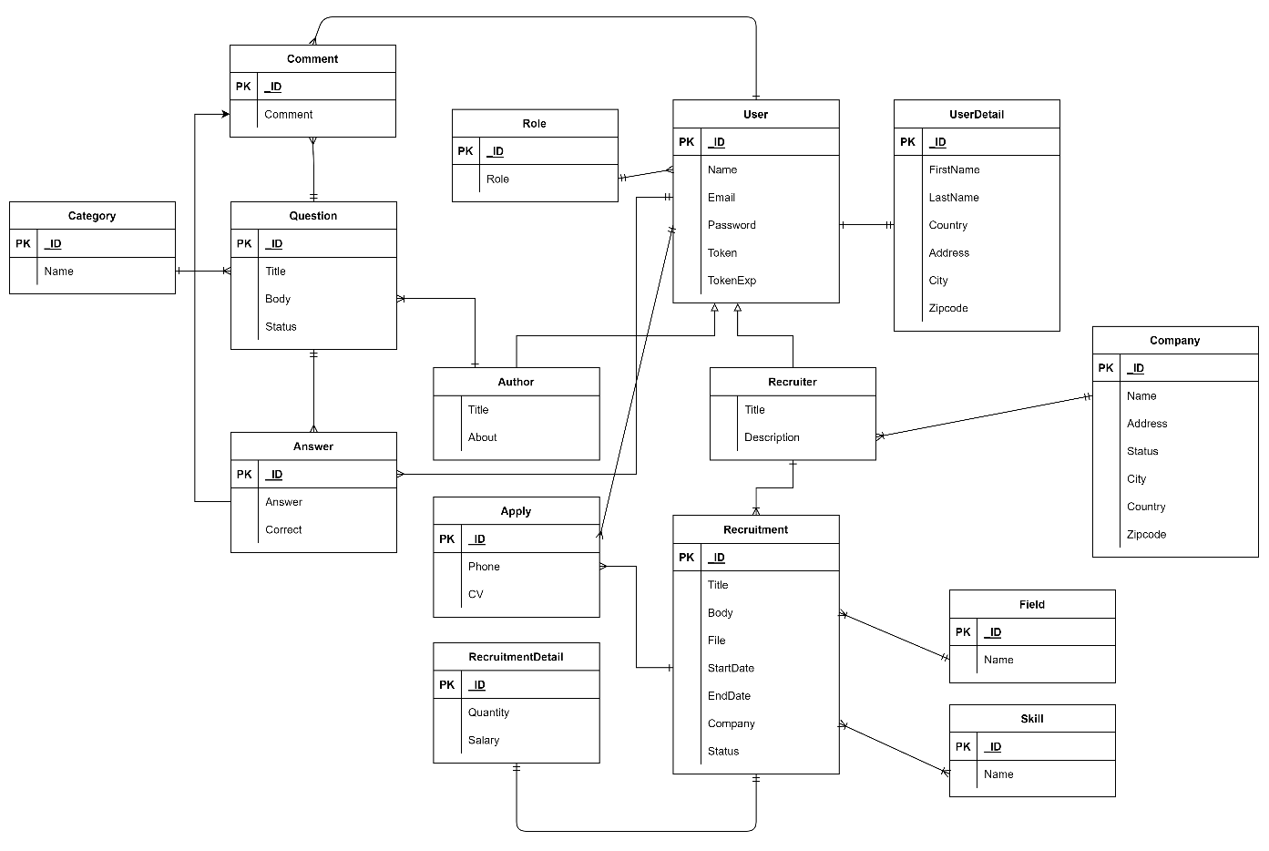

Figure 4. Database CDM diagram

#### PDM

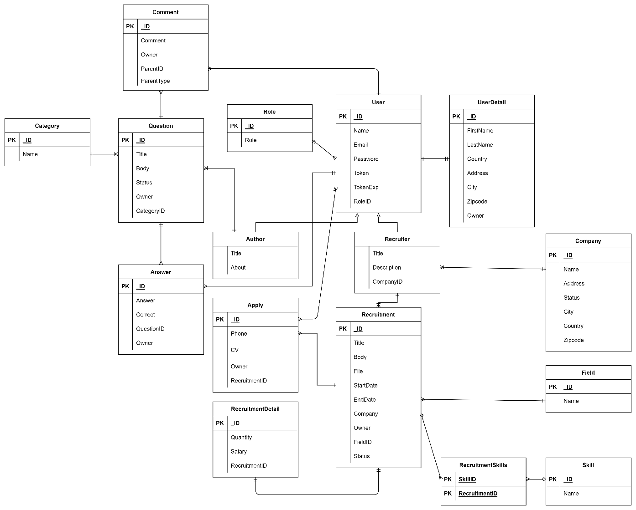

Figure 5. Database PDM diagram

### Database Model

|  |  |  |  |  |  |
| --- | --- | --- | --- | --- | --- |
| **Role Table** | | | | | |
| **STT** | **Field** | **Type** | **PK** | **FK** | **Description** |
| 1 | ID | int | x |  | ID of role |
| 2 | ROLE | varchar(32) |  |  | Name of role |

Table 1. Table role

|  |  |  |  |  |  |
| --- | --- | --- | --- | --- | --- |
| **User Table** | | | | | |
| **STT** | **Field** | **Type** | **PK** | **FK** | **Description** |
| 1 | ID | int | x |  | The ID of the user detail |
| 2 | NAME | varchar(64) |  |  | Name of user |
| 3 | EMAIL | varchar(64) |  |  | Email of user |
| 5 | PASSWORD | varchar (32) |  |  | The hashed password of the user |
| 5 | TOKEN | varchar(128) |  |  | Token of the user for authenticating |
| 6 | TOKEN_EXP | varchar(32) |  |  | The time when the token expires |
| 9 | ROLE_ID | int |  | x | The role this user belongs to |

Table 2. User table

|  |  |  |  |  |  |
| --- | --- | --- | --- | --- | --- |
| **Author Table (Inherent from User)** | | | | | |
| **STT** | **Field** | **Type** | **PK** | **FK** | **Description** |
| 1 | TITLE | int |  |  | Title of author |
| 2 | ABOUT | text |  |  | Content about the author |

Table 3. Author table

|  |  |  |  |  |  |
| --- | --- | --- | --- | --- | --- |
| **Recruiter Table (Inherent from User)** | | | | | |
| **STT** | **Field** | **Type** | **PK** | **FK** | **Description** |
| 1 | TITLE | int |  |  | Title of author |
| 2 | DESCRIPTION | text |  |  | Content about the author |
| 3 | COMPANY_ID | Int |  | x | The company the recruiter belongs to |

Table 4. Recruiter table

|  |  |  |  |  |  |
| --- | --- | --- | --- | --- | --- |
| **User Detail Table** | | | | | |
| **STT** | **Field** | **Type** | **PK** | **FK** | **Description** |
| 1 | ID | int | x |  | ID of user |
| 2 | FIRSTNAME | varchar(32) |  |  | Firstname of user |
| 3 | LASTNAME | varchar(128) |  |  | Lastname of user |
| 5 | COUNTRY | varchar(64) |  |  | Country of user |
| 6 | ADDRESS | int |  |  | Address of user |
| 7 | CITY | varchar(32) |  |  | City of user |
| 8 | ZIP_CODE | varchar(32) |  |  | Zipcode of user |
| 9 | OWNER | int |  | x | The user this info belongs to |

Table 5. User detail table

|  |  |  |  |  |  |
| --- | --- | --- | --- | --- | --- |
| **Category Table** | | | | | |
| **STT** | **Field** | **Type** | **PK** | **FK** | **Description** |
| 1 | ID | int | x |  | ID of category |
| 2 | NAME | varchar(32) |  |  | Name of category |

Table 6. Category table

|  |  |  |  |  |  |
| --- | --- | --- | --- | --- | --- |
| **Question Table** | | | | | |
| **STT** | **Field** | **Type** | **PK** | **FK** | **Description** |
| 1 | ID | int | x |  | ID of post |
| 2 | OWNER | int |  | x | The ID of the user that owns the question |
| 3 | CATEGORY_ID | int |  | x | The ID of the category of the post |
| 4 | TITLE | varchar(255) |  |  | Title of post |
| 5 | BODY | varchar(255) |  |  | Content of the post |
| 6 | STATUS | int |  |  | Status of the post |

Table 7. Question table

|  |  |  |  |  |  |
| --- | --- | --- | --- | --- | --- |
| **Answer Table** | | | | | |
| **STT** | **Field** | **Type** | **PK** | **FK** | **Description** |
| 1 | ID | int | x |  | ID of answer |
| 2 | ANSWER | text |  |  | The content of the answer |
| 3 | QUESTION_ID | int |  | x | The question of this answer |
| 3 | OWNER | int |  | x | The user that answers this |

Table 8. Answer table

|  |  |  |  |  |  |
| --- | --- | --- | --- | --- | --- |
| **Comment Table** | | | | | |
| **STT** | **Field** | **Type** | **PK** | **FK** | **Description** |
| 1 | ID | int | x |  | ID of comment |
| 2 | COMMENT | text |  |  | The content of the comment |
| 3 | PARENT_ID | int |  | x | The foreign id of the model this comment belongs to |
| 4 | PARENT_TYPE |  |  |  | The type of parent model this comment belongs to |

Table 9. Comment

|  |  |  |  |  |  |
| --- | --- | --- | --- | --- | --- |
| **Company Table** | | | | | |
| **STT** | **Field** | **Type** | **PK** | **FK** | **Description** |
| 1 | ID | int | x |  | ID of company |
| 2 | NAME | varchar(32) |  |  | Name of company |
| 3 | ADDRESS | varchar(128) |  |  | Address of the company |
| 5 | COUNTRY | varchar(64) |  |  | Country of company |
| 6 | CITY | varchar(32) |  |  | City of company |
| 7 | ZIP_CODE | varchar(32) |  |  | Zipcode of company |
| 8 | STATUS | int |  |  | The status of the company (Verified or Unverified) |

Table 10. Company table

|  |  |  |  |  |  |
| --- | --- | --- | --- | --- | --- |
| **Skill Table** | | | | | |
| **STT** | **Field** | **Type** | **PK** | **FK** | **Description** |
| 1 | ID | int | x |  | ID of skill |
| 2 | SKILL | varchar(32) |  |  | The skill |

Table 11. Skill table

|  |  |  |  |  |  |
| --- | --- | --- | --- | --- | --- |
| **Field Table** | | | | | |
| **STT** | **Field** | **Type** | **PK** | **FK** | **Description** |
| 1 | ID | int | x |  | ID of field |
| 2 | FIELD | varchar(32) |  |  | The field (position) for recruitment |

Table 12. Field table

|  |  |  |  |  |  |
| --- | --- | --- | --- | --- | --- |
| **Recruitment Table** | | | | | |
| **STT** | **Field** | **Type** | **PK** | **FK** | **Description** |
| 1 | ID | int | x |  | ID of recruitment |
| 2 | TITLE | varchar(64) |  |  | The title of recruitment |
| 3 | CONTENT | text |  |  | The detailed content of the recruitment |
| 4 | FILE | text |  |  | The path of the file of the recruitment |
| 5 | START_DATE | date |  |  | The start date of the recruitment |
| 6 | END_DATE | date |  |  | The end date of the recruitment |
| 7 | RECRUITER_ID | int |  | x | The id of the recruiter |

Table 13. Recruitment table

|  |  |  |  |  |  |
| --- | --- | --- | --- | --- | --- |
| **Apply Table** | | | | | |
| **STT** | **Field** | **Type** | **PK** | **FK** | **Description** |
| 1 | ID | int | x |  | The ID of the apply |
| 2 | PHONE | varchar(12) |  |  | The phone of the user applied |
| 3 | CV | varchar(64) |  |  | The path of the cv file |
| 4 | OWNER | int |  | x | The user id of this apply |
| 5 | RECRUITMENT_ID | int |  | x | The id of the recruitment of this apply |

Table 14. Apply table

|  |  |  |  |  |  |
| --- | --- | --- | --- | --- | --- |
| **Recruitment Detail Table** | | | | | |
| **STT** | **Field** | **Type** | **PK** | **FK** | **Description** |
| 1 | ID | int | x |  | The ID of detail recruitment |
| 2 | QUANTITY | int |  |  | The quantity of the applicant for this recruitment |
| 3 | SALARY | int |  |  | The default salary for this recruitment |
| 4 | RECRUITMENT_ID | int |  | x | The ID of recruitment |

Table 15. Recruitment detail table

|  |  |  |  |  |  |
| --- | --- | --- | --- | --- | --- |
| **Recruitment Skill Table** | | | | | |
| **STT** | **Field** | **Type** | **PK** | **FK** | **Description** |
| 1 | RECRUITMENT_ID | int | x |  | ID of recruitment |
| 2 | SKILL_ID | int | x |  | ID of skill |

Table 16. Recruitment skill

Chatbox data:

**Domain**

The domain defines the universe in which your assistant operates. It specifies the intents, entities, slots, responses, forms, and actions your bot should know about. It also defines a configuration for conversation sessions.

Intents

The intents key in your domain file lists all intents used in your NLU data and conversation training data.

Below are some examples of intents used by the chatbox

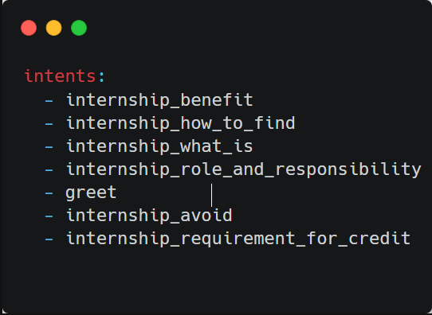

Figure 6. Rasa intents example

Responses

Responses are actions that send a message to a user without running any custom code or returning events. These responses can be defined directly in the domain file under the responses key and can include rich content such as buttons and attachments. For more information on responses and how to define them, see Responses.

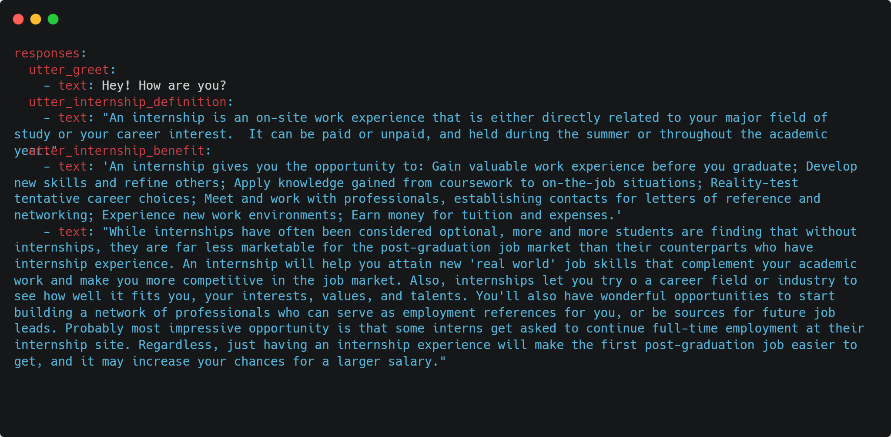

Figure 7. Rasa responses example

Actions

Actions are the things your bot can actually do. For example, an action could:

* Respond to a user,
* Make an external API call,
* Query a database, or
* Just about anything!

NLU training data

NLU training data consists of example user utterances categorized by intent. Training examples can also include entities. Entities are structured pieces of information that can be extracted from a user's message. You can also add extra information such as regular expressions and lookup tables to your training data to help the model identify intents and entities correctly.

NLU training data is defined under the new key. Items that can be added under this key are:

Training examples

Training examples are grouped by intent and listed under the examples key. Usually, you'll list one example per line as follows:

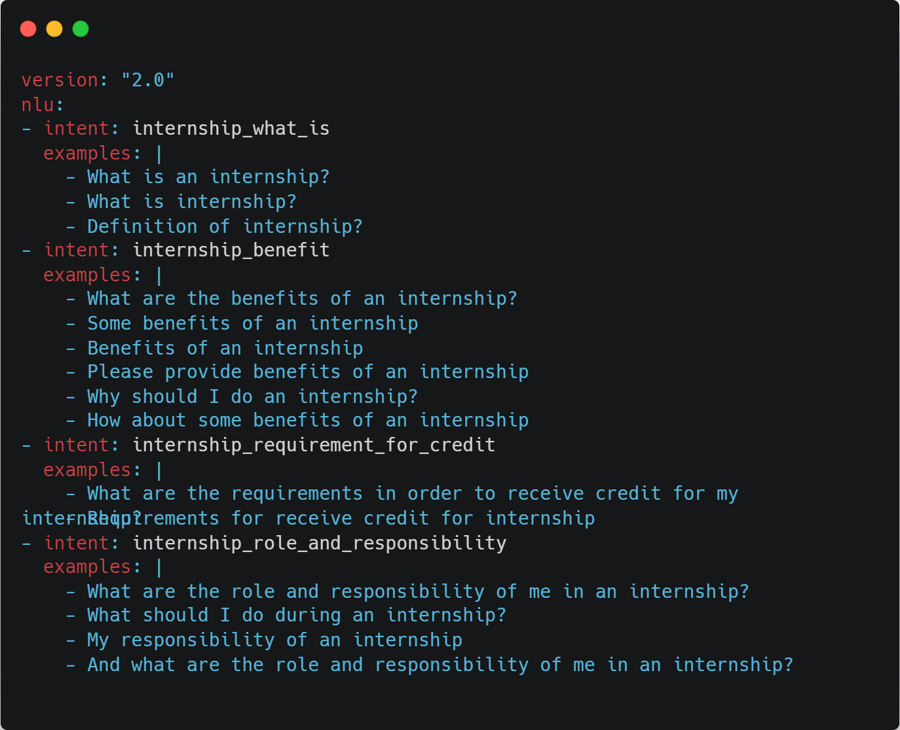

Figure 8. Rasa training data example

Story

A story is a representation of a conversation between a user and an AI assistant, converted into a specific format where user inputs are expressed as intents (and entities when necessary), while the assistant's responses and actions are expressed as action names.

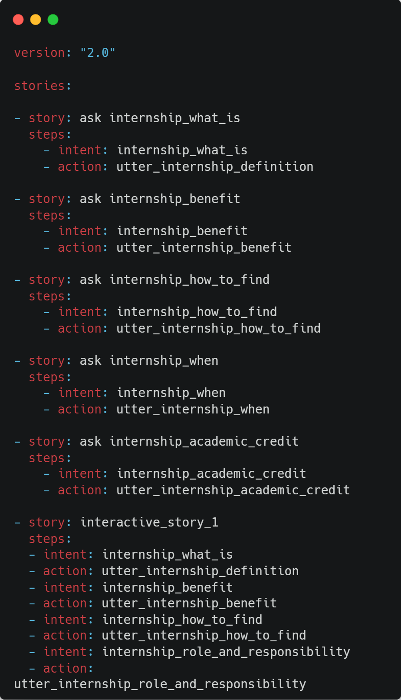

Figure 9. Rasa story example

Prototype:

Below are prototypes of the website:

First, there is a home page that contains recent posts (questions) for users to find answers about the topic they need to resolve.

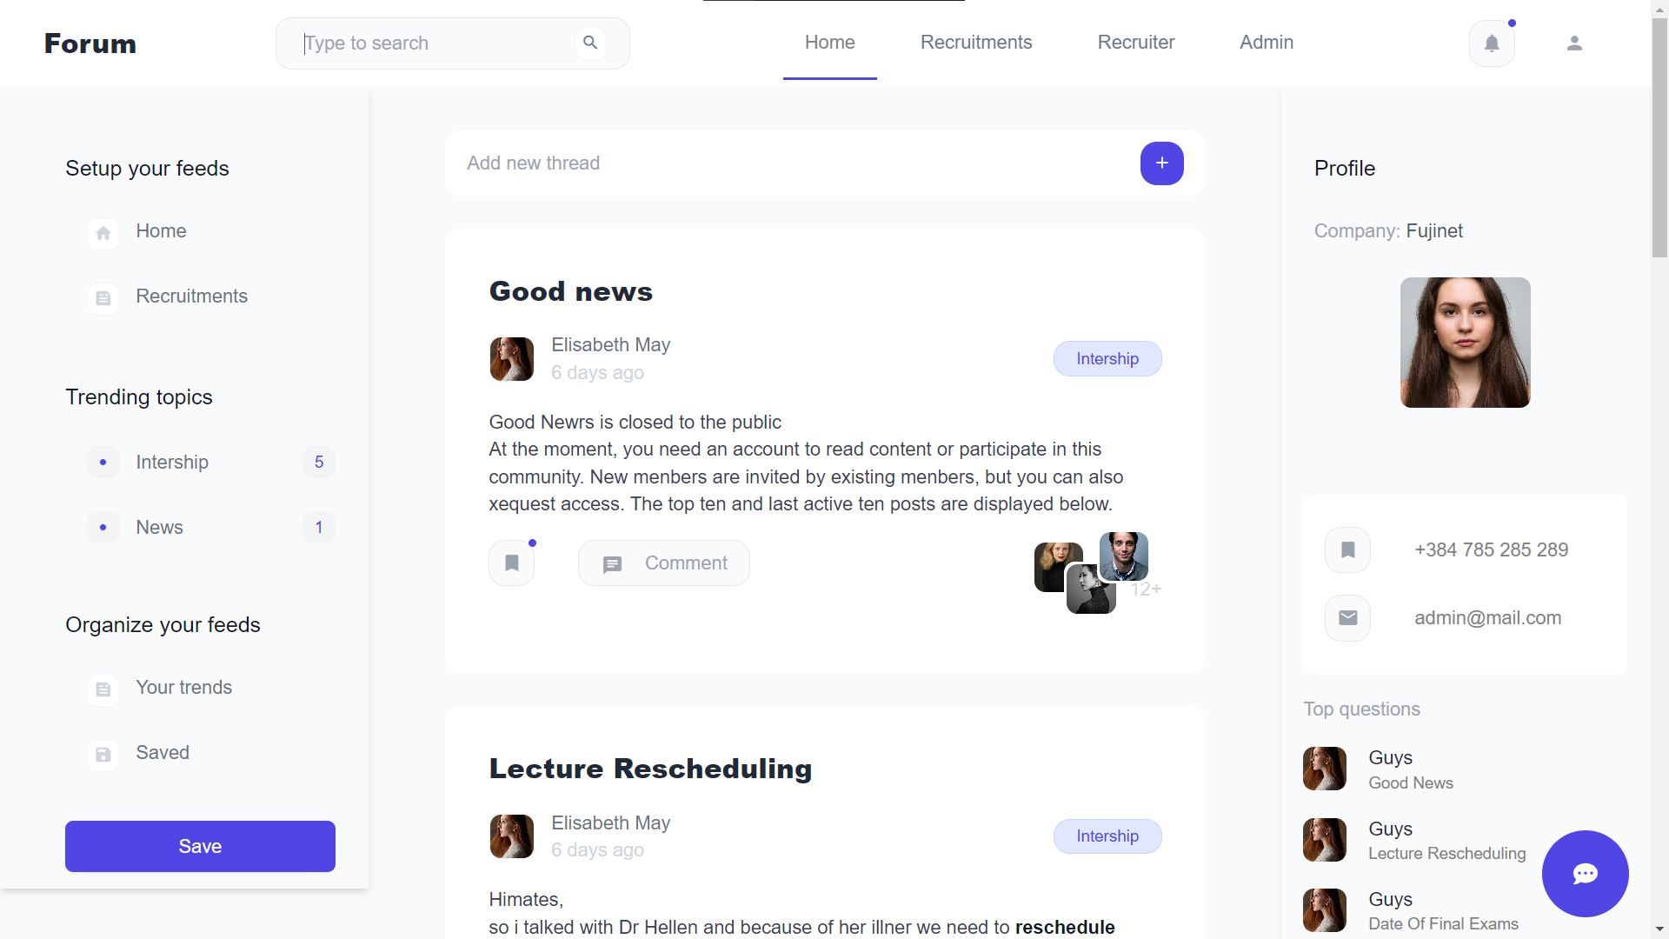

Figure 11. Home page prototype

After clicking on the post (question), there will be detail page show answers related to the question that the user has selected. The page contains the most relevant answers and comments about the answer as well

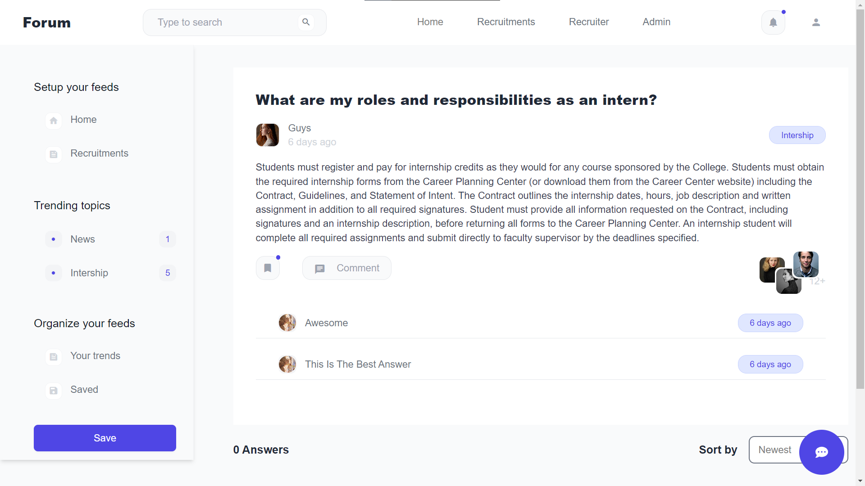

Figure 12. Detail question page prototype

There also have a home page that contains recent posts about the question for the user to find answers about the topic they need to resolve.

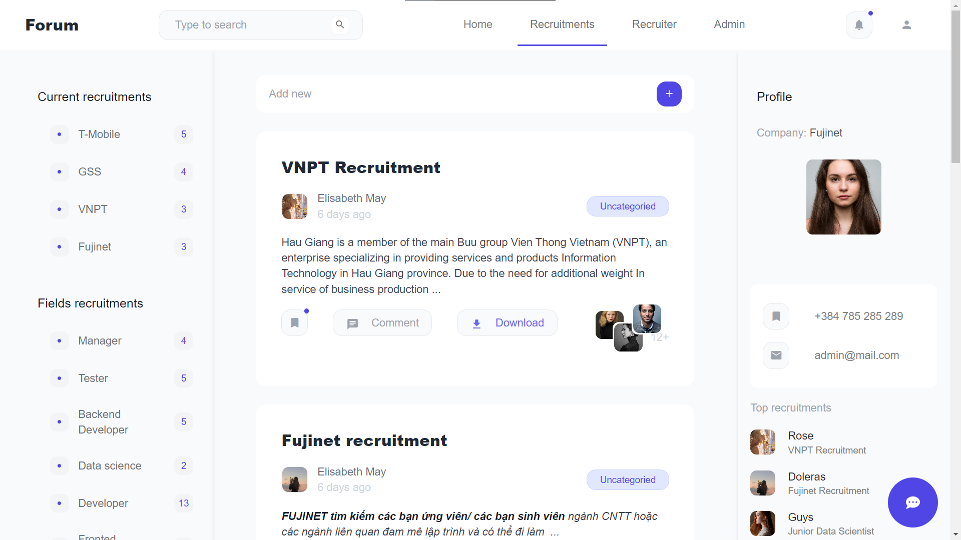

Figure 13. Recruitments page prototype

After clicking on the recruitment, the recruitment detail page shows the full content of the recruitment the user has selected. The page also contains the option to allow the user to apply to this recruitment

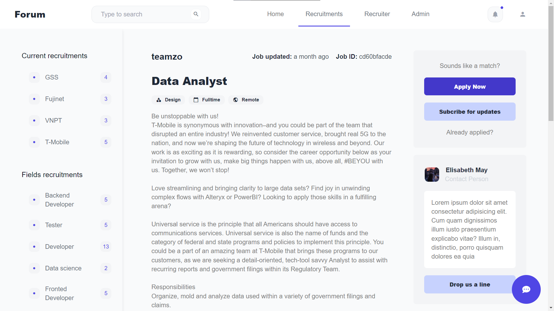

Figure 14. Detail recruitment prototype

Below are some prototypes of admin, recruiter, and author to help them manage the contents they have uploaded to the website

Admin panel allows the administrator to manage almost any content on the website

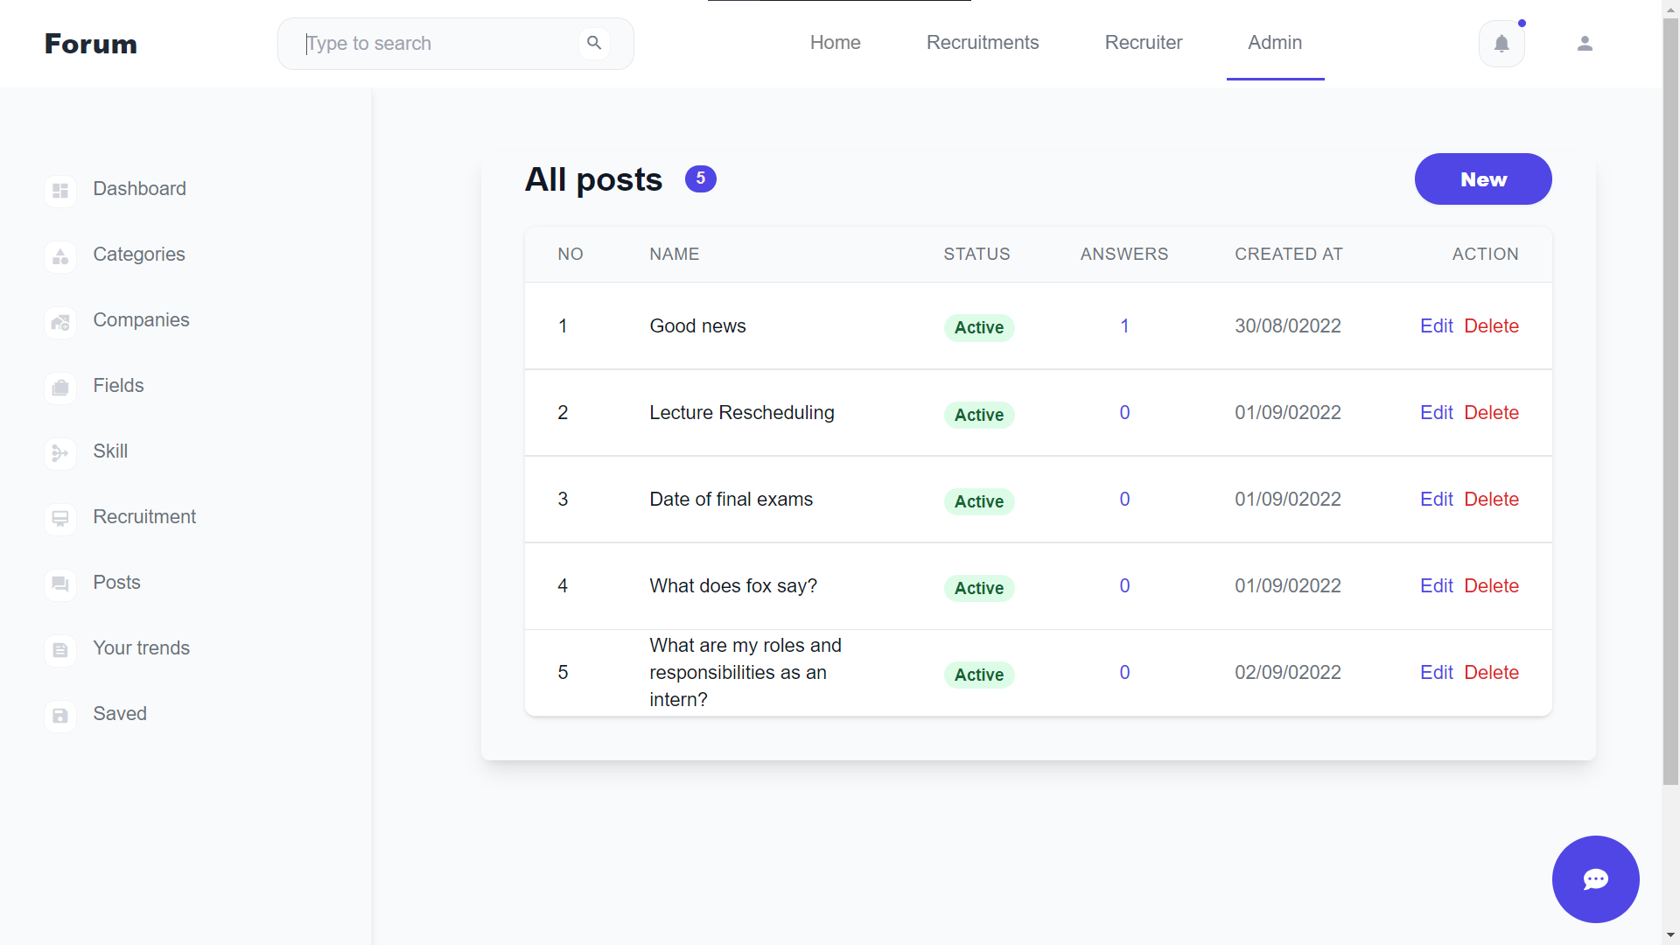

Figure 15. Admin panel prototype

The recruiter panel allows the recruiters to manage the recruitments and related content they have uploaded to the website

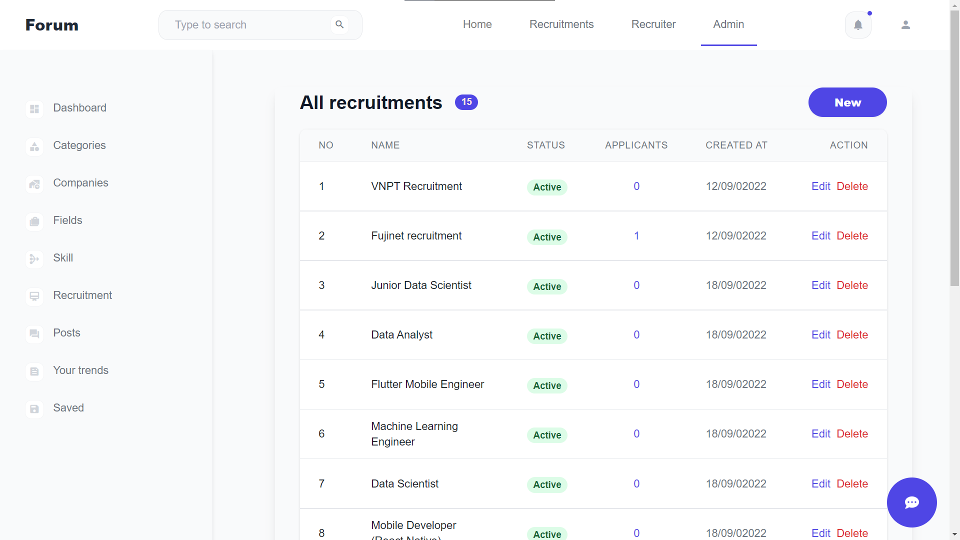

Figure 16. Recruiter panel prototype

### Use Cases diagram

#### User

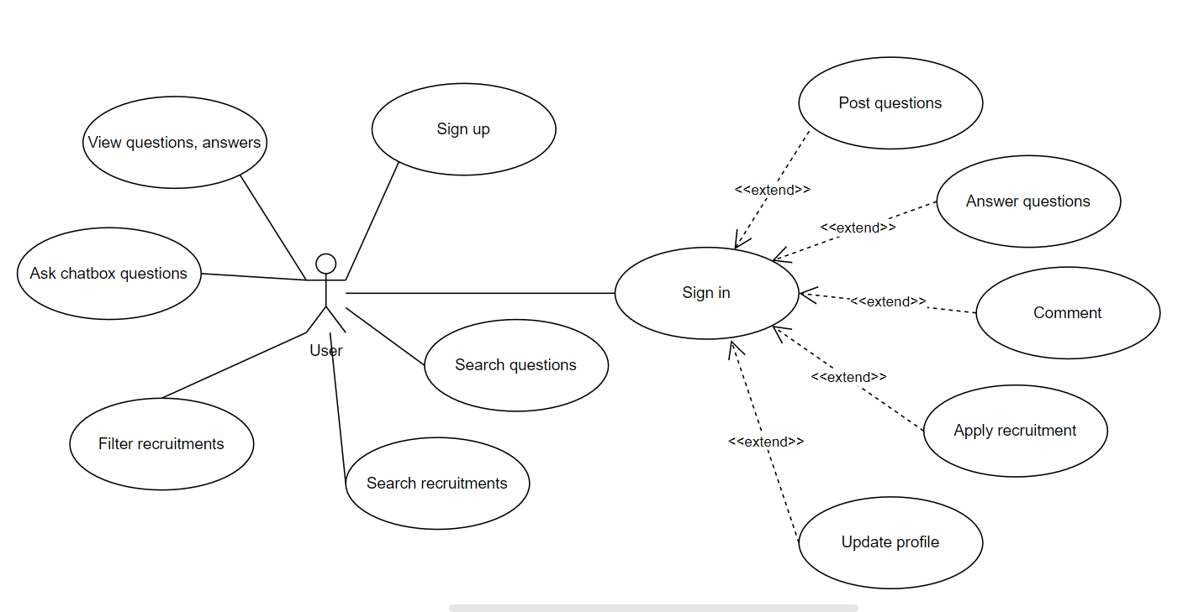

Figure 17. User use case diagram

After signing up, guests will become “User”, they can search for questions and recruitments and do advanced functions: view detailed recruitment, answer questions and apply for recruitments.

#### Recruiter

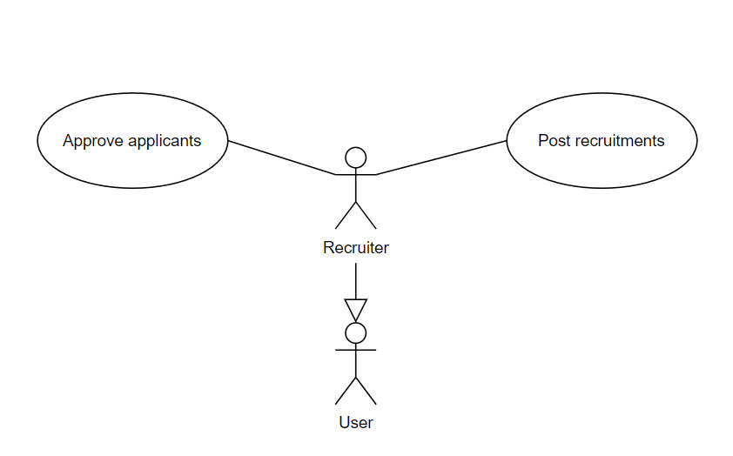

Figure 18. Recruiter use case diagram

After applying for the recruiter and the admin has approved it, users will become “Recruiter”, in addition to features belonging to “User”, “Recruiter” can post recruitments and do advanced features related to recruitment: view applicants and approve applicants.

#### Admin

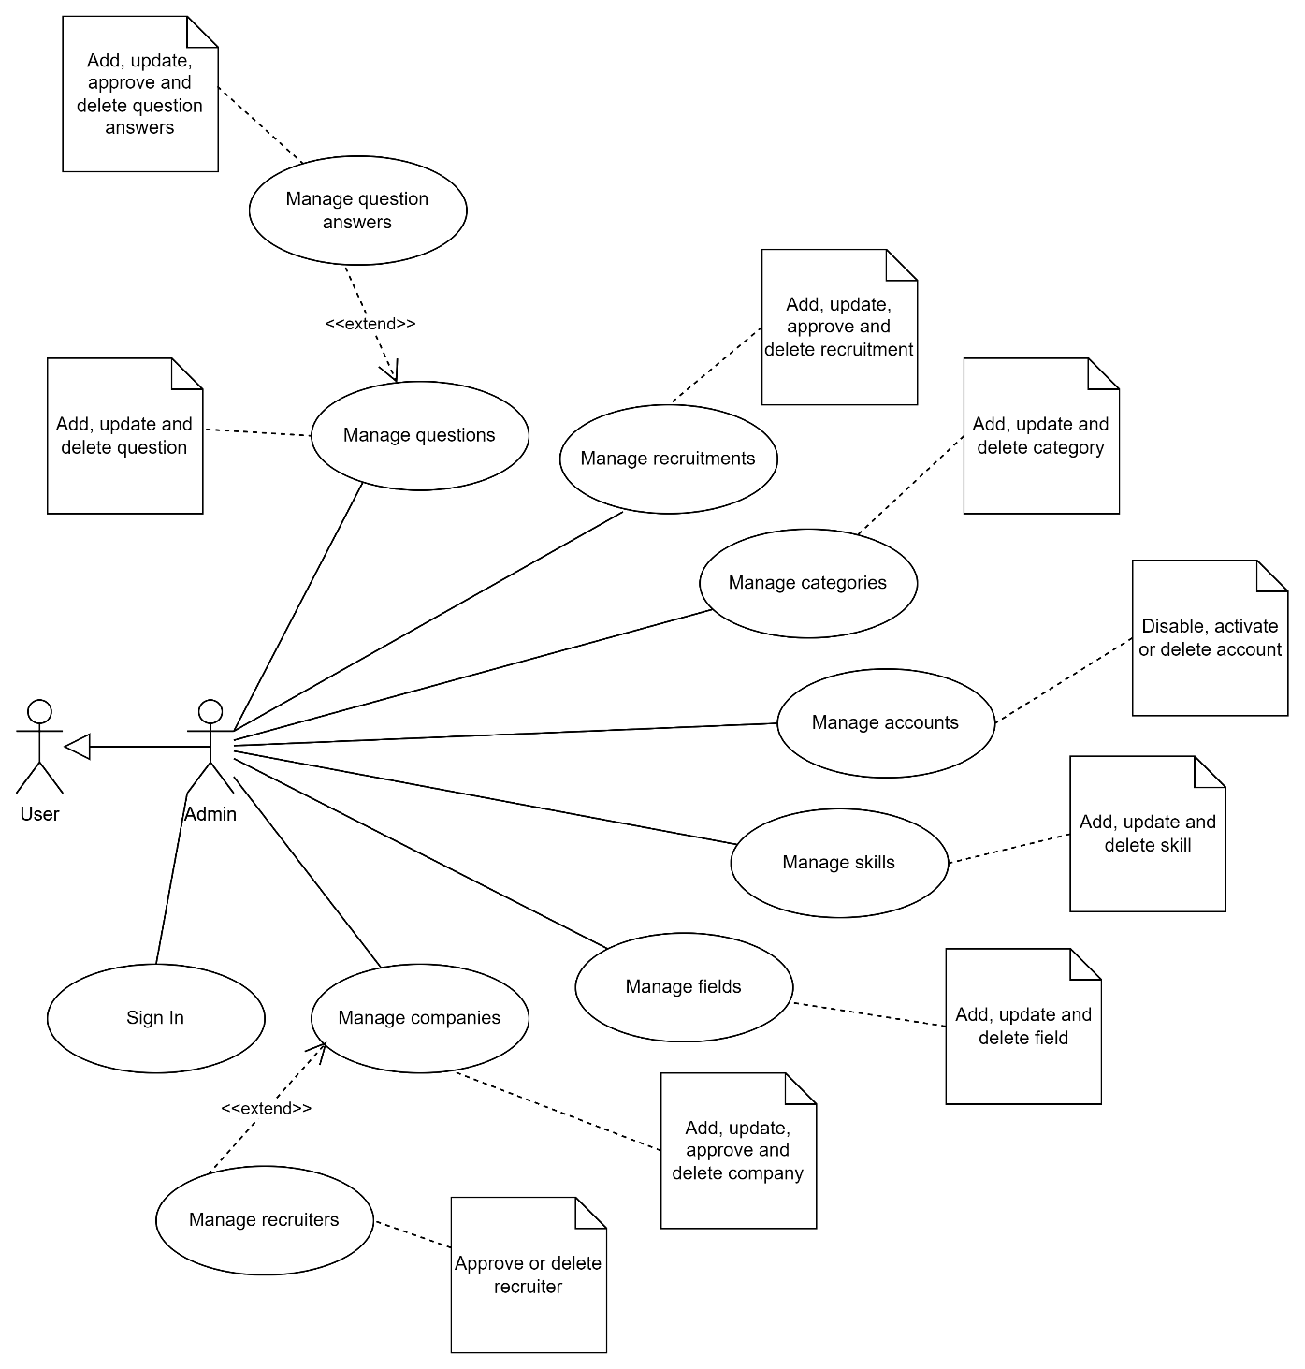

Figure 19. Admin use case diagram

“Admin” who has full rights on the system and interacts directly with the database. “Admin” can log in and manage the account of users, they can view, or update contents on the website such as questions, answers, and recruitments, …

### Detail Use Cases

#### Sign up

|  |  |
| --- | --- |
| **Id** | UC_01 |
| **Use case name** | Sign up |
| **Description** | Provide a feature to allow users to sign up |
| **Actor** | Guest |
| **Condition** | No condition |
| **Activation** | Click on the “Sign up” button on the navigation bar or go to the signup page |
| **Processing** | 1. Show form to input info of the user 2. User input info into the form 3. Click on the “Sign up” button to sign up. If successfully sign up, show the success notification and redirect to the home page, otherwise show an error notification along with error messages |

#### Sign in

|  |  |
| --- | --- |
| **Id** | UC_02 |
| **Use case name** | Sign in |
| **Description** | Provide a feature to allow the user to sign in |
| **Actor** | Guest have signed up |
| **Condition** | No condition |
| **Activation** | Click on the “Sign in” button on the navigation bar or go to sign in page |
| **Processing** | 1. Show form to input info of the user 2. User input info into the form 3. Click on the “Sign in” button to sign in. If successfully sign in, show the success notification and redirect to the home page, otherwise show an error notification along with error messages |

#### Update profile

|  |  |
| --- | --- |
| **Id** | UC_03 |
| **Use case name** | Update profile |
| **Description** | Provide a feature to allow the user to edit the profile |
| **Actor** | User |
| **Condition** | The user has signed in |
| **Activation** | Click on the “Account setting” option on the menu and go to the account setting page |
| **Processing** | 1. Show form to edit info of the user 2. User inputs new info into the form 3. Click on the “Save” button to save changes. If successfully update, show the success notification, otherwise show an error notification along with error messages |

#### Manage posted questions

|  |  |
| --- | --- |
| **Id** | UC_04 |
| **Use case name** | Manage posted questions |
| **Description** | Provide a feature to allow the user to manage posted questions |
| **Actor** | User |
| **Condition** | Has logged in |
| **Activation** | Click on the “Questions” tab in the sidebar panel |
| **Processing** | 1. Show a list of questions that the user has posted and the actions correspond to each question 2. Click on the action corresponding to the account to edit or delete the question |

#### Update posted questions

|  |  |
| --- | --- |
| **Id** | UC_05 |
| **Use case name** | Update posted questions |
| **Description** | Provide a feature to allow users to update posted questions |
| **Actor** | User |
| **Condition** | Has login |
| **Activation** | Click on the “Edit” or “Delete” button in the questions list |
| **Processing** | 1. When clicking on the “Edit” button: 2. Redirect to the edit question page 3. Display the form to update the question with the old value that has been set by default 4. Click on the “Save” button to update the question. If successfully update, show the success notification, otherwise show an error notification along with error messages 5. When clicking on the “Delete” button: 6. Display the confirm dialog for user confirm. 7. Click on the “Ok” button to delete. If successfully update show the success notification, otherwise show an error notification along with error messages |

#### Manage posted answers

|  |  |
| --- | --- |
| **Id** | UC_06 |
| **Use case name** | Manage posted answers |
| **Description** | Provide a feature to allow the user to manage posted answers |
| **Actor** | User |
| **Condition** | Has logged in |
| **Activation** | Click on the “Answers” tab in the sidebar panel |
| **Processing** | 1. Show a list of answers that the user has posted and the actions correspond to each question 2. Click on the action corresponding to the account to edit or delete the answer |

#### Update posted questions

|  |  |
| --- | --- |
| **Id** | UC_07 |
| **Use case name** | Update posted answers |
| **Description** | Provide a feature to allow users to update posted answers |
| **Actor** | User |
| **Condition** | Has login |
| **Activation** | Click on the “Edit” or “Delete” button in the answers list |
| **Processing** | 1. When clicking on the “Edit” button: 2. Redirect to the edit answer page 3. Display the form to update the answer with the old value that has been set by default 4. Click on the “Save” button to update the answer. If successfully update, show the success notification, otherwise show an error notification along with error messages 5. When clicking on the “Delete” button: 6. Display the confirm dialog for user confirm. 7. Click on the “Ok” button to delete. If successfully update show the success notification, otherwise show an error notification along with error messages |

#### Manage posted comments

|  |  |
| --- | --- |
| **Id** | UC_08 |
| **Use case name** | Manage posted comments |
| **Description** | Provide a feature to allow users to manage posted comments |
| **Actor** | User |
| **Condition** | Has logged in |
| **Activation** | Click on the “Comments” tab in the sidebar panel |
| **Processing** | 1. Show a list of questions that the user has posted and the actions correspond to each question 2. Click on the action corresponding to the account to edit or delete the comment |

#### Update posted questions

|  |  |
| --- | --- |
| **Id** | UC_09 |
| **Use case name** | Update posted comments |
| **Description** | Provide a feature to allow users to update posted comments |
| **Actor** | User |
| **Condition** | Has login |
| **Activation** | Click on the “Edit” or “Delete” button in the comments list |
| **Processing** | 1. When clicking on the “Edit” button: 2. Redirect to the edit comment page 3. Display the form to update comments with the old value that has been set by default 4. Click on the “Save” button to update. If the successfully update, show the success notification, otherwise show an error notification along with error messages 5. When clicking on the “Delete” button: 6. Display the confirm dialog for user confirm. 7. Click on the “Ok” button to delete. If successfully update show the success notification, otherwise show an error notification along with error messages |

#### Manage posted recruitments

|  |  |
| --- | --- |
| **Id** | UC_10 |
| **Use case name** | Manage posted recruitments |
| **Description** | Provide a feature to allow the recruiter to manage posted recruitment |
| **Actor** | Recruiter |
| **Condition** | Has logged in with recruiter account |
| **Activation** | Click on the “Recruitments” tab in the sidebar panel |
| **Processing** | 1. Show a list of recruitments that the recruiter has posted and the actions correspond to each recruitment 2. Click on the action corresponding to the account to edit or delete the recruitment |

#### Update posted recruitments

|  |  |
| --- | --- |
| **Id** | UC_11 |
| **Use case name** | Update posted recruitments |
| **Description** | Provide a feature to allow recruiters to update posted recruitment |
| **Actor** | Recruiter |
| **Condition** | Has login with a recruiter account |
| **Activation** | Click on the “Edit” or “Delete” button in the recruitments list |
| **Processing** | 1. When clicking on the “Edit” button: 2. Redirect to the edit recruitment page 3. Display the form to update recruitment with the old value that has been set by default 4. Click on the “Save” button to update. If successfully update, show the success notification, otherwise show an error notification along with error messages 5. When clicking on the “Delete” button: 6. Display the confirm dialog for user confirm. 7. Click on the “Ok” button to delete. If successfully update show the success notification, otherwise show an error notification along with error messages |

#### Manage applies of posted recruitments

|  |  |
| --- | --- |
| **Id** | UC_12 |
| **Use case name** | Manage applies of posted recruitments |
| **Description** | Provide a feature to allow the recruiter to manage applications of posted recruitment |
| **Actor** | Recruiter |
| **Condition** | Has logged in with recruiter account |
| **Activation** | Click on the “Applies” tab in the sidebar panel |
| **Processing** | 1. Show a list of applies of the recruitments that the recruiter has posted and the actions corresponding to each apply 2. Click on the action corresponding to the account to view, approve or download the cv of the applicant |

#### Update applies of posted recruitments

|  |  |
| --- | --- |
| **Id** | UC_13 |
| **Use case name** | Update applies of posted recruitments |
| **Description** | Provide a feature to allow recruiters to update applications of posted recruitment |
| **Actor** | Recruiter |
| **Condition** | Has login with a recruiter account |
| **Activation** | Click on the “Approve” button in the recruitments list |
| **Processing** | 1. When clicking on the “Approve” button: 2. Show confirm dialog for the recruiter 3. Click on the “Ok” button to approve. If successfully update show the success notification, otherwise show an error notification along with error messages 4. When clicking on the “Download” button: 5. If successfully download the CV, show the success notification, otherwise show an error notification along with error messages |

#### Account management

|  |  |
| --- | --- |
| **Id** | UC_14 |
| **Use case name** | Account management |
| **Description** | Provide account management functionalities to the admin |
| **Actor** | Admin |
| **Condition** | Has login with admin role |
| **Activation** | Click on the “Account” tab in the admin panel |
| **Processing** | 1. Show a list of users and the actions correspond to each user account 2. Click on the action corresponding to the account to edit or delete the account |

#### Update account

|  |  |
| --- | --- |
| **Id** | UC_15 |
| **Use case name** | Update account |
| **Description** | Provide account update functionalities to the admin |
| **Actor** | Admin |
| **Condition** | Has login with admin role |
| **Activation** | Click on the “Edit” or “Delete” button in the accounts list |
| **Processing** | 1. When clicking on the “Edit” button: 2. Redirect to the edit account page 3. Display the form to update the account with the old value that has been set by default 4. Click on the “Save” button to update your account. If successfully update the account, show the success notification, otherwise show an error notification along with error messages 5. When clicking on the “Delete” button: 6. Display the confirm dialog for user confirm. 7. Click on the “Ok” button to delete. If successfully update show the success notification, otherwise show an error notification along with error messages |

#### Question management

|  |  |
| --- | --- |
| **Id** | UC_16 |
| **Use case name** | Admin questions management |
| **Description** | Provide questions management functionalities to admin. Including adding, editing, deleting, or approving the question |
| **Actor** | Admin |
| **Condition** | Has login with admin role |
| **Activation** | Click on the “Questions” tab in the admin panel |
| **Processing** | 1. Show a list of questions and the actions that correspond to each post. In addition, provide a “New” button to add a new post 2. Click on the “New” button to open the tab for input question info to insert into the database 3. Click on the action corresponding to the post to edit or delete the question 4. Click on the approve action to approve the question |

#### Update question

|  |  |
| --- | --- |
| **Id** | UC_17 |
| **Use case name** | Admin update question |
| **Description** | Provide options to add, edit or delete the questions to the admin |
| **Actor** | Admin |
| **Condition** | Has login with admin role |
| **Activation** | Click on the “New”, “Edit” or “Delete” buttons in the questions list |
| **Processing** | 1. When clicking on the “New” button: 2. Show form to input info of the question 3. Click on the “Save” button to save the question. If successfully add the question and show the success notification, otherwise show an error notification along with error messages 4. When clicking on the “Edit” button: 5. Redirect to the edit question page 6. Display the form to update the question with the old value that has been set by default 7. Click on the “Save” button to update the question. If successfully update the question, show the success notification, otherwise show an error notification along with error messages 8. When clicking on the “Delete” button: 9. Display the confirm dialog for user confirm. 10. Click on the “Ok” button to delete. If successfully update show the success notification, otherwise show an error notification along with error messages |

#### Answer management

|  |  |
| --- | --- |
| **Id** | UC_18 |
| **Use case name** | Answers management |
| **Description** | Provide answer management functionalities to admin. Including adding, editing, or deleting the answer |
| **Actor** | Admin |
| **Condition** | Has login with admin role |
| **Activation** | Click on the “Answers” tab in the admin panel |
| **Processing** | 1. Show a list of answers and the actions that correspond to each answer. In addition, provide a “New” button to add a new course 2. Click on the “New” button to open the tab for input answer info for a question to insert into the database 3. Click on the action corresponding to the answer to edit or delete the answer |

#### Update answer

|  |  |
| --- | --- |
| **Id** | UC_19 |
| **Use case name** | Update answer |
| **Description** | Provide options to add, edit or delete the answer |
| **Actor** | Admin |
| **Condition** | Has login with admin role |
| **Activation** | Click on the “New”, “Edit” or “Delete” buttons in the answers list |
| **Processing** | 1. When clicking on the “New” button: 2. Show form to input info of the answer 3. Click on the “Save” button to save. If successfully add an answer and show the success notification, otherwise show an error notification along with error messages 4. When clicking on the “Edit” button: 5. Redirect to the edit answer page 6. Display the form to update the answer with the old value that has been set by default 7. Click on the “Save” button to update the answer. If successfully update the answer, show the success notification, otherwise show an error notification along with error messages 8. When clicking on the “Delete” button: 9. Display the confirm dialog for user confirm. 10. Click on the “Ok” button to delete the answer. If successful, show the success notification, otherwise show an error notification along with error messages |

#### Recruitment management

|  |  |
| --- | --- |
| **Id** | UC_20 |
| **Use case name** | Recruitment management |
| **Description** | Provide recruitment management functionalities to admin. Including adding, editing, or deleting recruitment |
| **Actor** | Admin |
| **Condition** | Has login with admin role |
| **Activation** | Click on the “Recruitments” tab in the admin panel |
| **Processing** | 1. Show a list of recruitments and the actions that correspond to each one. In addition, provide a “New” button to add a new recruitment 2. Click on the “New” button to open the tab for input recruitment info to insert into the database 3. Click on the action corresponding to the recruitment to edit or delete it |

#### Update recruitment

|  |  |
| --- | --- |
| **Id** | UC_21 |
| **Use case name** | Update recruitment |
| **Description** | Provide options to add, edit or delete the recruitment |
| **Actor** | Admin |
| **Condition** | Has login with admin role |
| **Activation** | Click on the “New’, “Edit” or “Delete” buttons in the recruitments list |
| **Processing** | 1. When clicking on the “New’ button: 2. Show form to input info about the recruitment 3. Click on the “Save” button to save. If successfully add recruitment, show the success notification, otherwise show an error notification along with error messages 4. When clicking on the “Edit button: 5. Redirect to the edit recruitment page 6. Display the form to update recruitment with the old value that has been set by default 7. Click on the “Save” button to update recruitment. If successfully update, show the success notification, otherwise show an error notification along with error messages 8. When clicking on the “Delete” button: 9. Display the confirm dialog for user confirm. 10. Click on the “Ok” button to delete. If successfully update show the success notification, otherwise show an error notification along with error messages |

#### Apply management

|  |  |
| --- | --- |
| **Id** | UC_22 |
| **Use case name** | Applies management |
| **Description** | Provide applies management functionalities to admin. Including adding, editing, or deleting the apply |
| **Actor** | Admin |
| **Condition** | Has login with admin role |
| **Activation** | Click on the “Applies” tab in the admin panel |
| **Processing** | 1. Show a list of quizzes and the actions that correspond to each quiz. In addition, provide a “New’ button to add new quiz 2. Click on the “New’ button to open the tab for input quiz info to insert into the database 3. Click on the action corresponding to the quiz to edit or delete the apply |

#### Question categories management

|  |  |
| --- | --- |
| **Id** | UC_23 |
| **Use case name** | Question categories management |
| **Description** | Provide categories management functionalities to admin. Including adding, editing, or deleting the category |
| **Actor** | Admin |
| **Condition** | Has login with admin role |
| **Activation** | Click on the “Categories” tab in the admin panel |
| **Processing** | 1. Show a list of categories and the actions corresponding to each category. In addition, provide a “New’ button to add a new category 2. Click on the “New’ button to open the tab for input category info to insert into the database 3. Click on the action corresponding to the category to edit or delete the category |

#### Update categories

|  |  |
| --- | --- |
| **Id** | UC_24 |
| **Use case name** | Update category |
| **Description** | Provide options to add, edit or delete the categories |
| **Actor** | Admin |
| **Condition** | Has login with admin role |
| **Activation** | Click on the “New’, “Edit” or “Delete” buttons in the categories list |
| **Processing** | 1. When clicking on the “New’ button: 2. Show form to input info on the category. 3. Click on the “Save” button to save the category. If successfully add a category, show the success notification, otherwise show an error notification along with error messages 4. When clicking on the “Edit” button: 5. Redirect to the edit category page 6. Display the form to update the category with the old value that has been set by default 7. Click on the “Save” button to save the category. If the success update category, show the success notification, otherwise show an error notification along with error messages 8. When clicking on the “Delete” button: 9. Display the confirm dialog for user confirm. 10. Click on the “Ok” button to delete the category. If successfully delete the category, show the success notification, otherwise show an error notification along with error messages |

#### Skill management

|  |  |
| --- | --- |
| **Id** | UC_25 |
| **Use case name** | Skills management |
| **Description** | Provide skills management functionalities to admin. Including adding, editing, or deleting the skill |
| **Actor** | Admin |
| **Condition** | Has login with admin role |
| **Activation** | Click on the “Skills” tab in the admin panel |
| **Processing** | 1. Show a list of skills and the actions that correspond to each skill. In addition, provide a “New’ button to add a new skill 2. Click on the “New’ button to open the tab for input skill info to insert into the database 3. Click on the action corresponding to the skill to edit or delete the |

#### Update skill

|  |  |
| --- | --- |
| **Id** | UC_26 |
| **Use case name** | Update skill |
| **Description** | Provide options to add, edit or delete the skill |
| **Actor** | Admin |
| **Condition** | Has login with admin role |
| **Activation** | Click on the “New’, “Edit” or “Delete” buttons in the skills list |
| **Processing** | 1. When clicking on the “New’ button: 2. Show form to input info on the skill. 3. Click on the “Save” button to save the skill. If successfully add skill, show the success notification, otherwise show an error notification along with error messages 4. When clicking on the “Edit” button: 5. Redirect to the edit skill page 6. Display the form to update the skill with the old value that has been set by default 7. Click on the “Save” button to save the skill. If the success update skill, show the success notification, otherwise show an error notification along with error messages 8. When clicking on the “Delete” button: 9. Display the confirm dialog for user confirm. 10. Click on the “Ok” button to delete. If successfully delete, show the success notification, otherwise show an error notification along with error messages |

#### Field management

|  |  |
| --- | --- |
| **Id** | UC_27 |
| **Use case name** | Field management |
| **Description** | Provide field management functionalities to admin. Including adding, editing, or deleting the field |
| **Actor** | Admin |
| **Condition** | Has login with admin role |
| **Activation** | Click on the “Fields” tab in the admin panel |
| **Processing** | 1. Show a list of fields and the actions that correspond to each one. In addition, provide a “New’ button to add a new field 2. Click on the “New’ button to open the tab for input field info to insert into the database 3. Click on the action corresponding to the field to edit or delete it |

#### Update field

|  |  |
| --- | --- |
| **Id** | UC_28 |
| **Use case name** | Update field |
| **Description** | Provide options to add, edit or delete the field |
| **Actor** | Admin |
| **Condition** | Has login with admin role |
| **Activation** | Click on the “New’, “Edit” or “Delete” buttons in the fields list |
| **Processing** | 1. When clicking on the “New’ button: 2. Show form to input info on the field. 3. Click on the “Save” button to save the field. If successfully add, show the success notification, otherwise show an error notification along with error messages 4. When clicking on the “Edit” button: 5. Redirect to the edit field page 6. Display the form to update the field with the old value that has been set by default 7. Click on the “Save” button to save. If successfully update, show the success notification, otherwise show an error notification along with error messages 8. When clicking on the “Delete” button: 9. Display the confirm dialog for user confirm. 10. Click on the “Ok” button to delete. If successfully delete, show the success notification, otherwise show an error notification along with error messages |

#### Search questions

|  |  |
| --- | --- |
| **Id** | UC_29 |
| **Use case name** | Search questions |
| **Description** | Provide questions searching functionality |
| **Actor** | User |
| **Condition** | No need to log in |
| **Activation** | Click on “Search” input in the navigation bar |
| **Processing** | 1. Input the keyword in the search input bar. 2. Press enter or click on the search icon 3. Show all the questions match the keyword that the user has inputted |

#### Search recruitments

|  |  |
| --- | --- |
| **Id** | UC_30 |
| **Use case name** | Search recruitments |
| **Description** | Provide recruitments searching functionality |
| **Actor** | User |
| **Condition** | No need to log in |
| **Activation** | Click on “Search” input in the navigation bar |
| **Processing** | 1. Input the keyword in the search input bar. 2. Press enter or click on the search icon 3. Show all the recruitments match the keyword that the user has inputted |

#### Filter recruitments

|  |  |
| --- | --- |
| **Id** | UC_31 |
| **Use case name** | Filter recruitments |
| **Description** | Provide recruitments filter functionality |
| **Actor** | User |
| **Condition** | No need to log in |
| **Activation** | Click or check on filter options in the sidebar |
| **Processing** | 1. Click on filter options on the sidebar 2. Users will be redirected to the page to show all the recruitments match the filter condition |

#### Apply recruitment

|  |  |
| --- | --- |
| **Id** | UC_32 |
| **Use case name** | Apply recruitment |
| **Description** | Provide a feature to allow users to apply to a recruitment |
| **Actor** | User |
| **Condition** | Login to account |
| **Activation** | Click on the “Apply” button on the detail recruitment page |
| **Processing** | 1. User input information (phone and cv) to apply 2. The user clicks apply button to apply |

## ForumBot: Chatbot to answer questions automatically

### Overview

The chatbot is developed to be a conversational bot to interact with users on the website. This chatbot was implemented using the Rasa framework, as this gives insight into the functioning of the chatbox, and its learning and assessment model.

The architecture of the system developed includes 4 main components (Fig. 1). To develop the chatbox and integrate it into the website, a phase of analysis and preparation is required. The first step in creating the chatbox is defining the goals that need to be achieved by the bot: in this case, the main goal is to provide support to the users by answering Frequently Asked Questions (FAQs) about internships.

### Training data

To train the bot to answer FAQs about internships, a list of collected questions and answers needs to be analyzed. Based on the analysis, the final data to train the chatbot is organized and defined in domain.yml and data.yml files. Once the data is finalized, the chatbox needs to be fed all the data with the corresponding responses. Then the bot created needs to be tested and trained to fine-tune the results.

A client application is then created to communicate with the conversational agent. It is developed to provide a user interface for the students to send their questions and receive responses. Once the client application is ready, then it needs to be integrated into the website. This integration makes it easier for the students to use the chatbox within the website.

The development of the bot itself in Rasa consists of four phases: the definition of intents, the definition of responses, story creation, and rules.

#### Intent

An intent corresponds to the intention of the users interacting with the chatbot. It is defined for each type of request the application supports. Rasa, Alexa, Dialog flow, Watson, and so on have NLP engines that require different ways to phrase an intent to work accurately to understand the users’ requests. Rasa prefers at least 5 examples for each intent to get the best results.

Intents are identified by thoroughly analyzing the collected list of questions and answers from students of CICT and some FAQs from the CICT website about internships. The main keywords are identified and added to the intent by providing 5 examples for each intent. Figure 2 shows one such keyword identified, and an intent is created which is named “internship_benefit”. Likewise, 21 intents are added in the chatbox with more than or equal to 5 examples. The screenshot of the intent created is shown in figure 3.

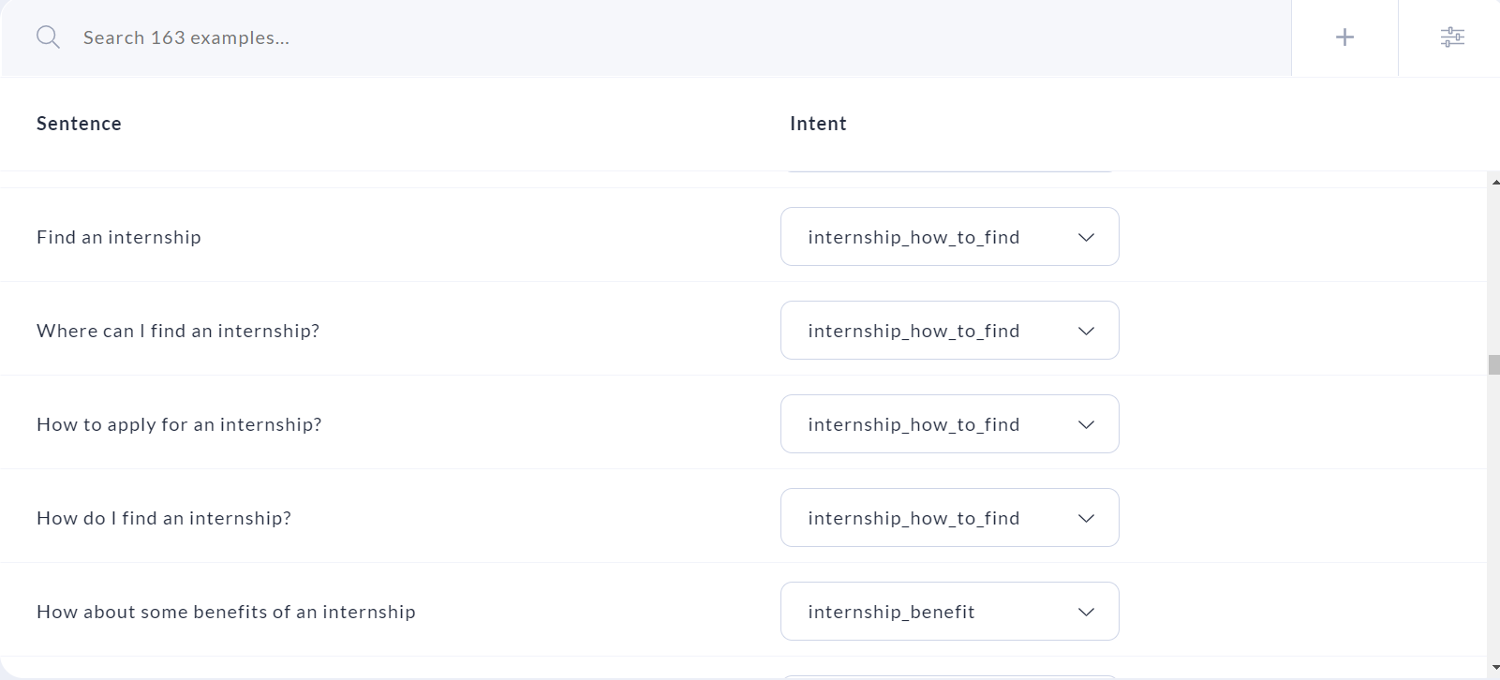

Figure 20. ForumBot intents

#### Actions

All actions executed by the bot are specified with the action: key followed by the name of the action. While writing stories, you will encounter two types of actions:

Responses: start with utter_ and send a specific message to the user. Here is an example of a response

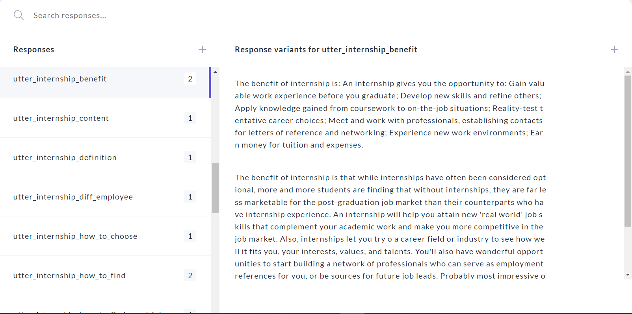

Figure 21. Response example of ForumBot

Custom actions: start with action_, run arbitrary code and send any number of messages (or none). The custom actions are defined inside the project using Python to execute code and send any format of the response to the users such as images, buttons, and JSON, …

#### Stories

Stories are used to train a machine learning model to identify patterns in conversations and generalize to unseen conversation paths. Rules describe small pieces of conversations that should always follow the same path and are used to train the RulePolicy.

A story defines the flow of the conversation and the response of the chatbot according to the intents identified. For each intent, a branch is created in order to provide the corresponding response. The nodes in the story tree are triggered based on the user input. A story tree is created by inserting conditions and specifying appropriate responses for each intent identified as shown in figure 4. During the first iteration of the study, 23 stories were created in the chatbox.

Stories are composed of:

* Story: The story's name. The name is arbitrary and not used in training; you can use it as a human-readable reference for the story.
* Metadata: arbitrary and optional, not used in training, you can use it to store relevant information about the story like e.g. the author
* A list of steps: The user messages and actions that make up the story

Below is one flowchart example of a story for training the chatbox

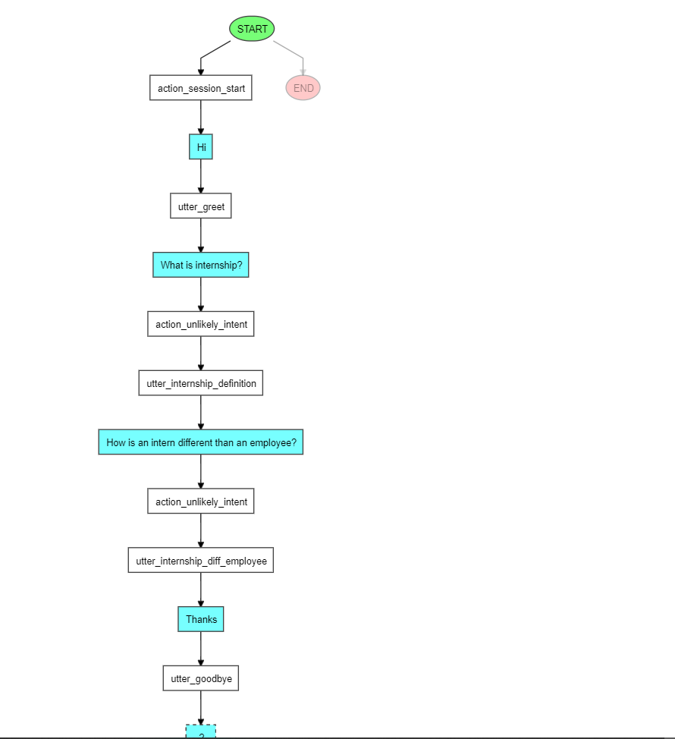

Figure 10. Flowchart of an example of a conversation between chatbox and user

Below is an example of one story of the chatbox:

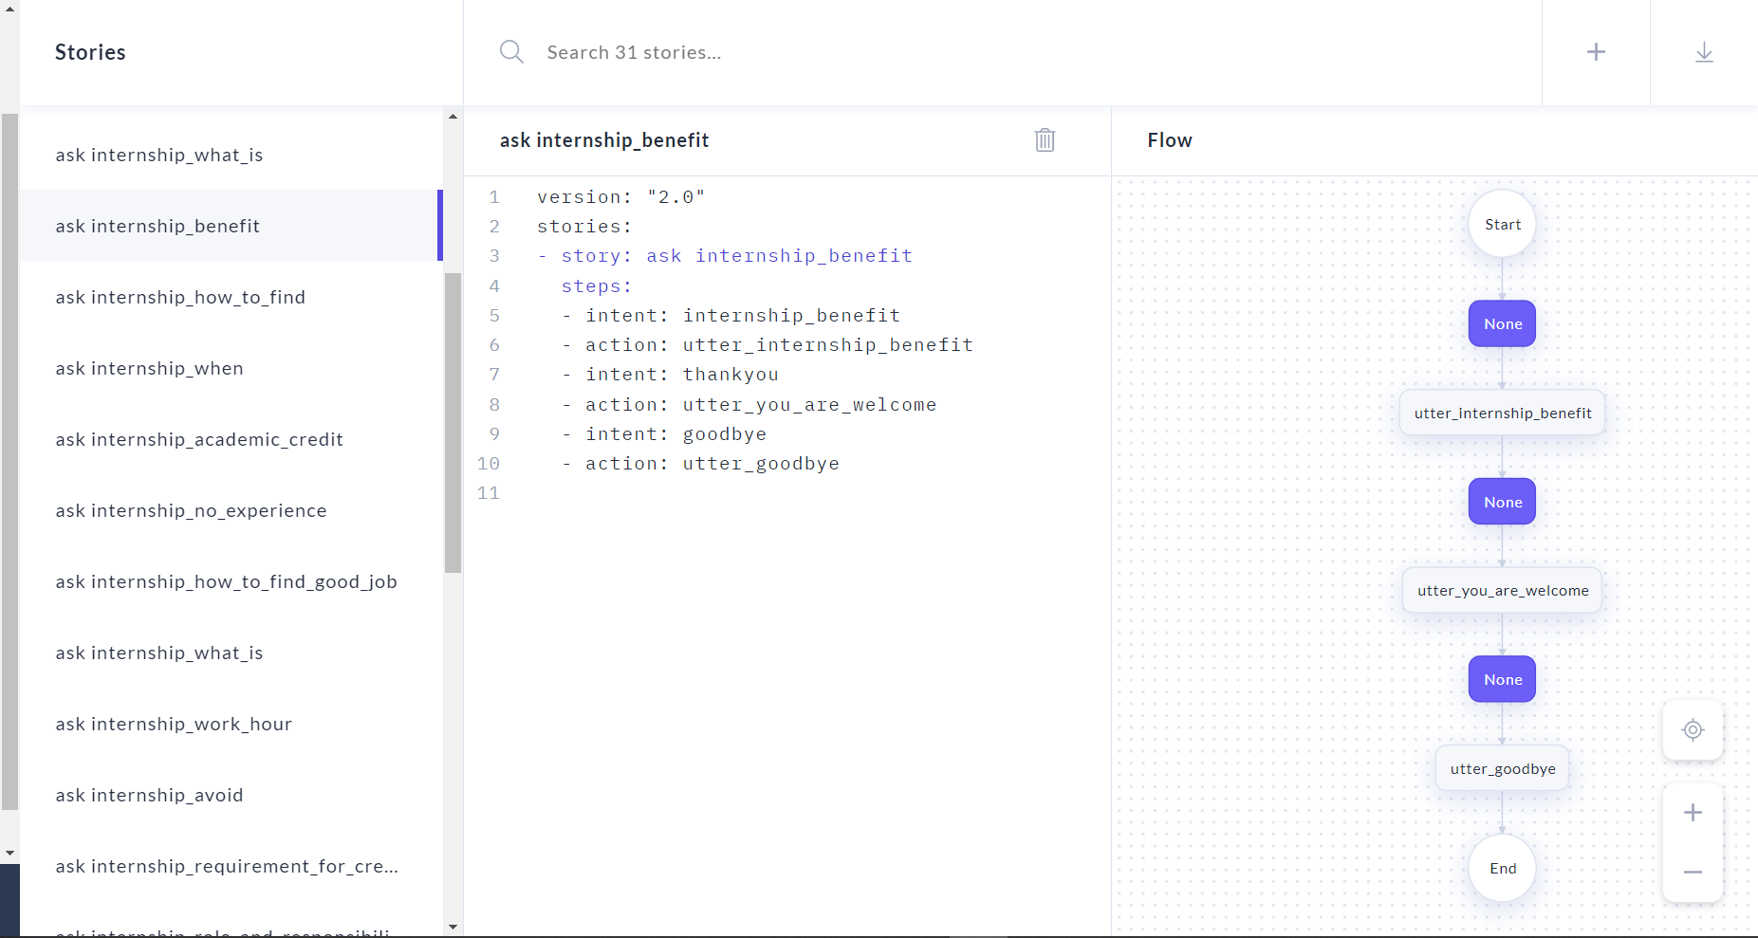

Figure 22. Story example fo ForumBot

#### Rules

Rules are listed under the rules key and look similar to stories. A rule also has a steps key, which contains a list of the same steps as stories do. Rules can additionally contain the conversation_started and conditions keys. These are used to specify conditions under which the rule should apply.

An example of a rule as shown below:

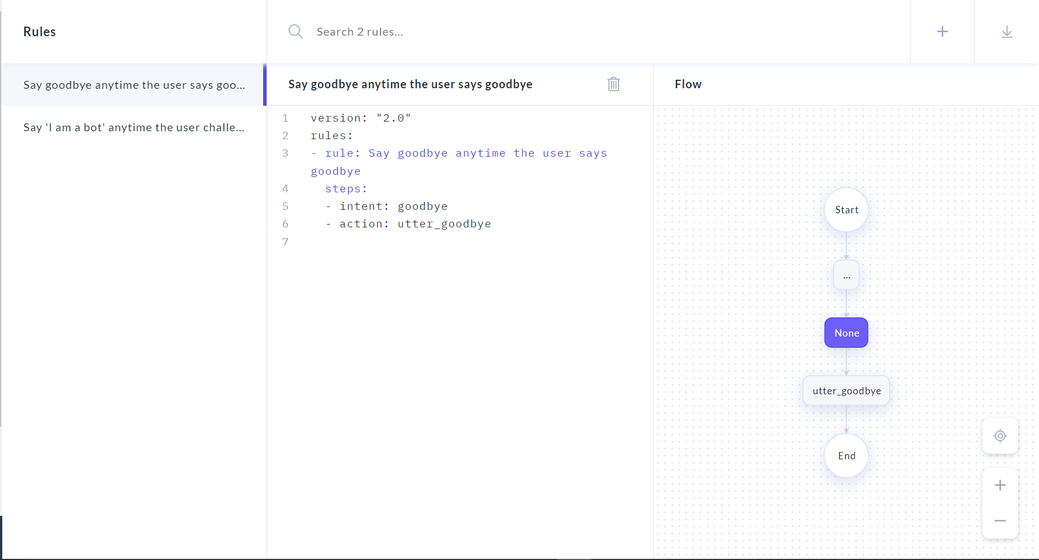

Figure 23. Rule example of ForumBot

#### Evaluate

After having prepared and organized the training data. The training process will take place. After that, the evaluation process will run to get the evaluation results for a better understanding of the chatbox’s performance. The evaluation results are produced using cross-validation to help achieve higher accuracy for intent classification. Long term, this feature supports the goal of helping conversation work smarter, by automatically surfacing the things that need attention.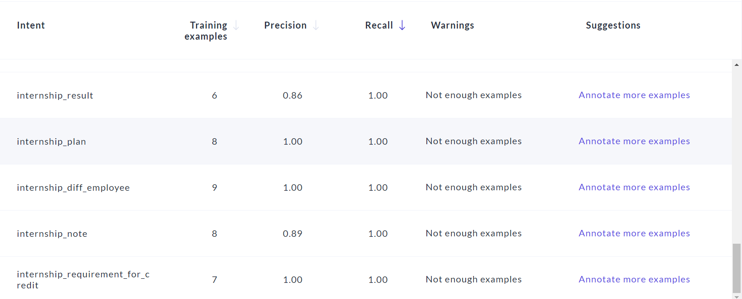

Figure 24. Chatbox evaluation results

## Detail Of Functions In The System

### Authenticate

#### Sign Up Function

When users sign up, they have to enter their email address, username, and password. If there are some errors in the signing-up process, the system will show notifications. Otherwise, show a success notification to the user.

#### Sign In Function

Users sign in with a signed-up email and password, and the system will authenticate, their email and password are both valid and, in the database, the system will direct users to the main page. Otherwise, the system will show an error message.

### Chat function

The chat feature allows guest users to ask and receive answers from the chatbox. When users input a question, the chatbox will generate a response from the data it had trained before and send it to the users. Guest users can ask as much as they want but the conversation (the questions and answers) will not be saved and the guest user can not view it after they refresh the page.

However, users that have logged in not only can do as much as guest users, but they also can view old conversations and create as many conversations as they want.

### Question function

A question (or post) is a type of information that contains details of the question and is uploaded by users. The question include titles to help users have an overview of the problem of the question and the content, and describe the detailed information on what they need to resolve. The question will be marked published after the admin previews the details to make sure it does not contain unclear information and does not violate the rules.

Questions searching functionality

To search questions, users need to enter keywords in the input box, after that, press “Enter” or click the search button. The system will compare with name and description in the database with the keywords. If it returns empty, the system will show a notification about no result found.

### Answer function

An answer is a type of information that contains details of the content that users post to solve the problem of others users’ questions on the website. The answer will be marked correct after the admin previews the details to make sure it does not contain unclear information and solve the problem the poster asks.

### Comment function

Comments allow users to provide feedback on the question as well as the answers to help other users recognize those questions or answers are correct and can be trusted or not.

### Recruitment function

Recruitment is a type of information that contains details of the job that the recruiter post on the website and is uploaded by the recruiter or admin. Recruitment includes a title to help users have a brief description of the job and the position and the content, describing the detailed information what the requirements, and skills needed to apply for this job. Recruitment will be published after the admin previews the details to make sure it does not contain unclear information and is appropriate, after that, the admin will decide to approve or reject it.

Recruitments searching functionality

To search recruitments, users need to enter keywords in the input box, after that, pressing “Enter” and clicking the search button. The system will compare with name and description in the database with the keywords. If it returns empty, the system will show a notification about no result found.

### Apply recruitment

Apply recruitment is a feature that allows users to apply for a specific recruitment they are interested in. Apply recruitment is only available if the user has logged in, if the user has not logged in, there will be an option to allow users to log in with a popup modal when applying for recruitment, the user needs to provide the phone number and CV file.

### User content management

User content management is a feature that allows the user to manage the content they have posted on the website. The user will have permission to add, update or delete the questions, answers, and comments of them on the website.

### Recruiter management

Recruiter management is a feature that allows the recruiter to manage and add more recruitments to the website. The recruiter will have permission to add, update or delete the recruitments. They also can view and approve applicants if needed.

### Admin management

Admin management is a feature that allows the admin to manage and add more content (such as questions, recruitments, or answers) to the website. Admin will have all the permission to add, update or delete any content on the website including modifying users' accounts. Admin can also manage (add, update or delete the) categories, companies, skills, or positions of the courses used on the website.

### User Interface

#### Navigation bar



Figure 25. Navigation bar before signing in

The search bar, sign-in button, and sign-up button will be displayed on the navigation bar before signing in.



Figure 26. Navigation bar after signing in

After signing in, users will see the project button, which the user can click to open the menu to go to their dashboard or log out.



Figure 27. Navigation bar after signing in with recruiter role

The recruiter route will be displayed on the navigation bar before signing in with the recruiter role.



Figure 28. Navigation bar after signing in with admin role

Besides the recruiter route, the admin route will also be displayed on the navigation bar before signing in with the admin role.

#### Main page

The main page will be shown when users access the application. The navigation bar shows the name and logo of the application, search bar, sign in and sign up. The button with the menu icon is for users to quickly switch to other pages (such as recruitments, other topics, recruiter, or admin). There also have overview features of the website as well as some info about the website to help users understand what the website is mainly about.

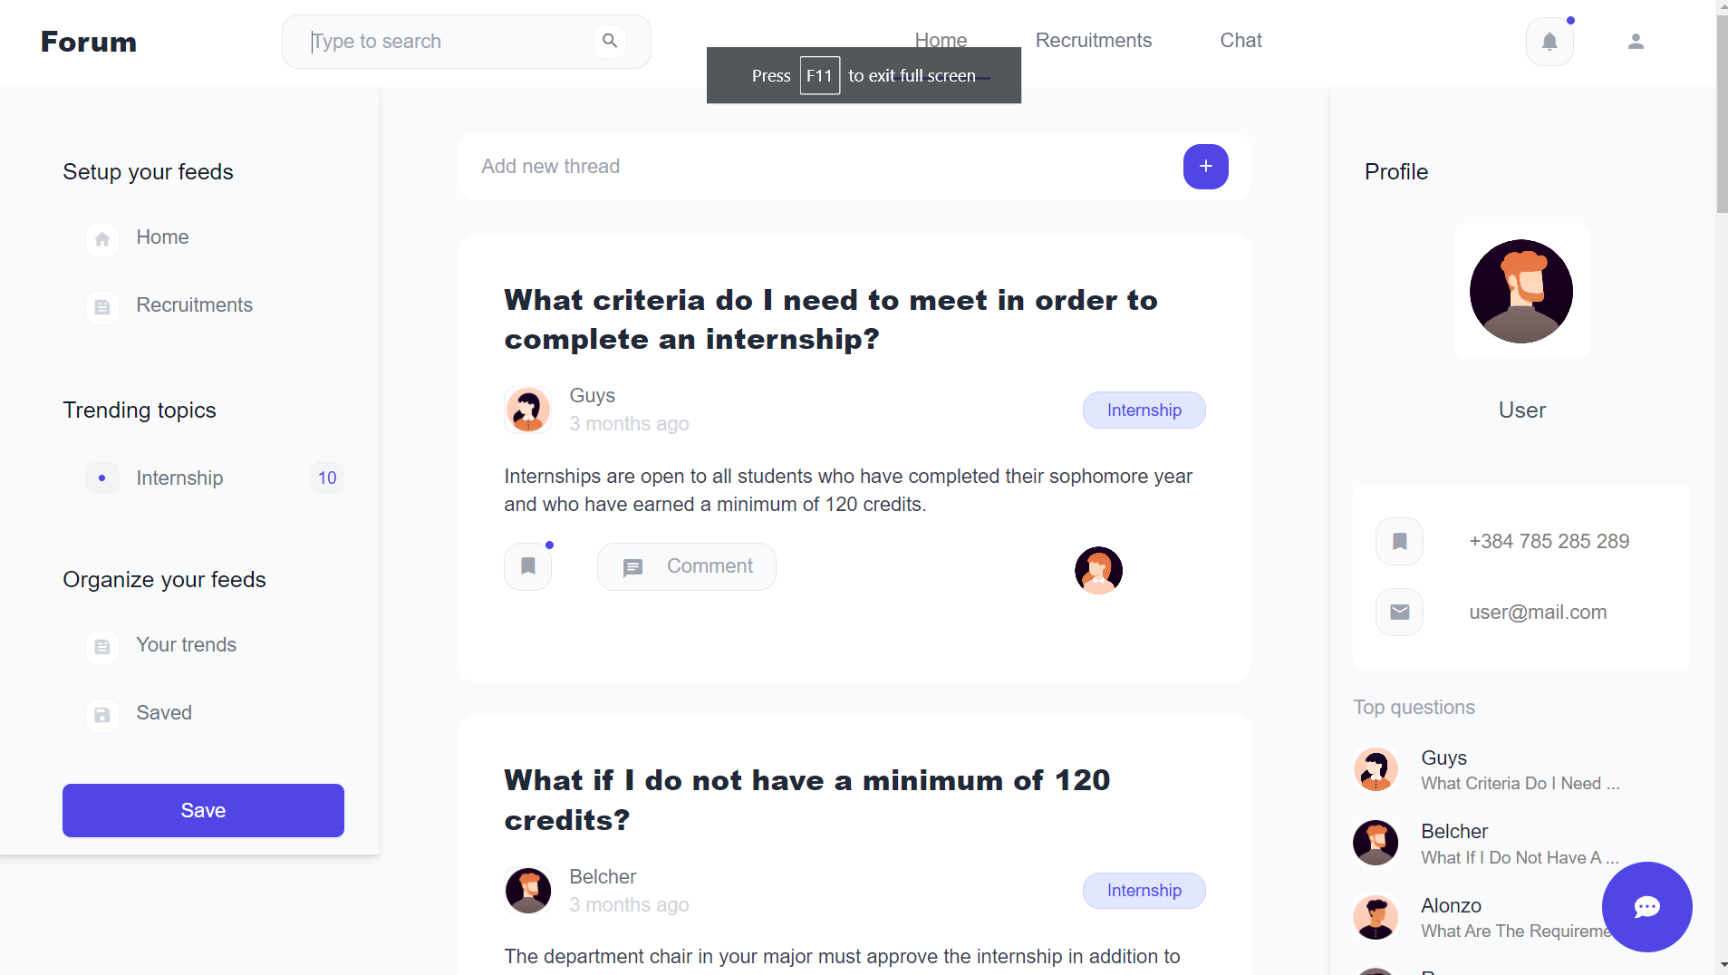

Figure 29. Main page

The chatbox popup window allows users to input questions and receive answers directly from the chatbox of the website. However, the conversation will not be saved when users chat using this feature.

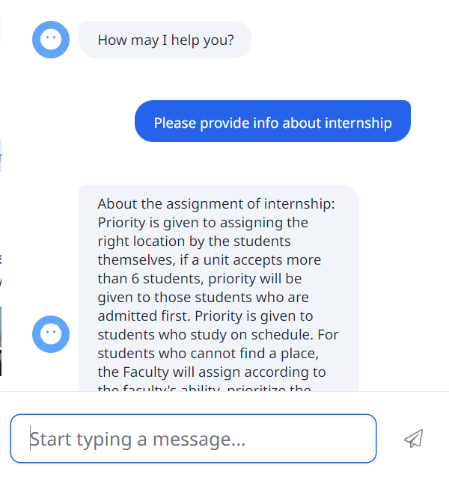

Figure 30. Chatbox popup message

#### Sign up page



Figure 31. Sign-up form on the sign-up page

To become a “Member”, users have to sign up with an email, username, and password. The email of the user must be unique for identification, if users enter a duplicate email, an error message will be shown.

#### Sign in page

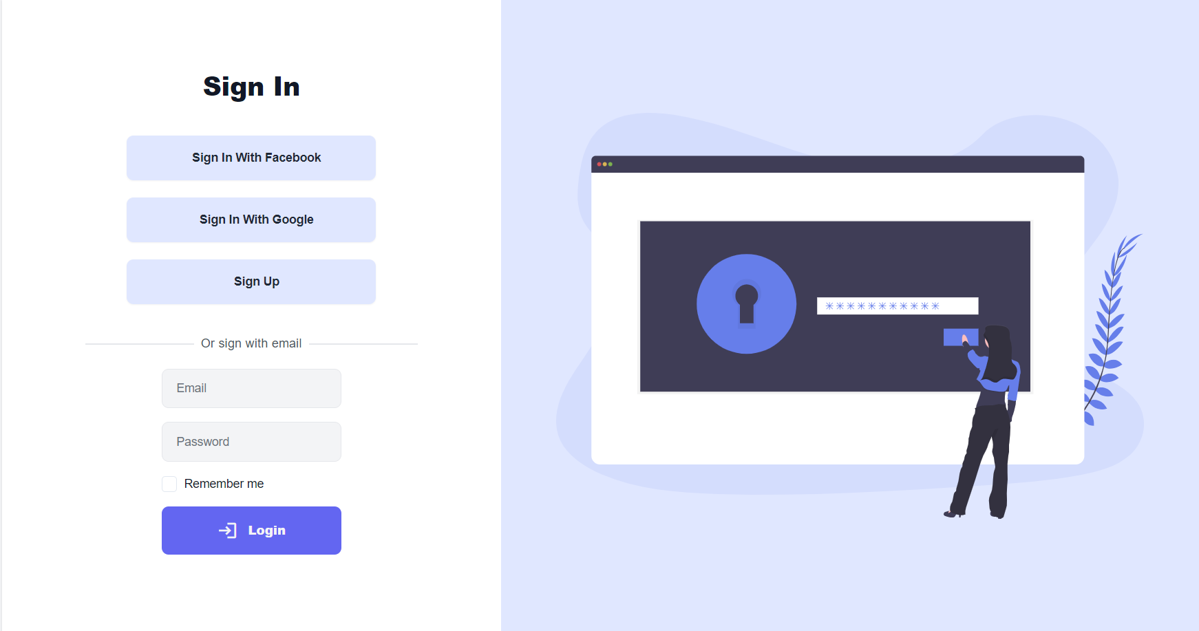

Figure 32. Login form on the login page

Users can sign in with the email and password that they signed up with before, if the email or password is invalid, the system will show the error. Otherwise, the notification will show successful login for the user.

#### Chat page

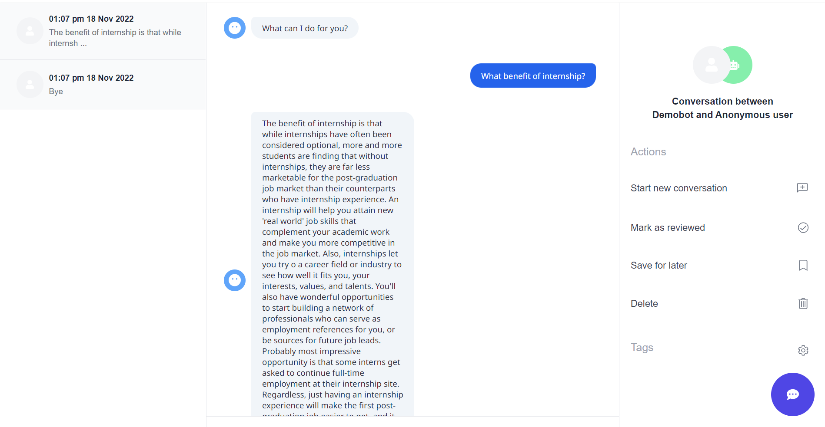

Figure 33. Chat page

On the chat page, users can chat with the chatbox to ask about the problem they want to know about internships. After input, the chatbox will respond to the users with the answer to the problem using the trained model. The users can create as many conversations for easy to keep track of them for preview later instead of chatting in only one conversation which leads to a long and hard-to-remember conversation

#### Questions page

On the questions page, users will see the most popular questions to select to view detail. There is an option to allow users, who have logged in to the website, to add new questions quickly by clicking on the button “Add new”, after clicking the button, the user will be redirected to the “New question” page to create a new question.

Besides, users can also see the trending topics of questions to filter questions by topic on the left sidebar. In addition, on the right sidebar, users will see their profile and a list of top questions on the website

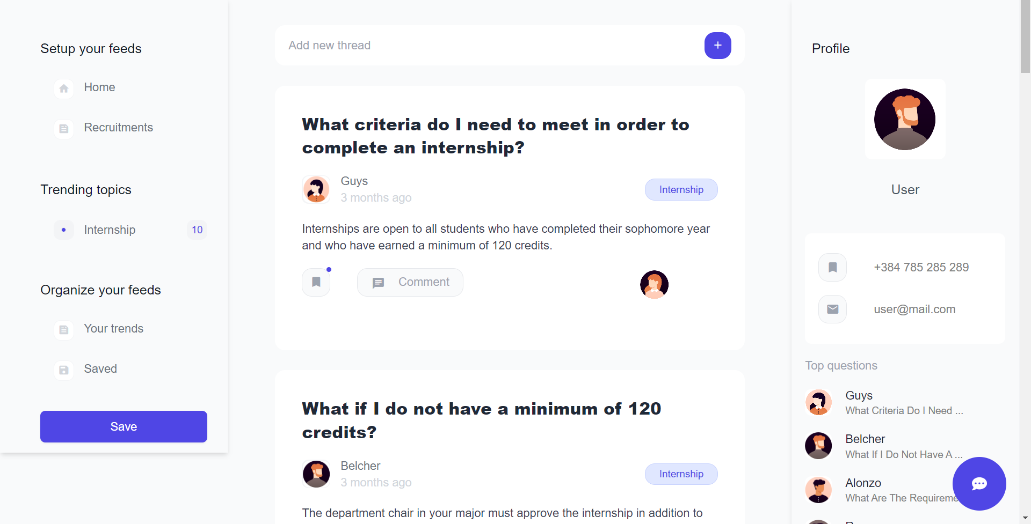

Figure 34. List of questions and categories on the home page

#### Detail question page

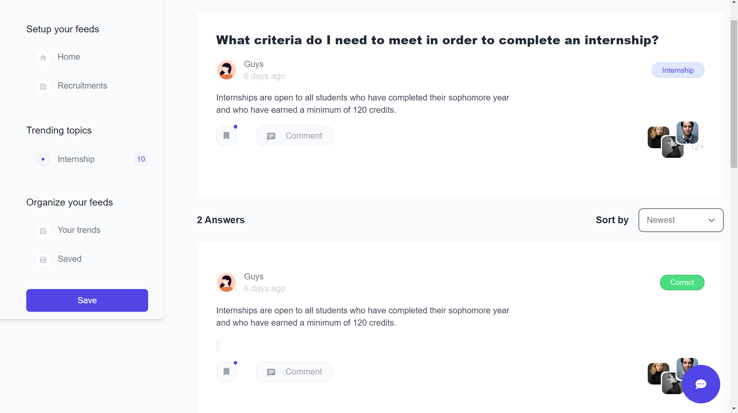

Figure 35. List of answers, and comments on the detail question page

On the detail question page, users will see the most popular answers to the question they have selected. Besides, users can also see the option to allow them to add an answer to this question by clicking on the “Answer” button. After clicking the button, the answer form will be shown to allow users to create a new answer for this question.

In addition, users can also see the trending topics of questions to filter questions by topic on the left sidebar, and the option to sort the answers.

#### Question topic page

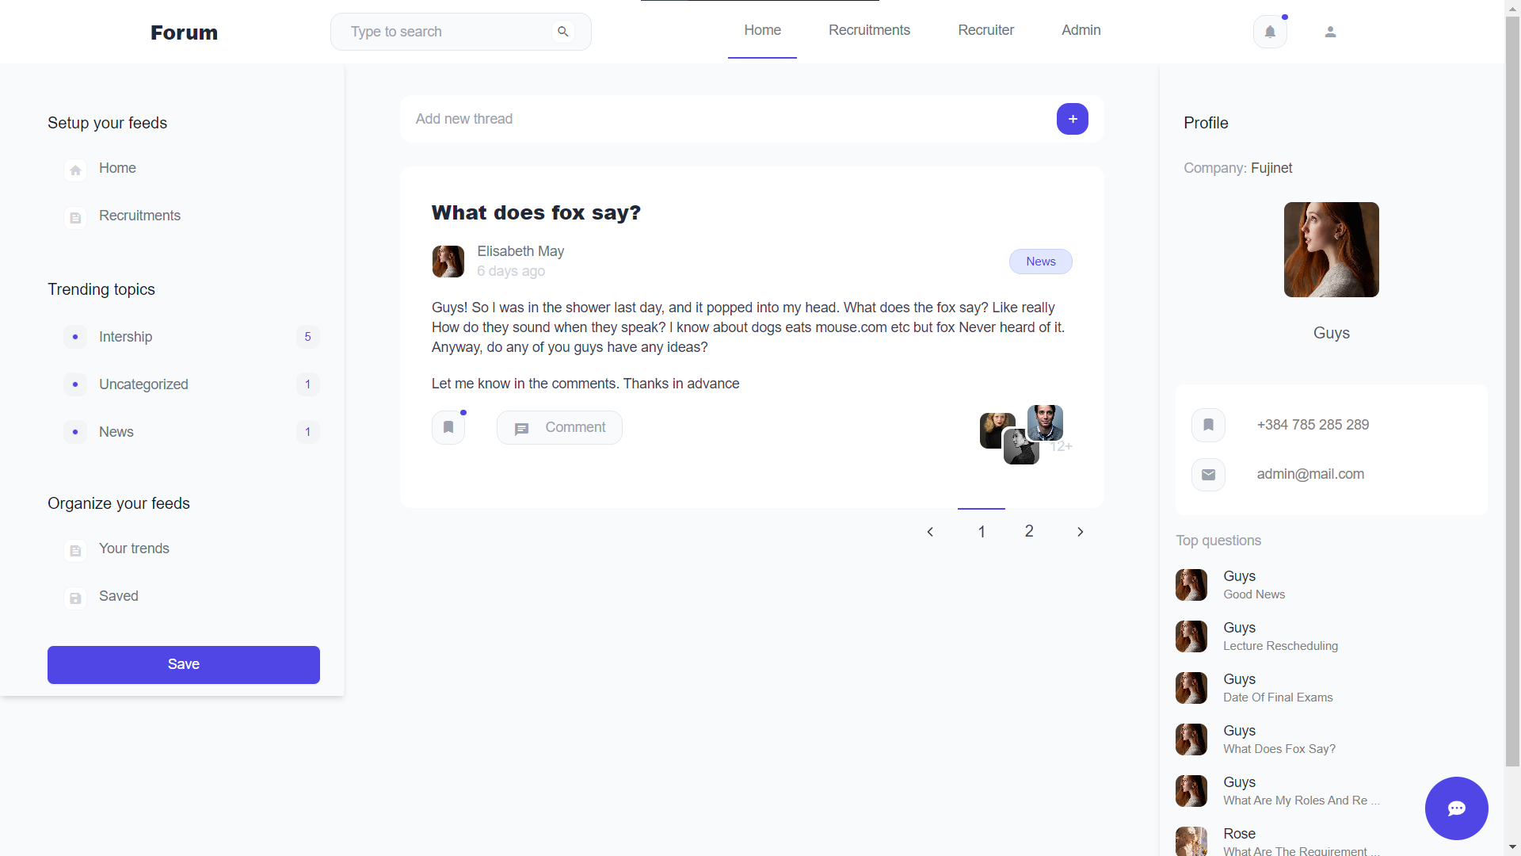

Figure 36. Questions topic page

On the “Question topic” page, users will see all the questions belong to a specific topic. The question topic page has similar content as the “Question” page such as the left sidebar and right sidebar,

#### Recruitments page

On the recruitments page, users will see the most popular recruitments to select to view detail. There is an option to allow users, who have logged in to the website with the “Recruiter” role, to add new recruitments quickly by clicking on the button “Add new”, after clicking the button, the user will be redirected to the “New recruitment” page to create a new one.

Besides, users can also see the companies, skills, and fields on the sidebar to filter recruitments on the left sidebar. In addition, on the right sidebar, users will see their profile and a list of top recruitments on the website

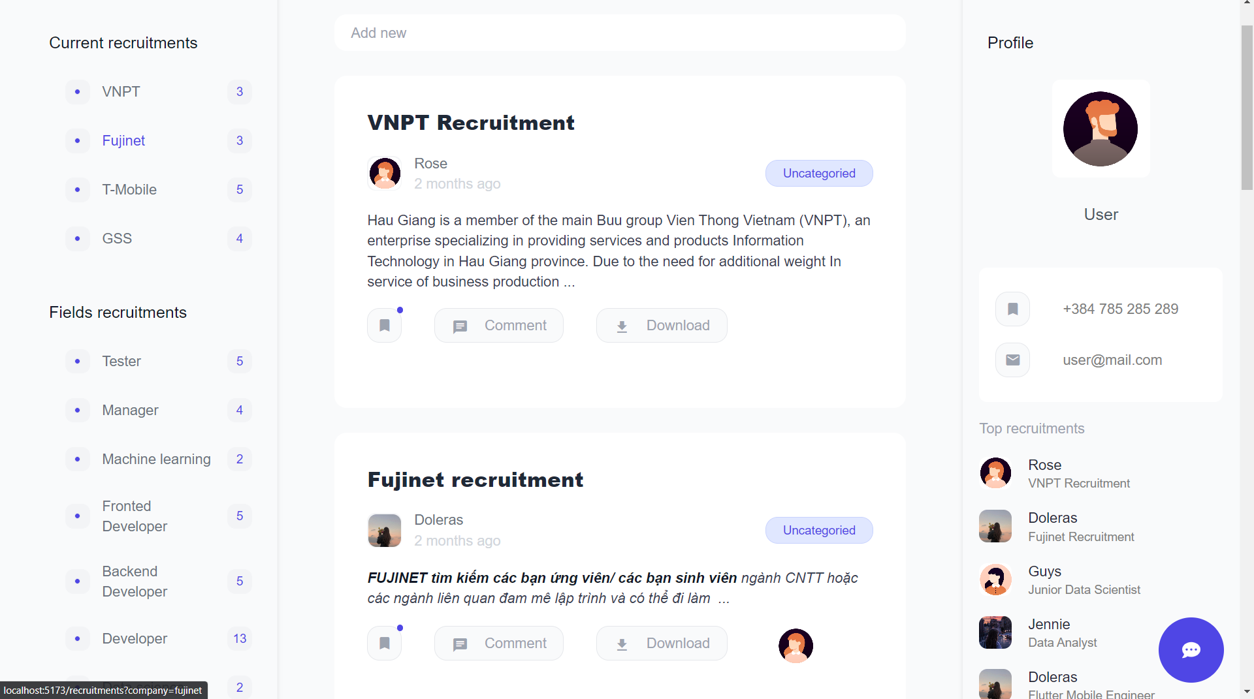

Figure 37. List of recruitments on the recruitments page

#### Detail recruitment page

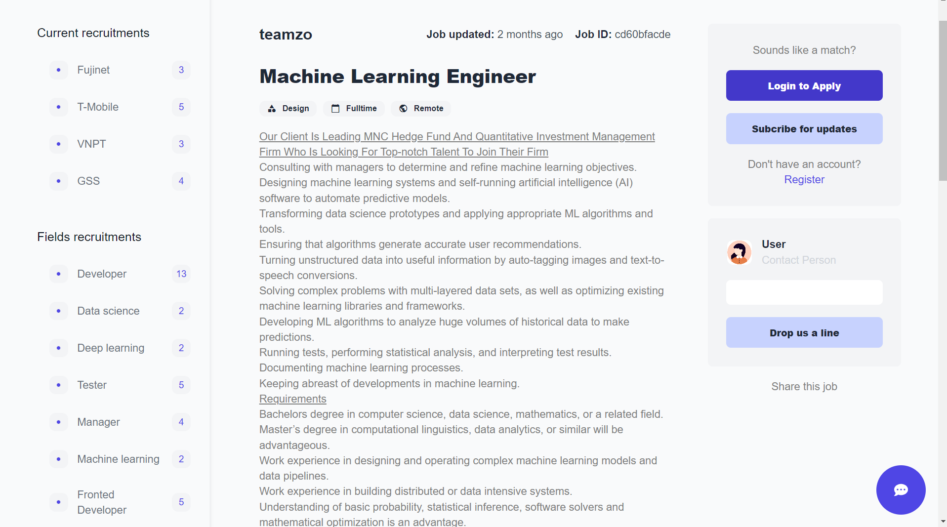

Figure 38. Detail recruitment info on the detail recruitment page

On the detail recruitment page, users will see the content description of the recruitment they have selected. In addition, users can also see the option to allow them to apply to this recruitment if they have logged in, otherwise, there will be an option to allow them to log in, and after have logged in they will be able to apply.

When the user clicks on apply button, the popup with be shown to allow the user to enter the information needed to apply (phone number and CV)

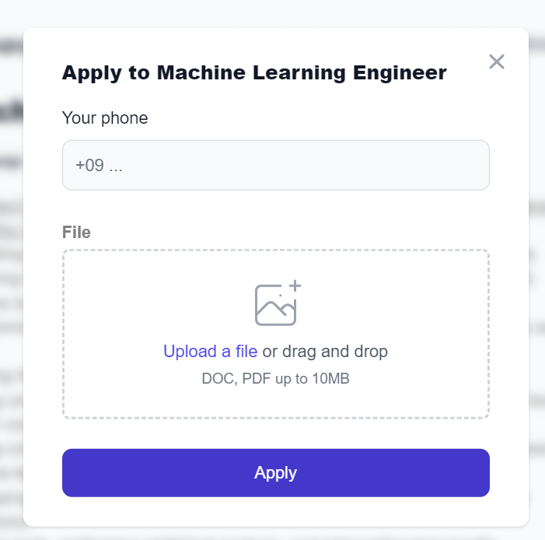

Figure 39. Apply recruitment form

#### Search questions

Search question input will be shown in the header of the website to help users quickly search for the questions they want to learn. After inputting the keyword and clicking search users will be redirected to the search results page where the questions that match the keyword will be displayed.

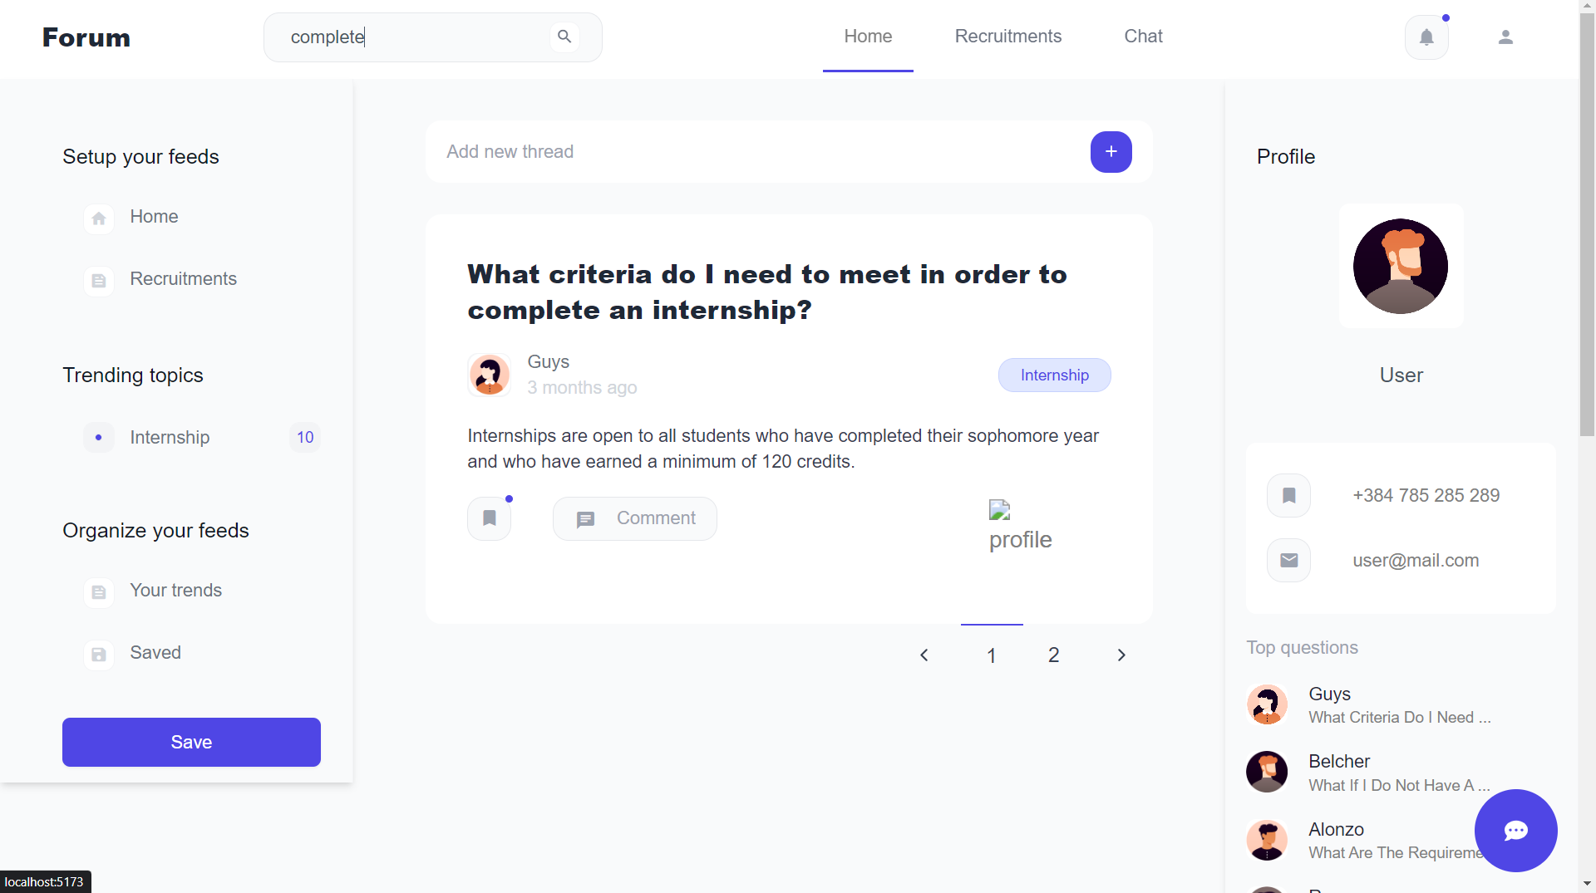

Figure 40. Search questions result page

#### Search recruitments

Search recruitment input will be shown in the header of the website to help users quickly search for the questions they want to learn. After inputting the keyword and clicking search users will be redirected to the search results page where the recruitments match with the keyword will be displayed.

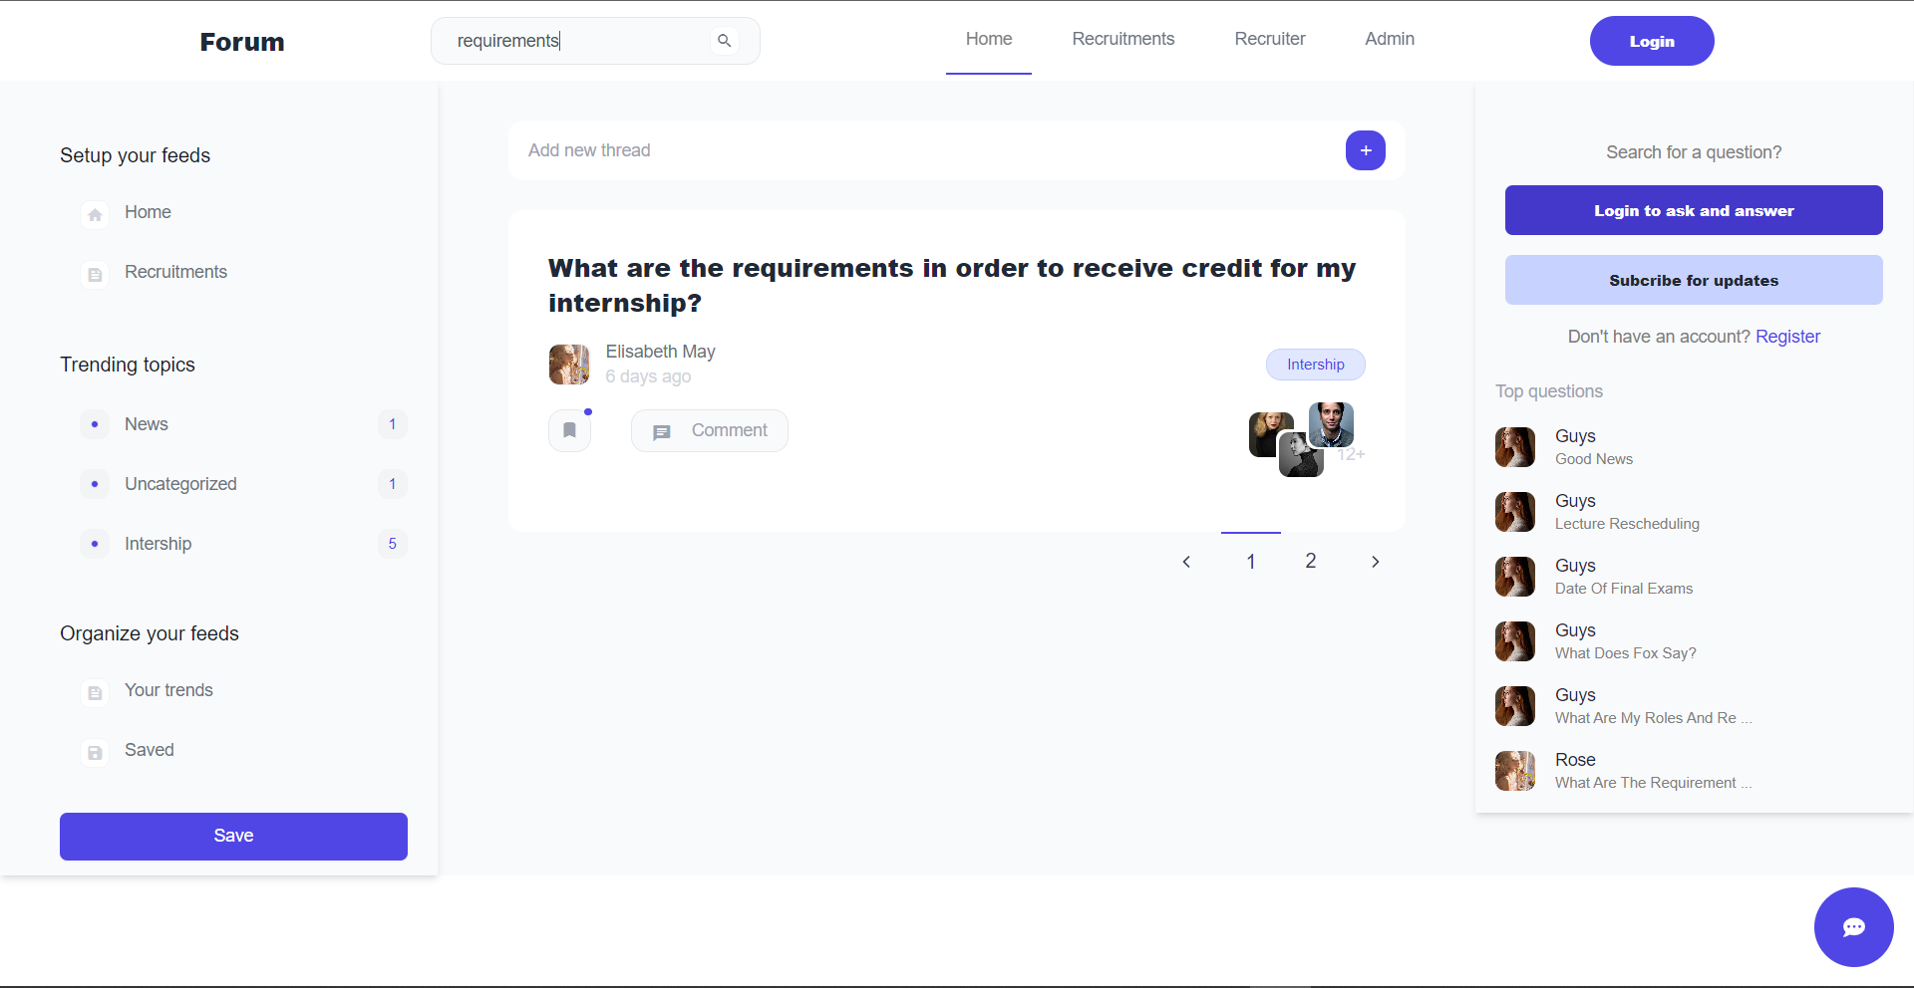

Figure 41. Search the recruitments result page

#### User profile setting

On the user profile page, the users will see detailed information about them and can edit the information if needed. The users can edit the title, and description about them or change the profile picture

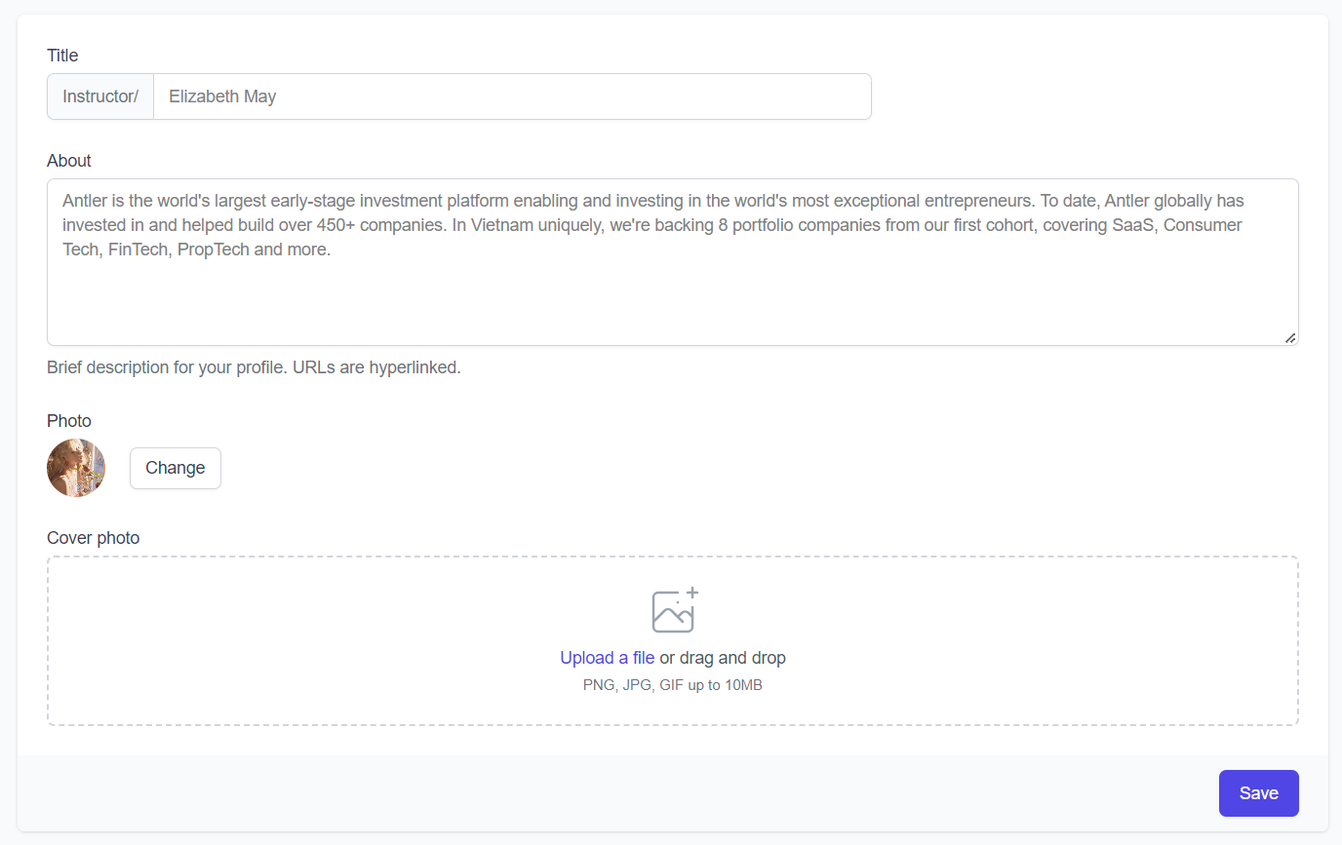

Figure 42. User profile setting page

#### Questions management page for users

The questions management page is where users can manage the questions they have posted on the website. The page will show the list of all questions that they have uploaded with the respective action for them to update (edit, delete).

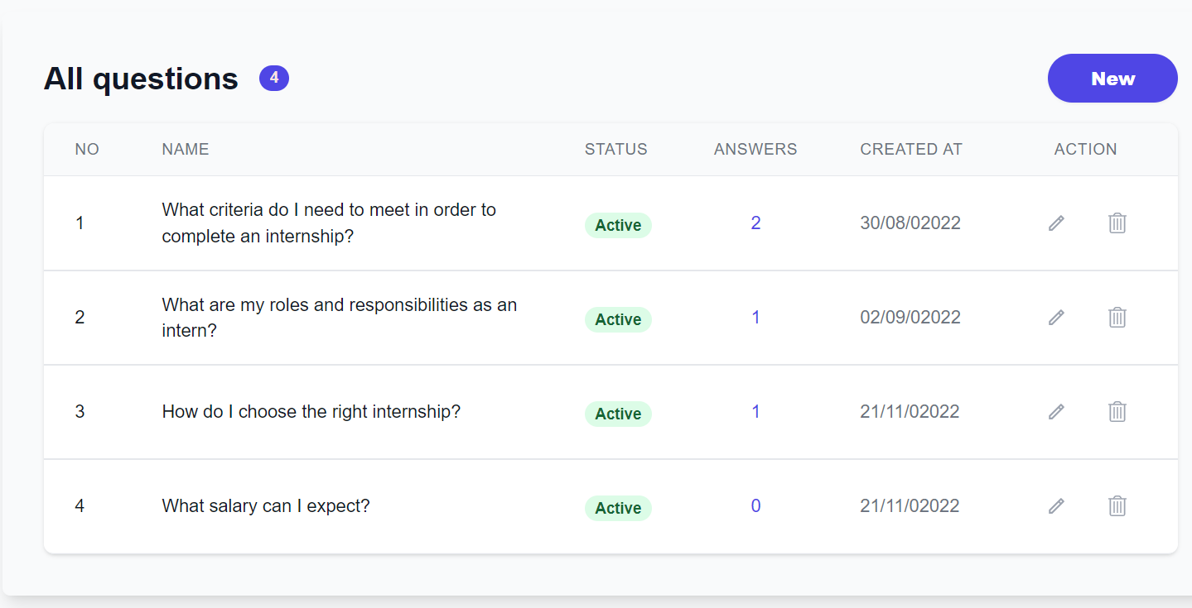

Figure 43. Questions management page for users

When the users click on the edit question, they will be redirected to the edit question page to edit the question. The users can edit the name and content of the question by inputting the new name and new content and then clicking submit button to update.

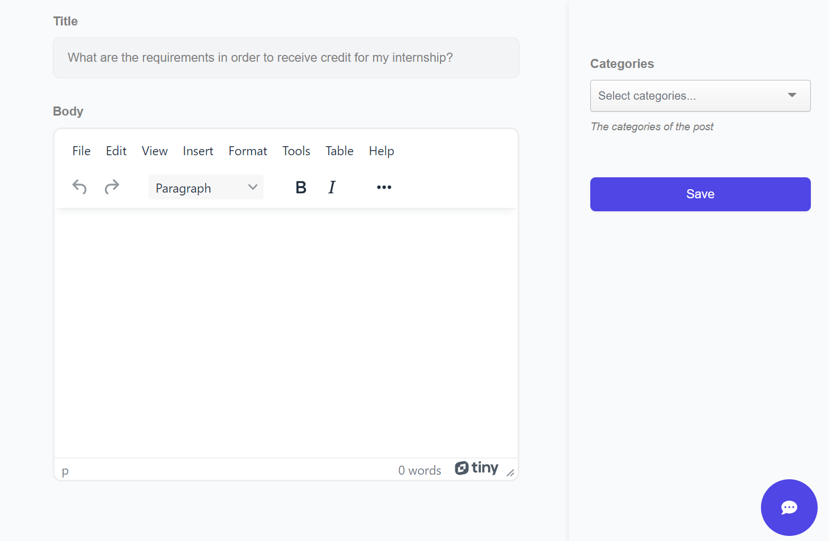

Figure 44. Question form for users

#### Answers management page for users

The answers management page is where users can manage the answers they have posted on the website. The page will show the list of all answers that they have answered with the respect action for them to update (edit, delete).

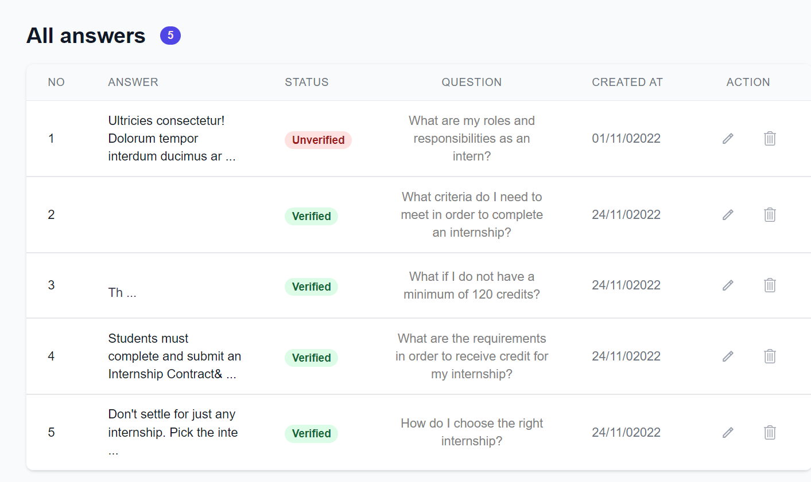

Figure 45. Answers management page for users

When the users click on the edit button, they will be redirected to the edit answer page to edit the answer. The users can edit the content of answers by inputting the new content and then clicking submit button to update.

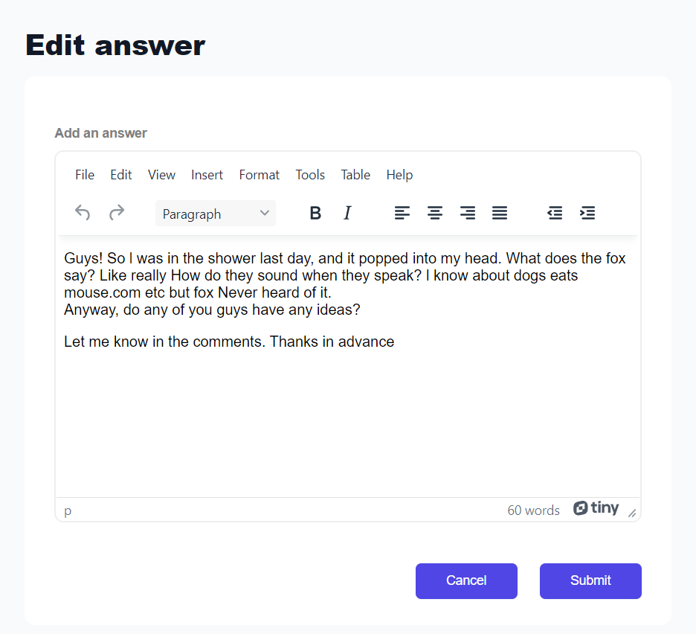

Figure 46. Edit the answer page for the user

#### Comments management page for users

The comments management page is where users can manage the comments they have commented on the website. The page will show the list of all comments with the respective action for them to update (edit, delete).

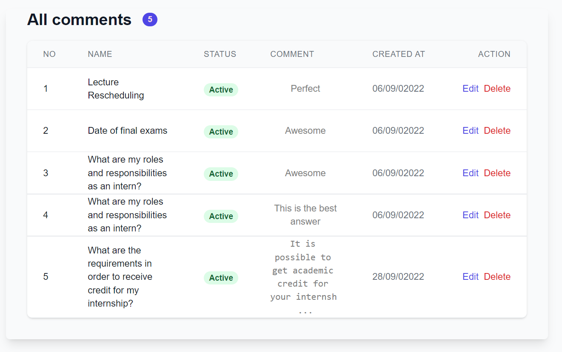

Figure 47. Comments management page for users

When the users click on the edit button, they will be redirected to the edit comment page to edit the comment. The users can edit the content of the comment by inputting the new content and then click submit button to update.

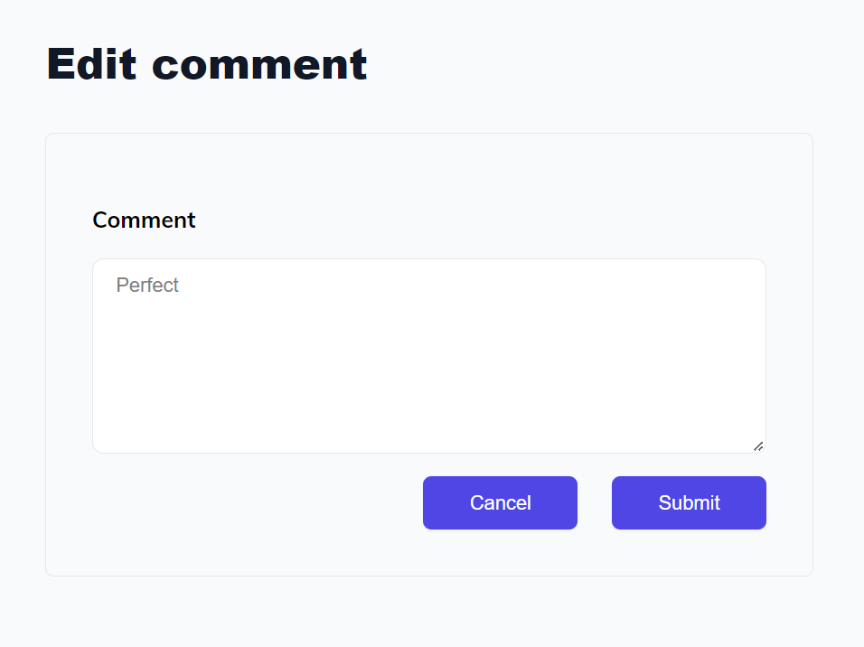

Figure 48. Edit the comment page for the user

#### Categories management page

The categories management page is where the admin can manage the categories of the questions on the website. The page will show the list of all categories available with the respective action for the admin to update the category (edit, delete). In addition, the admin can also add a new category by a tap on the add category section, then inputting the name of the category and click submit button.

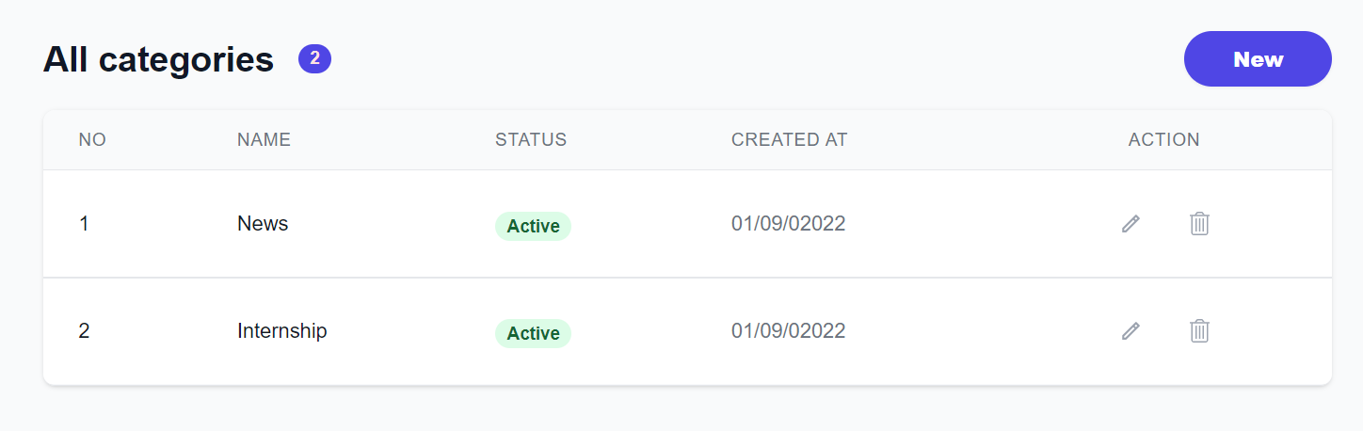Figure 49. Categories management page

When the admin clicks on the edit category, the admin will be redirected to the edit category page to edit the category. The admin can edit the name of the category by inputting the new name and then clicking submit button to update the category.

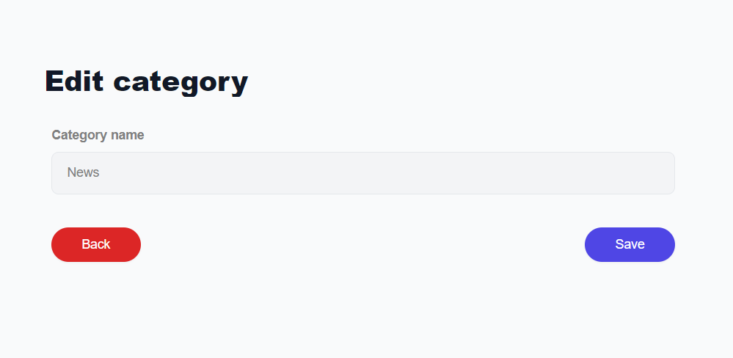

Figure 50. Edit category form

#### Accounts management page

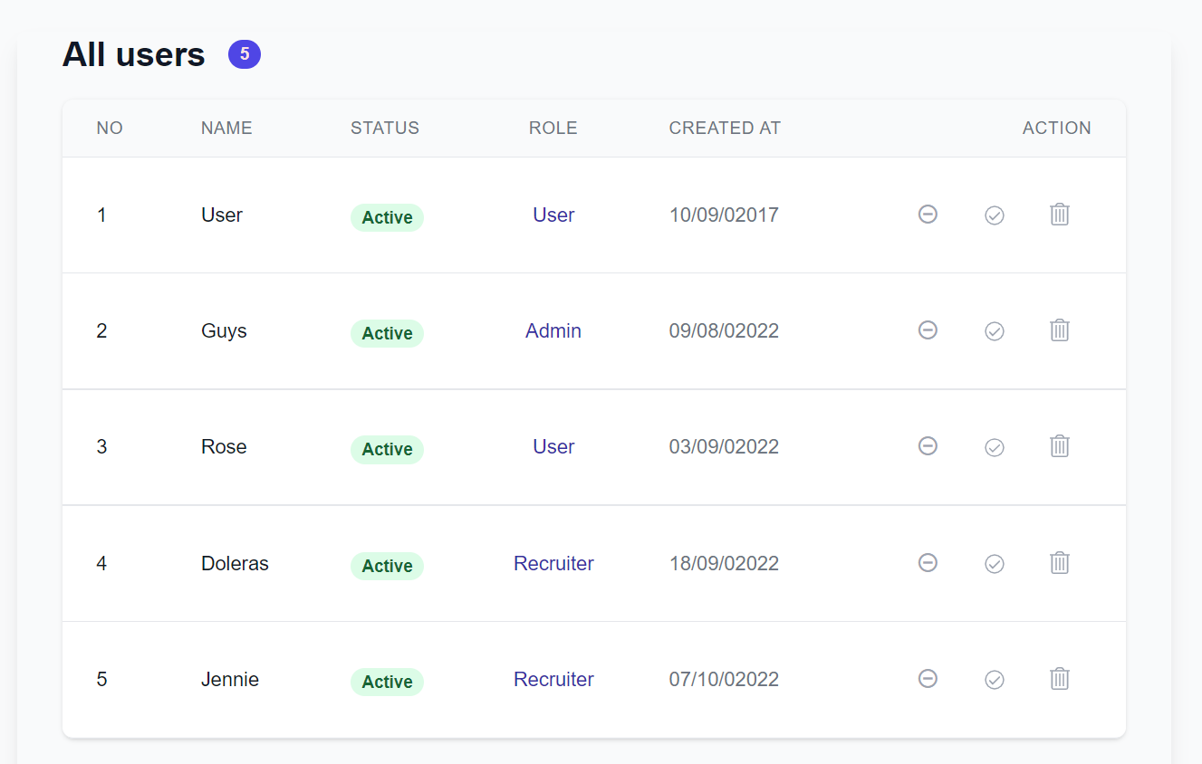

Figure 51. Accounts management page

The accounts management page is where the admin can manage the account of the users on the website. The page will show the list of all accounts available with the respective action for the admin to update the account (disable, activate, or delete).

#### Companies management page

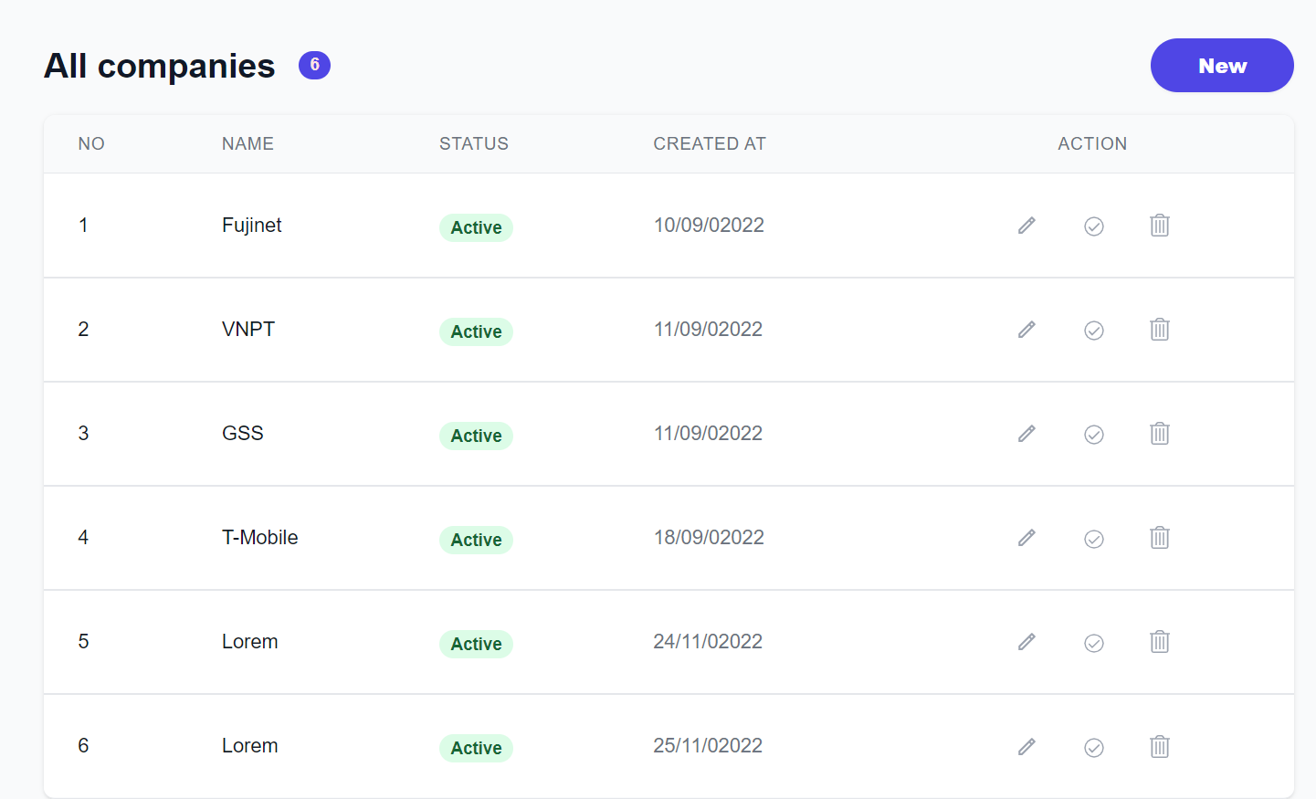

Figure 52. Companies management page

The companies management page is where the admin can manage the companies on the Chatbox Forum website. The page will show the list of all companies available with the respective action for the admin to update (edit, delete).

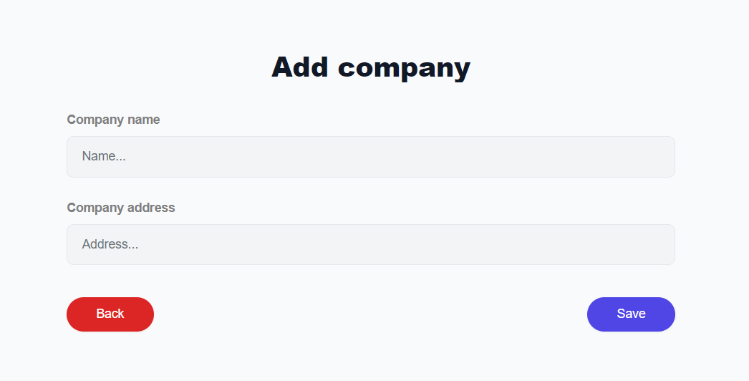

Figure 53. Add company form

In addition, the admin can also add a new company by a tap on the add company button, then inputting the name of the company, and address and click submit button.

When the admin clicks on the editing company, the admin will be redirected to the edit company page to edit the company. The admin can edit the name and address of the company by inputting the new name and new address and then click submit button to update the company.

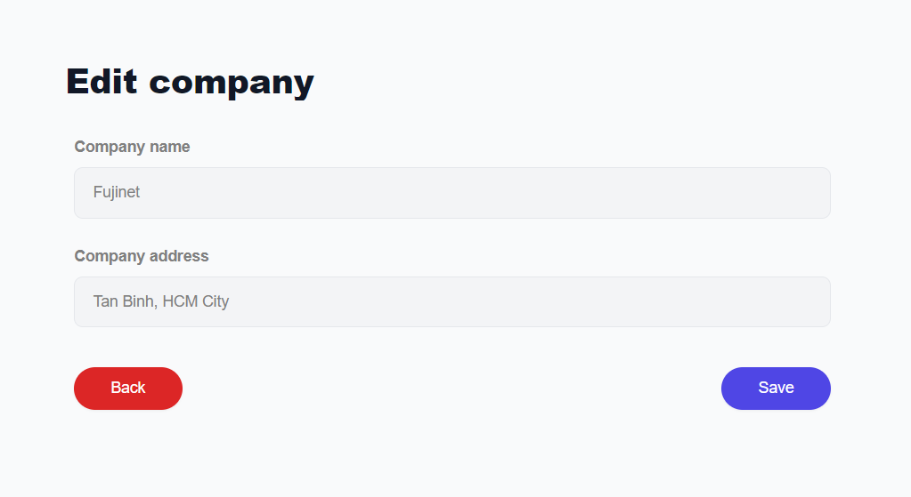

Figure 54. Edit company form

#### Fields management page

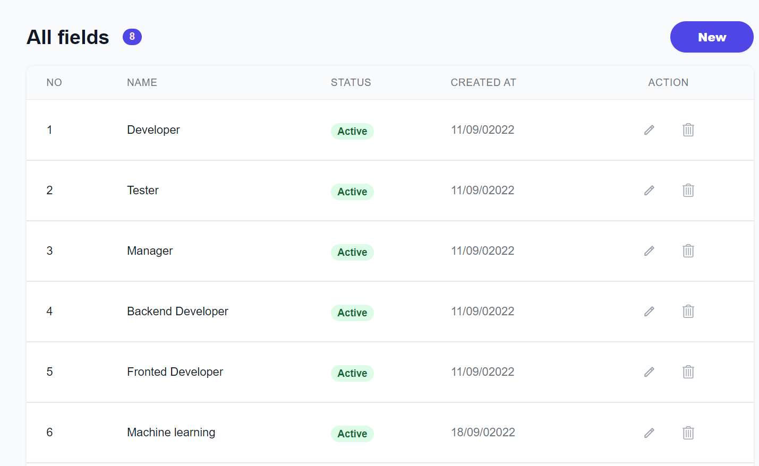

Figure 55.Fields management

The fields management page is where the admin can manage the field of the recruitments in Chatbox Forum website. The page will show the list of all fields available with the respective action for the admin to update (edit, delete).

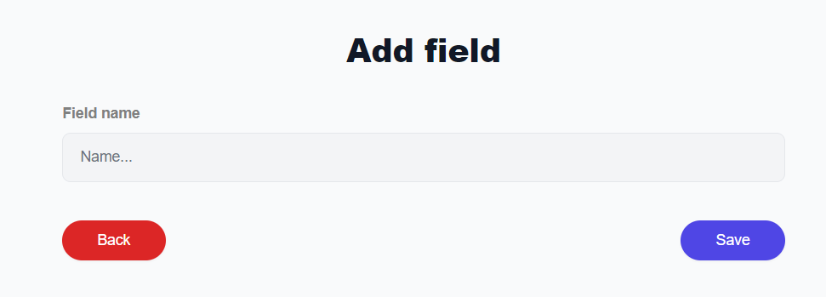

Figure 56. Add field form

In addition, the admin can also add a new field by tapping on the add field button, then inputting the name of the field and click submit button.

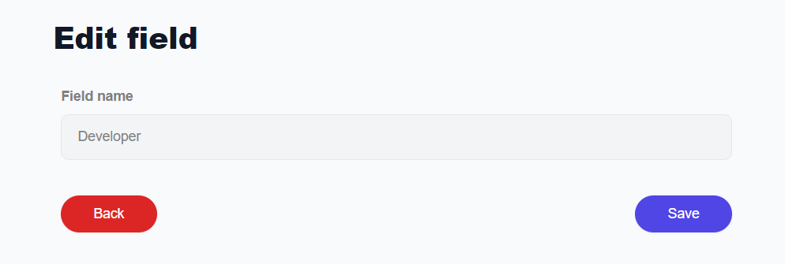

Figure 57. Edit field form

When the admin clicks on the edit field, the admin will be redirected to the edit field page to edit the field. The admin can edit the name of the field by inputting the new name, then clicking submit button to update the field.

#### Skills management page

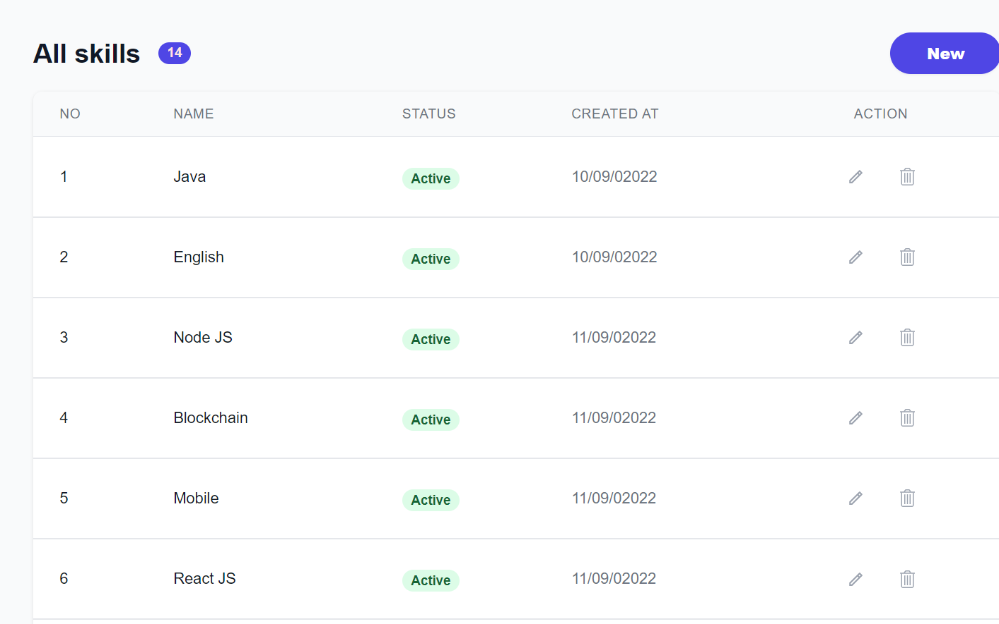

Figure 58. Skills management

The skills management page is where the admin can manage the skill of the recruitments on the Chatbox Forum website. The page will show the list of all skills available with the respective action for the admin to update (edit, delete).

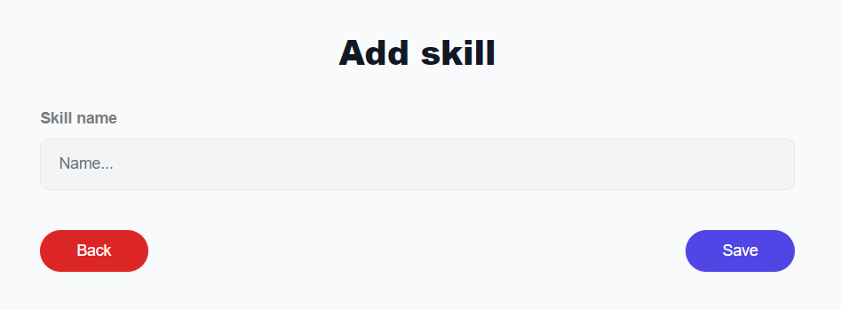

Figure 59. Add skill form

In addition, the admin can also add a new skill by tapping on the add button, then inputting the name of the skill and click submit button.

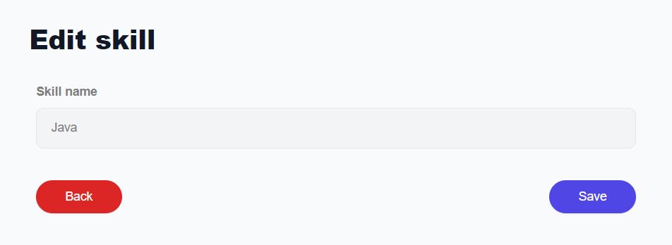

Figure 60. Edit skill form

When the admin clicks on the editing skill, the admin will be redirected to the edit skill page to edit the skill. The admin can edit the name of the skill by inputting the new name, then clicking submit button to update the field.

#### Questions management page

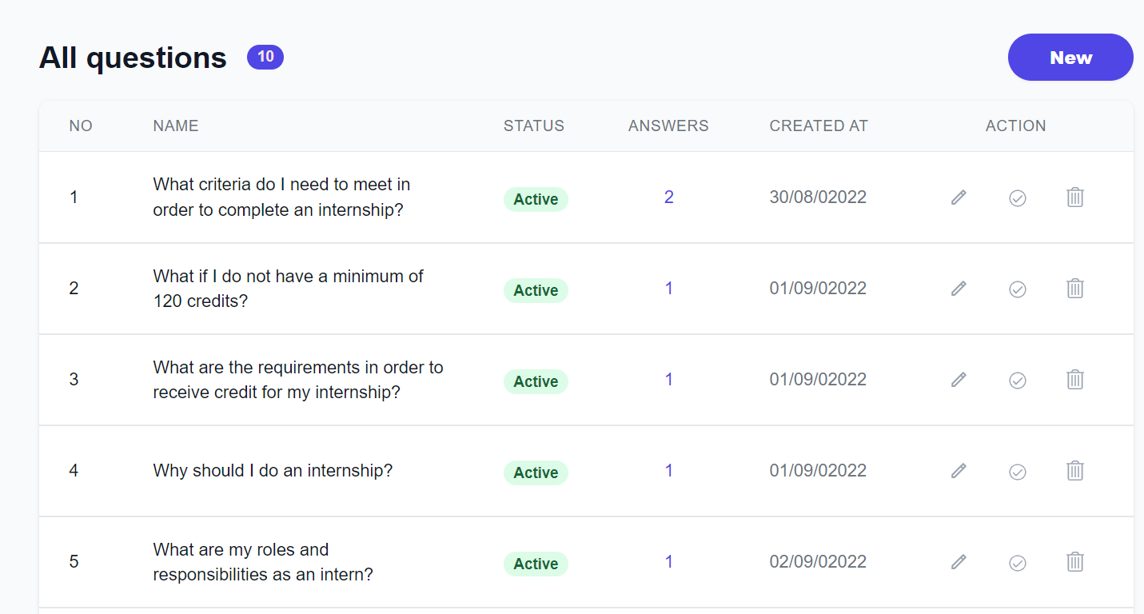

Figure 61. Questions management page

The question management page will display the list of questions for the admin to edit or delete. Moreover, when accessing this page, the admin can also add, update, delete or approve the question.

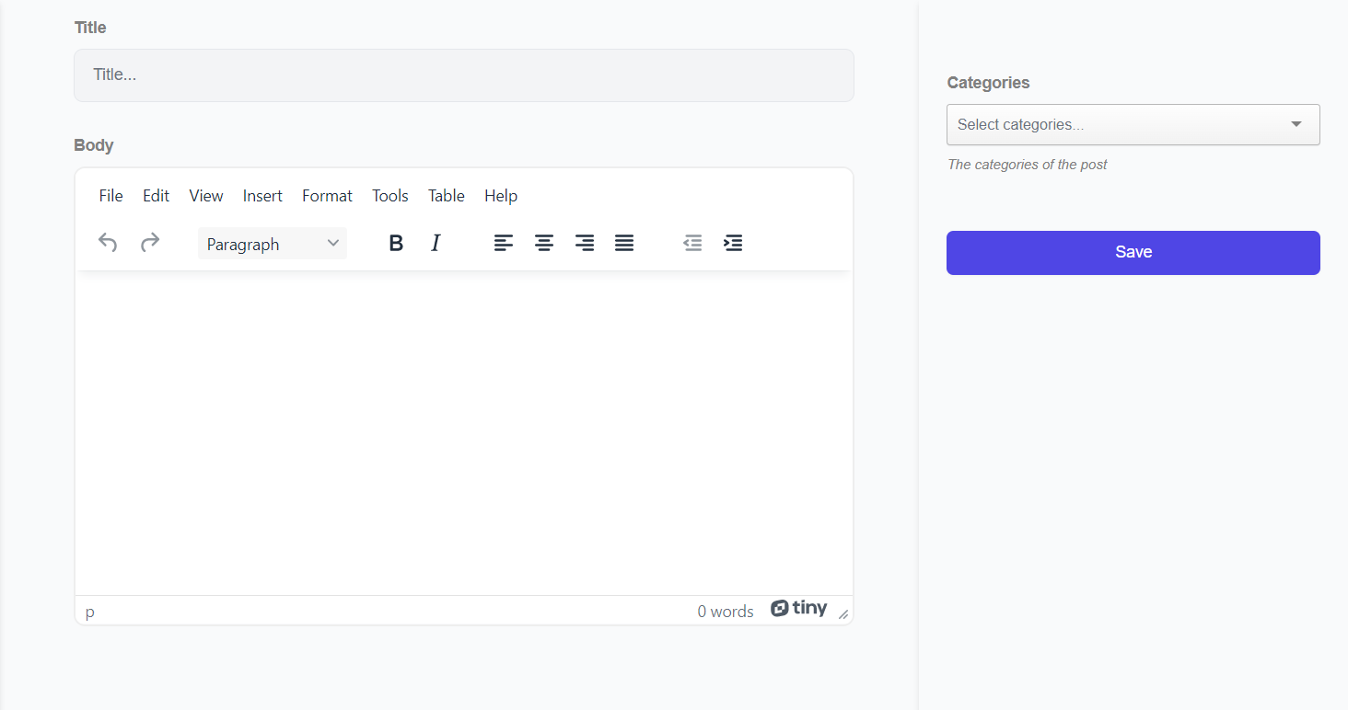

Figure 62. Add question form

When the admin clicks on the add button, the admin will be redirected to the add question page to insert a new question.



Figure 63. Update question form

When the admin clicks on the edit question, the admin will be redirected to the edit question page to edit the question as well as the question topics.

#### Answers management page

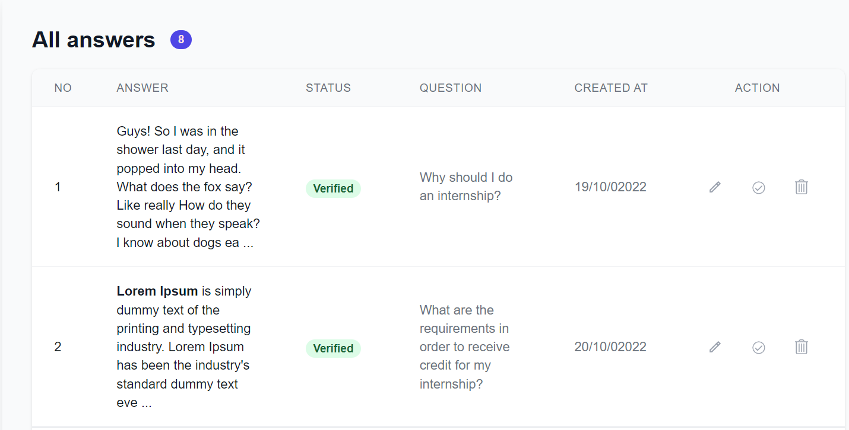

Figure 64. Answers management page

The answers management page will display the list of answers for the admin to edit or delete. Moreover, when accessing this page, the admin can add, update, delete or approve answers.



Figure 65. Add answer form

When the admin clicks on the add button, the admin will be redirected to the add question page to insert a new question.



Figure 66. Update answer form

When the admin clicks on the edit answer button, the admin will be redirected to the edit answer page to edit the answer

#### Recruitments management page

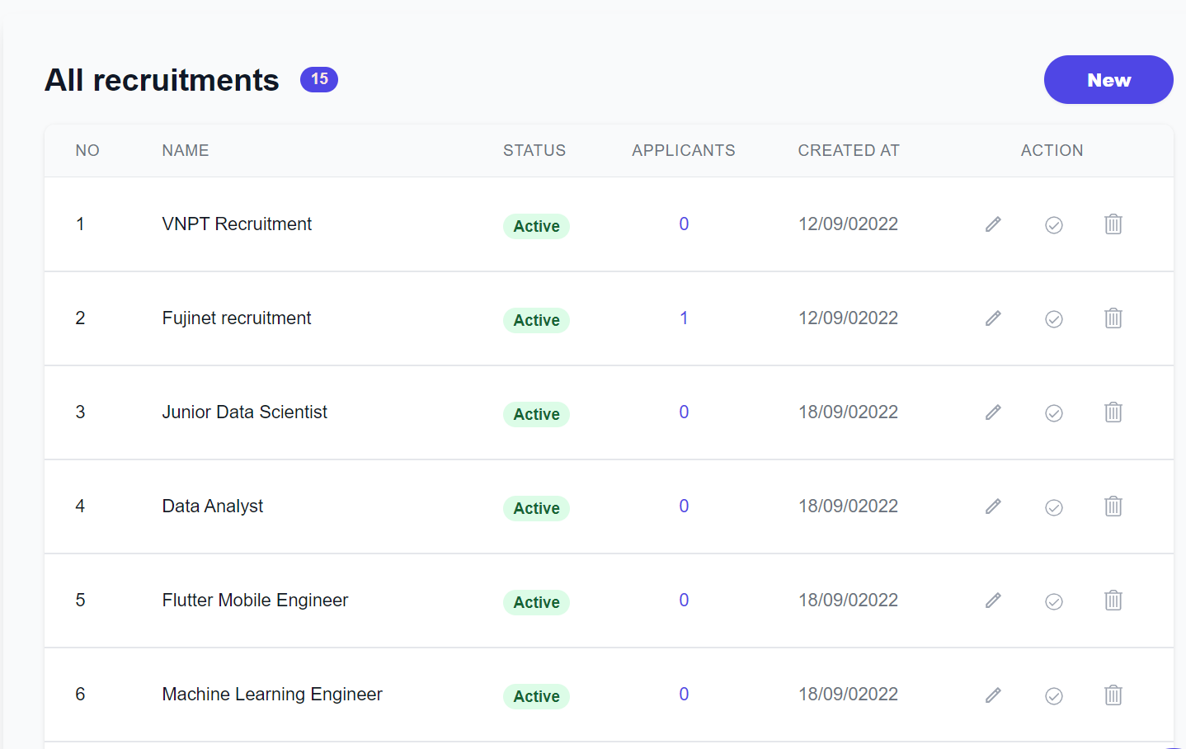

Figure 67. Recruitments management page

The recruitment management page will display the list of recruitments for the admin to edit or delete. Moreover, when accessing this page, the admin can add, update, delete or approve recruitment.

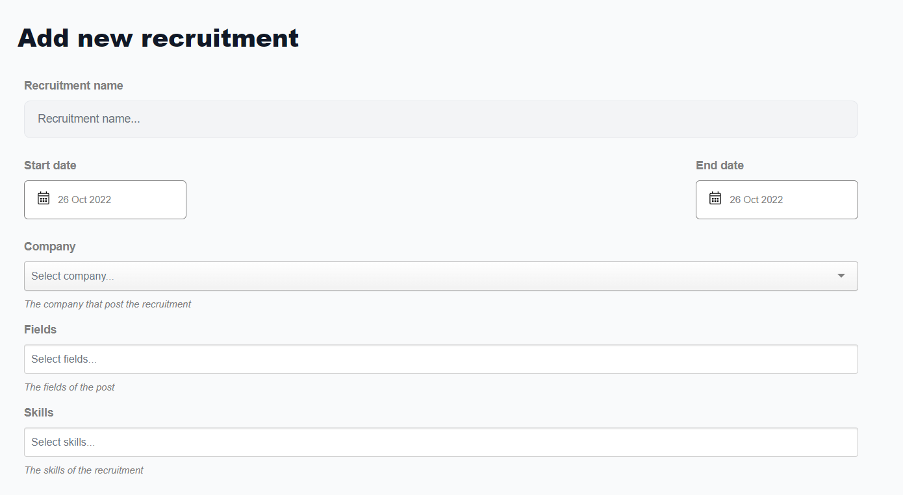

Figure 68. Add recruitment form (1)

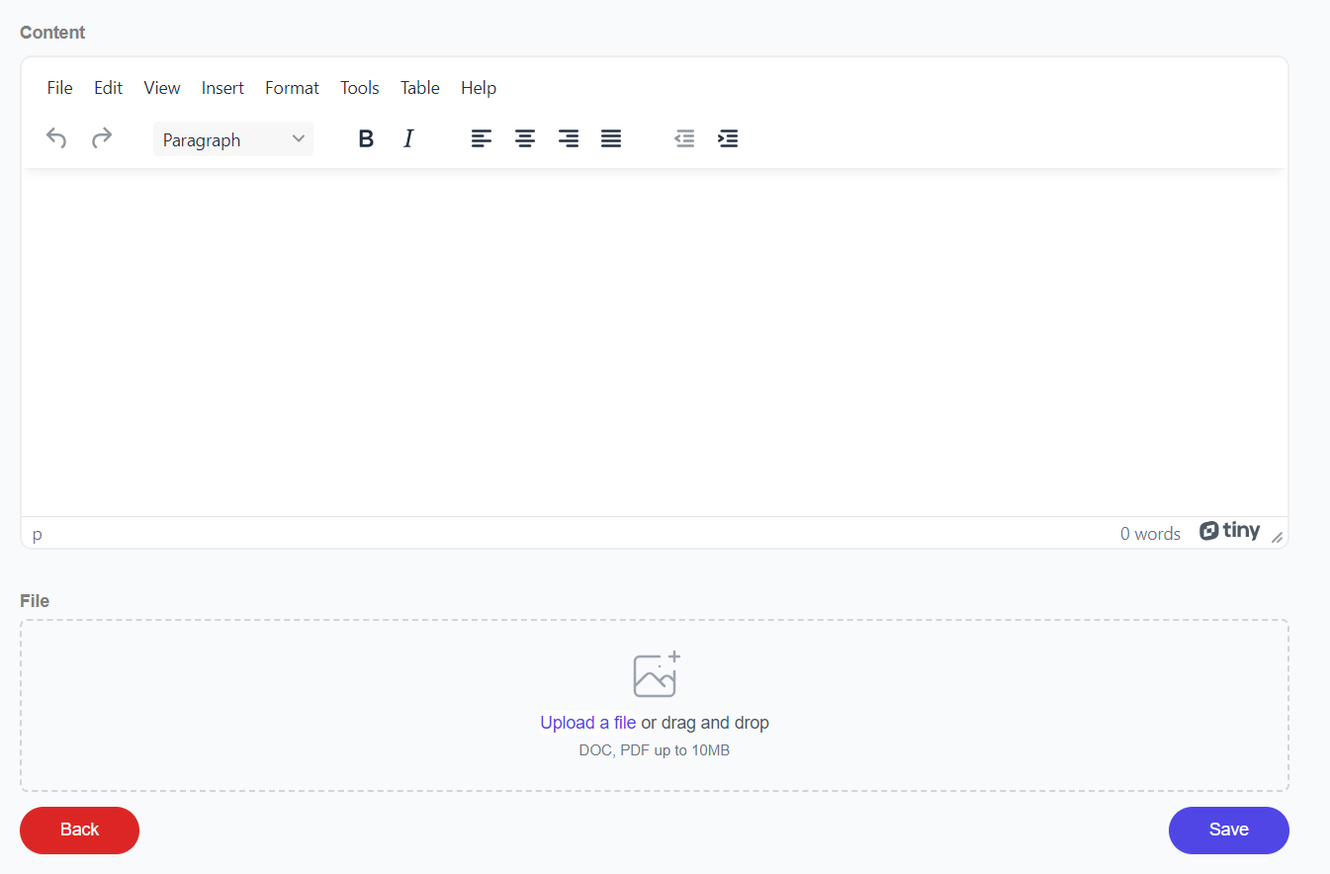

Figure 69. Add recruitment form (2)

When the admin clicks on the add button, the admin will be redirected to the add recruitment page to insert new recruitment.



Figure 70. Update recruitment form



Figure 71. Update recruitment form (2)

When the admin clicks on the edit recruitment, the admin will be redirected to the edit recruitment page to edit the recruitment

#### Recruitments management page for recruiter

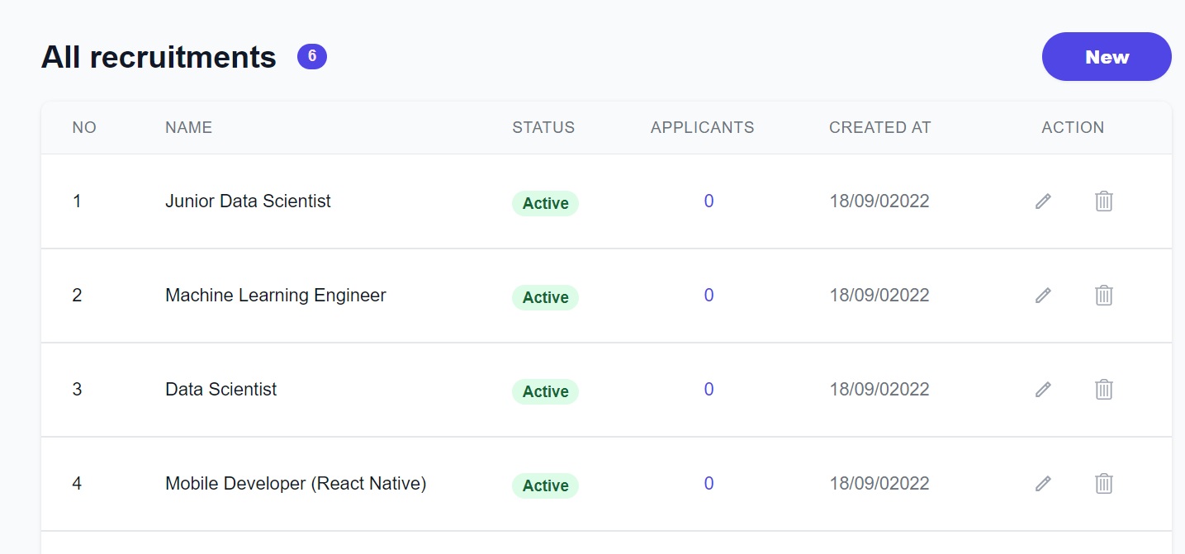

Figure 72. Recruitments management page

The recruitment management page will display the list of recruitments belonging to the recruiter to edit or delete. Moreover, when accessing this page, the recruiter can add, update, or delete recruitment.





When the recruiter clicks on the add button, the recruiter will be redirected to the add recruitment page to insert new recruitment.

Figure 73. Add question form



Figure 74. Update question form



When the recruiter clicks on the edit recruitment, the recruiter will be redirected to the edit recruitment page to edit the recruitment

#### Applies management for recruiters

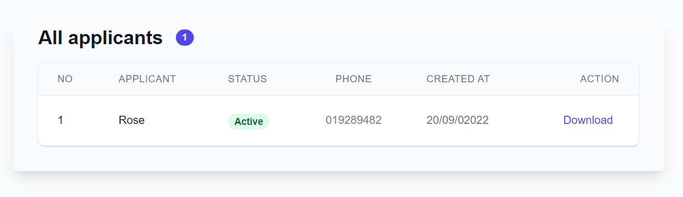

Figure 75. Recruitments management page

Applies management page will display the list of applicants that apply to recruitments of the recruiter to allow view info about applicants. Moreover, the recruiter can approve or download the cv of the applicant for more information.

# TESTING

## Purpose of Testing

The main goal of testing is to detect errors, and check whether the program has requirements have been met or not.

Objectives to be achieved:

The testing process includes usability testing, functional testing, compatibility testing, database testing, and security testing.

Usability testing is to check if the website and application are user-friendly. New users can understand the application easily or not.

* The content is correct, without any spelling errors.
* All error messages are correct, without any typos or any grammar and the error message must match the field label.
* A navigation menu is available on each page.
* A confirmation message is displayed for any delete operation.

Functional testing is to verify if the product meets the functional or business characteristics mentioned in the specification document.

* Check the email function (if registered with the same email).
* Check if the static path displayed on the browser is correct or not.
* Check all links and buttons are working and go to the respective page.
* Check the ability to force data entry, empty data, constraints data, and display a message when incorrect data is entered.

Compatibility testing to evaluate how well the software works in a particular browser

* Test the website on different browser
* Check content: images, and text on different screen resolutions.

Data testing is checking whether the data displayed in the web application matches the data stored in the database. Is the application action data correctly added to the database?

* The data displayed to the user is the same as the data in the database.
* Check data validity by inserting empty or invalid data into the database.

Security testing is testing to identify any security flaws and vulnerabilities.

* Confidential information such as passwords are encrypted.

## Testing scenario

Functionalities testing scenario:

|  |  |
| --- | --- |
| **ID** | **Description** |
| **1** | Test register feature |
| **2** | Test login feature |
| **3** | Test update profile |
| **4** | Test chat with chatbox feature |
| **5** | Test question feature |
| **6** | Test answer feature |
| **7** | Test comment feature |
| **8** | Test recruitment feature |
| **9** | Test apply to recruitment feature |

Table 17. Functionalities testing scenario

**Usability** testing scenario:

|  |  |
| --- | --- |
| **ID** | **Description** |
| **1** | Test content on the page |
| **2** | Test hyperlink and button |
| **3** | Test notifications |

Table 18. Usability testing scenario

Compatible testing scenario:

|  |  |
| --- | --- |
| **ID** | **Description** |
| **1** | Test pages on other browsers |
| **2** | Test pages on different resolution |

Table 19. Compatible testing scenario

Data testing scenario:

|  |  |
| --- | --- |
| **ID** | **Description** |
| **1** | Test data display on the website |
| **2** | Test constraint of data |

Table 20. Data testing scenario

Security testing scenario:

|  |  |
| --- | --- |
| **ID** | **Description** |
| **1** | Test login authenticate |
| **2** | Test admin authentication for admin management |
| **3** | Test recruiter authentication for recruiter management |

Table 21. Security testing scenario

Test environment:

Hardware:

* Asus VivoBook
* Processor: Intel Core i7

Software:

* Database: MongoDB
* Browser Chrome

## Testing results

### Register feature

|  |  |  |  |
| --- | --- | --- | --- |
| **ID** | **Description** | **Steps** | **Result** |
| **1** | Test register | Step 1: Open the register page  Step 2: Input username, email, and password  Step 3: Click the “Register” button | Success |

Table 22. Test case register feature

### Login feature

|  |  |  |  |
| --- | --- | --- | --- |
| **ID** | **Description** | **Steps** | **Result** |
| **1** | Test login | Step 1: Open the login page  Step 2: Input email, and password  Step 3: Click the “Login” button | Success |

Table 23. Test case login feature

### Update profile feature

|  |  |  |  |
| --- | --- | --- | --- |
| **ID** | **Description** | **Steps** | **Result** |
| **1** | Test update profile | Step 1: Open the profile page  Step 2: Input into the following fields to update those fields: first name, last name, address, city, country, zip code  Step 3: Click the “Save” button | Success |

Table 24. Test case update profile feature

### Chat feature

|  |  |  |  |
| --- | --- | --- | --- |
| **ID** | **Description** | **Steps** | **Result** |
| **1** | Test chat with the popup window | Step 1: Click on the chat icon  Step 2: Input the question and press “Enter” | Success |
| **2** | Test chat on the chat page | Step 1: Login into an account  Step 2: Open the “Chat” page  Step 2: Input the question and press “Enter” | Success |

Table 25. Test case chat feature

### Question feature

|  |  |  |  |
| --- | --- | --- | --- |
| **ID** | **Description** | **Steps** | **Result** |
| **1** | Test view detail question | Step 1: Open the “Question” page  Step 2: Click on the title of the question | Success |
| **2** | Test search question | Step 1: Open the “Question” page  Step 2: Input the keyword into the search bar  Step 3: Click the icon search or press “Enter” | Success |
| **1** | Test add question | Step 1: Login into the website with any account  Step 2: Open the “Question” page  Step 1: Click on the “Add new” button on the page  Step 2: Input information about the question  Step 3: Click the “Save” button | Success |

Table 26. Test case question feature

### Answer feature

|  |  |  |  |
| --- | --- | --- | --- |
| **ID** | **Description** | **Steps** | **Result** |
| **1** | Test add answer | Step 1: Login into the website with any account  Step 2: Open the “Question” page  Step 3: Choose one question to go to the detail page  Step 4: Click the “Add answer” button  Step 5: Input information about the answer  Step 6: Click the “Save” button | Success |

Table 27. Test case answer feature

### Comment feature

|  |  |  |  |
| --- | --- | --- | --- |
| **ID** | **Description** | **Steps** | **Result** |
| **1** | Test comment on the question | Step 1: Login into the website with any account  Step 2: Open the “Question” page  Step 3: Choose one question to go to the detail page  Step 4: Click the “Comment” button on a question  Step 5: Input information about the comment  Step 6: Click the “Save” button | Success |
| **2** | Test comment on the answer | Step 1: Login into the website with any account  Step 2: Open the “Question” page  Step 3: Choose one question to go to the detail page  Step 4: Click the “Comment” button on an answer  Step 5: Input information about the comment  Step 6: Click the “Save” button | Success |

Table 28. Test case comment feature

### Recruitment feature

|  |  |  |  |
| --- | --- | --- | --- |
| **ID** | **Description** | **Steps** | **Result** |
| **1** | Test view detail question | Step 1: Open the “Recruitment” page  Step 2: Click on the title of the recruitment | Success |
| **2** | Test search recruitment | Step 1: Open the “Recruitment” page  Step 2: Input the keyword into the search bar  Step 3: Click the icon search or press “Enter” | Success |
| **3** | Test add recruitment | Step 1: Login into a “Recruiter” account  Step 2: Open the “Recruitment” page  Step 1: Click on the “Add new” button on the page  Step 2: Input information about the recruitment  Step 3: Click the “Save” button | Success |

Table 29. Test case recruitment feature

### Apply recruitment feature

|  |  |  |  |
| --- | --- | --- | --- |
| **ID** | **Description** | **Steps** | **Result** |
| **1** | Test apply to recruitment | Step 1: Login into the website with any account  Step 2: Open the “Recruitment” page  Step 3: Choose one recruitment to go to the detail page  Step 4: Click the “Apply” button  Step 5: Input information about the apply  Step 6: Click the “Save” button | Success |

Table 30. Test case apply recruitment feature

# CONCLUSION AND FUTURE WORK

## Conclusion

Forumbot has reached the goal. We successfully created an application that provided a

chatbox that allows users to ask questions related to the internship and receive answers from it through a friendly UI/UX. Besides, the application also allows users to do other things such as: supporting users to search for questions, answers, and recruitments related to the internship that they are interested in.

Although Forumbot provides various useful functionalities, there are also some limits. At the present, Forumbot chatbox does not have high accuracy performance and does not understand other sentences that are different from the internship. The search functionality is limited, only supports search with name, but not its attributes such as content or topic of the question.

## Future work

We will integrate the apply recruitment feature into Gmail to allow the recruiter to send and receive messages to the applicants. We will add reviews and ratings for the questions as well as the recruitments to help users have the overall quality of the questions or recruitments before applying for it, and help to improve the question through the review of the users. Besides, we will enhance the search questions feature with more options such as based on categories, languages, or the programming languages of the courses. In addition, using AI to assist and recommend related questions and recruitments based on user behaviors will effectively enhance the quality of the website as well as the performance and interest of the users

# REFERENCES

|  |  |
| --- | --- |
| [1] | "Boostrap," [Online]. Available: https://www.boostrap.com. |
| [2] | "TailwindCSS," [Online]. Available: https://tailwindcss.com/. |
| [3] | "MySQL," [Online]. Available: https://www.mysql.com. |
| [4] | "Python," [Online]. Available: https://www.python.org. |
| [5] | M. Z. N. B. Aleksandar Petrovic, "Singibot - A Student Services Chatbot". |
| [6] | N. W. Rohit Tamrakar, "Design and Development of CHATBOT - A Review". |
| [7] | A. W. Vitor Rocio, "Building a Chatbot for student support". |